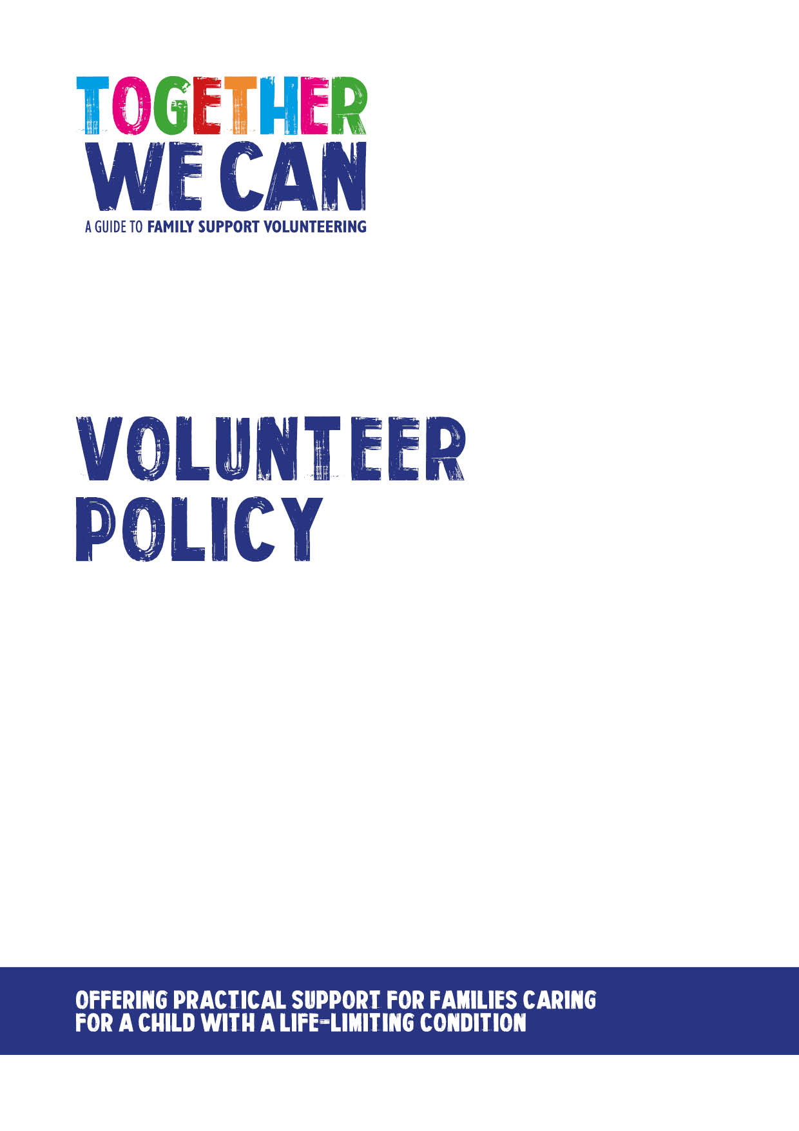

Together We Can is a collection of resources for organisations developing a service where volunteers support families of a child with a life-limiting or life-threatening condition. The resources were developed and tested specifically for this purpose with volunteers working in the homes of a child with a life-limiting condition, but might be useful for any organisation developing volunteer services.

Family Support Volunteer Policy

Acknowledgements

Author: Dr Ros Scott
Voluntary Sector Consultant

We would also like to acknowledge the contribution to the review and development of these materials from:

Lizzie Chambers Development Director, Together for Short Lives

Paul Crawte National Coordinator for Family Support Volunteers Project Together for Short Lives

Members of the Expert Advisory Group

Emma Aspinall Director of Care Services, Acorns Children’s Hospices

Anna Gill OBE Trustee, Together for Short Lives, Parent, Third Sector Trainer and Consultant

Tracy Rennie Director of Care, East Anglia Children’s Hospices (EACH)

Tom Smith People Development Manager, Noah’s Ark Children’s Hospice

Dr Justin Davis-Smith Executive Director of Volunteering, National Council for Voluntary Organisations (NCVO)

Disclaimer

While great care has been taken care to ensure that the contents of this document are correct and up to date at the time of publishing, neither its authors nor its publishers can guarantee its correctness and completeness. The information contained in the document is intended for general use only and users should take appropriate steps to verify such information and as necessary obtain legal and/or professional advice. None of the authors or the publishers accept responsibility for any loss, damage or expense resulting from the use of this information and no actions should be taken in reliance on it without relevant professional advice.

Contents Page

Part 1: Volunteer Involvement 3-5
1.1 The role of family support volunteers
1.2 Purpose of the Volunteering Policy
1.3 Definition of a volunteer
1.4 Diversity statement
1.5 Who can become a family support volunteer
1.6 Confidentiality
Part 2: Beginnings and endings 6-7
2.1 Volunteer role descriptions
2.2 Recruitment, selection and assessment
2.3 Disclosure and Barring Services
2.4 Volunteer Agreement
2.5 Volunteer Records
2.6 Ending the volunteering relationship

Part 3: Preparation and getting started 8-9
3.1 Induction
3.2 Training
3.3 Referral and matching families with volunteers
3.4 Support and supervision
3.5 Review and feedback

Part 4: Making it work 10-12
4.1 Unavailability and time out
4.2 Reimbursement of expenses
4.3 Insurance
4.4 Health and Safety
4.5 Communication
4.6 Social Media
4.7 Use of mobile phones, photography and electronic devices
4.8 Dress code
4.9 Dealing with problems and concerns

Part 5: Driving 13
Signposting to information on Volunteer Drivers

Part 1: Volunteer Involvement

  - The role of family support volunteers

Research suggests that volunteers have an important place within the multi-professional team and that volunteers bring many benefits, including enhancing the role of paid staff, and improving the experience of those cared for. Findings also suggest that volunteers help to de-medicalise care, are a valuable resource for staff and contribute to improving the quality of care.

The role of family support volunteers is to provide flexible practical and social support to children, young people and families and to spend time being there in whatever way can help most. Some families may want ongoing support, whilst others may want occasional support and so there will be opportunities for volunteers who are able to give a regular commitment and those who can help out on an occasional basis.

Volunteers should be valued and recognised for their time, skills and experience not instead of but in addition to paid staff. Their contribution should enhance the work of paid staff. Volunteers enable organisations to provide an increased range and choice of support available to children, young people and families. Volunteers also enable the development of strong links with local communities, facilitating engagement and dialogue by bringing the community into the care setting.

Volunteers may be involved in a number of activities including:

Practical support for families (e.g. ironing, shopping, gardening, transporting to appointments)
- Social support for siblings (e.g. supporting interests, play activities, helping with homework, taking out to activities)
- Social support for families (e.g. being there, listening)
- Administrative activirties like keeping accurate records of visits to families and ensuring regular feedback to staff

However, the following activities listed below are out of scope of the volunteer role within the organisation and volunteers should not be asked to or agree to:

- Be left alone with an affected child. The supervision of a parent or staff member is always required
- Give medication or other medical care
- Give personal care
- Lift
- Give financial help – e.g. withdraw money, handle any money on behalf of the family or sign cheques

  - Purpose of the Volunteering Policy

The purpose of this document is to set out [Organisation’s] aims and approach to the involvement of both regular and occasional volunteers. It is intended to provide clear and consistent guidance to both volunteers and staff involved in working with and managing volunteers. This document is not intended to create a legally binding relationship or contractual agreement with the volunteers. The engagement of volunteers will be binding in honour only, there being no legal agreement between [Organisation] and the volunteer.

Staff and volunteers are responsible for the success of this policy and should ensure that they take the time to read and understand it, asking for help if there is anything that they do not understand.

  - Definition of a volunteer

A ‘volunteer’ is anyone who gives their time and skills freely and adds value to an organisation without payment or expectation of payment other than reimbursement of expenses incurred in the course of their voluntary role. A volunteer must have successfully completed the organisation’s recruitment, selection and training assessment stages before taking up their role and will then be placed on the volunteer register. Only at this point will the person be recognised as a registered volunteer.

  - Diversity statement

[Organisation] is firmly committed to and works towards diversity in all areas of work. [Organisation] believes that the organisation benefits from the involvement of people from diverse cultures, with different perspectives and experiences. [Organisation] is committed to the development of a culture in which a wide range of different values, ideas, backgrounds, experiences, abilities and needs are encouraged, nurtured and valued. Diversity will be regularly monitored.

[Organsiation] actively seeks to recruit volunteers from all walks of life. We will not discriminate on the grounds of gender, disability, sexual orientation, race, religion or other characteristics.

  - Who can become a family support volunteer?

[Organisation] welcomes applications from anyone who is 18 or over and interested in becoming a volunteer. People who have been recently bereaved are advised to wait for a minimum of six months following the death of their loved one as coming to volunteer within a hospice and palliative care setting can often reopen recent losses and bereavements. This may be varied at the discretion of the organisation and will be handled on an individual basis.

1.6 Confidentiality

Volunteers are responsible for maintaining the confidentiality of all information relating to children, young people and families, staff, volunteers and the business of the organisation. Volunteers will not disclose any information about children, young people and families to a third party without the permission of the children, young people and families. When such agreement is sought, the volunteer will explain to the person how the information will be communicated and for what purpose. Failure to keep confidentiality will be considered a most serious matter and may result in the person being asked to stop volunteering. Exceptionally, a volunteer may disclose information obtained during the working relationship with the children, young people and families in the interests of the safety of the person and/or others. In advance of this disclosure, whenever practicable, the person’s permission will be sought and that of [volunteer’s manager].

Part 2: Beginnings and endings

2.1 Volunteer role descriptions

Role descriptions have been created to reflect the range of needs of children, young people and families and include an outline of the activities, the boundaries of the role and capabilities required. Examples are available in the Together We Can resource. These should be given to the volunteer and discussed at the first interview.

2.2 Recruitment, selection and assessment

When recruiting volunteers, it is important to recruit from a wide base of people with the aim of recruiting a diverse team of volunteers that are representative of the families that are supported and the local community. It is important both for children, young people and families and the volunteer to make sure that prospective volunteers are right for the role and that the role is right for them. There is therefore a robust assessment process in place to allow staff and the volunteer to explore this together.

The process consists of:

- Information for prospective volunteers about what to expect to enable them to make an informed choice as to whether to apply
- Application form
- Interview with two members of staff, (ideally this should be [Name, Title] and another member of the staff team who will work with the volunteer). The interview should aim to be a supportive discussion where both parties may explore whether this is the right role/right person for them. It will also explore the applicant’s attitudes and values in addition to skills
- Receipt of two satisfactory references (e.g. character/personal references from someone who has known the individual for a minimum of two years e.g. college tutor/current or previous employers), a satisfactory criminal records check and successful completion of the training
- Support throughout the process

If either the prospective volunteer or the staff feel that this may not be the right place for the volunteer, guidance will be given to help the volunteer find an alternative, more suitable role/organisation.

2.3 Disclosure and Barring Services

Note: As legislation is revised and updated from time to time organisations using this example are advised to check the current situation and update accordingly.

[Organisation] is committed to providing a safe and protected environment for children at all times. Therefore those volunteers working with children and young people in roles classed as regulated activity will require a criminal records check with acceptable vetting information being provided to [Organisation].

An unsatisfactory disclosure arising during the volunteer recruitment and selection process will result in the candidate’s application not being progressed further. An unsatisfactory discolsure arising from an update during the volunteer’s time with the organisation may also result in them being unable to continue as a volunteer.

2.3 Criminal Records Checks

Organisations with roles which are considered to be ‘regulated activity’ have a legal obligation to notify the DBS (Disclosure Barring Service) in England or equivalent if elsewhere if a member of staff or volunteer has harmed or posed a risk to a child or vulnerable adult whilst working for the service.

2.4 Volunteer Agreement

Once the volunteer has successfully completed the recruitment, selection and training, volunteers will be asked to sign a Volunteer Agreement (Example available via the Together We Can resource). The aim of the agreement is to set out what volunteers may expect and what is expected of them during their involvement as a family support volunteer. The volunteer will retain a copy and the other will be placed securely in the volunteer’s file.

2.5 Volunteer Records

All records are held in accordance with the Data Protection Act. Confidential records detailing names, addresses, telephone numbers and so on are held on [Organisation’s] database. Original copies of the volunteer application form, references and interview notes are also held in volunteer personal files. DBS Certificates (or equivalent) are held and destroyed in accordance with legal requirements.

Staff will also maintain file notes relating to key issues raised by or in discussions with volunteers in order to ensure effective volunteer support and management.

Volunteer records will be accorded the same confidentiality as staff personnel records and volunteers are welcome to access and inspect their personal record.

2.6 Ending the volunteering relationship

We recognise that volunteers may end their relationship with the organisation for a variety of reasons. There will also be occasions when the organisation may find it necessary to end volunteering relationships. When a volunteer decides to leave this should be taken forward and acknowledged by [Name, Job Title], who will ensure details are removed from the database when a volunteer leaves.

Part 3: Preparation and getting started

3.1 Induction

All new volunteers will undertake the full training programme as part of the assessment and preparation for the role. In additon, volunteers will be given a local induction to the organisation where they are based.

3.2 Training

As part of the recruitment and assessment process, volunteers will undertake a training programme of to give them the necessary skills and confidence for their role. The recommended programme length may vary depending on the size of the training group. Organisations may also choose to match the recommended training components in this programme to the existing training they have in place. It will cover areas such as: introduction to being a family support volunteer, introduction to the organisation, introduction to children’s palliative care, volunteer roles, responsibilities and relationships, the needs of families caring for a child with a life-limiting condition, loss grief and bereavement, reflection, self-care and resilience. Ongoing training will be provided as required.

Volunteers must complete all aspects of the training before being matched with a family. Once training has been satisfactorily completed volunteers will receive a certificate of completion. Volunteers will shadow a member of staff or experienced volunteer as observers on one or two home visits and before being matched with a family.

3.3 Referral and matching families with volunteers

The organisation is responsible for assessing and identifying familes who would like to have the support of a volunteer. It will be important to record the details of the family, age and condition of the affected child, ages of siblings where relevant and make up of family/carer group and the type of support requested. A referral form example is available in the Together We Can resource. Families will be referred to [Name, Job title] who, in conjunction with the care staff team, will make a match with a suitable volunteer. [Name, Job title] will make the introduction between the family and the volunteer.

[Organisation] recognises that sometimes families and or volunteers may feel that the match does not work for them. It is important that when this happens it should be raised with [Name, job title] as soon as possible so that alternative arrangements may be put in place for both parties.

NB There can sometimes be a delay following the recruitment of the volunteer and making a match with a family as matching families and volunteers can take time. It is important to keep in close touch with the volunteer during this time to ensure that they know what is happening and keep them involved in the organisation.

3.4 Support and supervision

The organisation will provide volunteers with regular support and supervision. All vounteers will have a clearly identified member of staff to whom they report. Supervision arrangements will be made to ensure support to volunteers in their work with children, young people and families, to assist effective working, personal development, self-care and resilience. Support and supervision will also offer opportunities for reflection, debrief and learning. This is a key part in ensuring quality of and in retaining volunteers.

The importance of volunteers feeding back to staff immediately about anything that they are unsure of or concerned about should be emphasised to volunteers.

3.5 Review and feedback

Review and feeedback is vital to the smooth running and ongoing development of family support volunteering. Feedback will be gathered from children, young people and families, volunteers and staff on progress and areas for development. This will be undertaken on an ongoing basis with volunteers through one to one and team meetings. A more formal review will take place as part of usual service monitoring and evaluation. Volunteers are strongly encouraged to raise any concerns as they arise and not hold on to these until the next one to one or review meeting.

Part 4: Making it work

4.1 Unavailability and time out

Volunteers are asked to let [Name, Job title] know if they will not be available for any reason. It is important to give as much notice as possible so that alternative arrangements for the family may be arranged.
Because many of the children and young people may have lowered immunity and the consequences of infections can be serious, should a volunteer develop sickness and diarrhoea or other potentially infectious conditions, they are asked to notify [Name, job title] as soon as they can. Volunteers will be asked to have no contact with children, young people and families and [Organisation] for at least 48 hours after sickness and diarrhoea symptoms have subsided or until the infectious stage of the condition has passed.
There is a wide range of factors which may lead to a volunteer wishing to take
time out from their work as a family support volunteer. These may include personal or family illness or a significant life event including bereavement. [Organisation] will support any volunteer who wishes time out from their volunteering. It is important that [Name, Job title] is notified as soon as possible so that alternative support may be organised for the children, young people and families.

4.2 Reimbursement of expenses

[Organisation] strongly encourages all volunteers to claim reasonable actual out of pocket expenses incurred in the course of their volunteering. Travel: bus, train or car will be reimbursed, as will any telephone calls made from home as an agreed part of their voluntary role. All receipts or travel tickets must be kept and accompany any completed expenses claim form. Expenses claim forms can be obtained from [Name, Job title]. Mileage will be reimbursed at the current [Organisation] mileage rate and in accordance with their policy on expenses.

4.3 Insurance

All registered volunteers are covered by [Organisation] under the Employers Liability, Public Liability, and Personal Accident policies. Volunteers driving [Organisation] vehicles will be covered by vehicle insurance from [Organisation]. However, volunteers using their own vehicles for the purposes of [Organisation] must have comprehensive vehicle cover that covers the volunteer for volunteer use; business use is insufficient.

4.4 Health and Safety

[Organisation] requires that volunteers and staff exercise a duty of care to themselves and others with regard to Health and Safety. They are required to follow [Organisation] Health and Safety Policy and procedures, to co-operate in maintaining healthy and safe conditions and to avoid actions which may be detrimental to the health and safety of themselves and others.

Volunteers should not undertake any activity where they feel there is an element of risk attached to the task. They should discuss their concerns with [Name, Job title] or other member of staff and only when the issue is resolved should the volunteer undertake the task/activity.

4.5 Communication

Good communication is a shared responsibility and is essential to safe and effective working within the organisation. [Organisation] staff will make every effort to ensure effective and timely methods of communication in order to keep volunteers up to date. Volunteers also have a responsibility to make every effort to keep up to date with all information provided and to ask if there is anything they are unsure about.

Teamwork throughout the organisation is important and it is vital that staff and volunteers communicate well to ensure effective team working.

4.6 Social Media

Social media is a popular and fast developing communications tool. All volunteers should consider carefully the information they disclose on social networking sites. Where volunteers associate themselves with [Organisation] they should act in a manner which does not reflect negatively on the organisation.

In order to protect themselves, children, young people and families and their organisation, volunteers are asked not to feature children, young people and families on social media and not to accept invitations to be social media friends from children, young people and families.

A separate Social Medial Policy provides [Organisation’s] approach to social media and guidance for volunteers. An Example is included in the Together We Can resource.

4.7 Use of mobile phones, photography and electronic devices

Volunteers are asked to use discretion in using mobile phones during volunteering activities. Volunteers are not permitted to take, receive copies of or upload photographs of children or young people and their families on any mobile phone, tablet, camera or other device even if asked to do so by children, young people and families.

4.8 Dress code
Volunteers are asked to consider the sensitivity of working with people of all cultures, children, young people and families in addition to their health and safety. Volunteers are asked to dress appropriately for their role and may be asked to wear certain protective clothing or to tie their hair back depending on the requirements of the activity they are undertaking.
4.9 Dealing with problems and concerns

[Organisation] is committed to providing high quality support to children, young people and families and to volunteers and staff. It is fundamental that good communications and good working relationships are established and maintained between volunteers, staff and children, young people and families. With a spirit of trust and respect between people working together, the number of occasions when serious problems arise should be minimal. However if they do, it is important that guidance exists on how to deal with the situation.

If a volunteer has concerns about their experience they should follow the steps outlined below:

- In the first instance speak to [Name, Job title]. The aim is always to resolve issues locally whenever possible.

Should the volunteer still be unhappy with the outcome of these discussions they should:

- Speak to the nominated member of the staff team [Name, Job title] who will then investigate the situation further.

Should the volunteer still be unhappy with the outcome at this point they should:

- Take their concern to [Name, Senior membet of staff] who will review the situation. The decision made at this step is final.

If a volunteer’s activities do not meet with the organisation’s expectations or standards [Name, Job title] will:

- Talk with the volunteer concerned and give support and help to improve the situation. This may include the offer of further training.
- If this proves unsuccessful, an alternative, more suitable role may be offered depending on circumstances.
- If this action still proves unsuccessful, a discussion between [Name, Job title] and the volunteer will explore a possible way forward which may include asking the volunteer to stop volunteering.

In each of the above situations the volunteer will be encouraged to bring someone to support them during these meetings.

There may be times however when the situation is so serious that the volunteer may be asked to stop volunteering at an earlier stage in the process. Situations that would be considered very serious include: fraud, theft, serious breach of confidentiality, inappropriate behaviour towards children, young people and families, fellow volunteers or staff eg harassment, bullying, violence, inappropirate use of social media, breakdown of working relationships etc.

[Organisation] will maintain confidential records relating to any incident/difficult situation involving a volunteer, including notes of any discussions or meetings held with the volunteer or other persons involved.

Part 5: Driving Families

Guidance is available from ROSPA https://www.rospa.com/rospaweb/docs/advice-services/road-safety/drivers/volunteer-drivers.pdf

Guidance may also available from National Volunteering Organisations such as:

- NCVO
- Volunteer Scotland
- Volunteer Now (Northern Ireland)
- Volunteering Wales

Naylor, C., Mundle, C., Weaks, L., & Buck, D. (2013). Volunteering In Health And Care: Securing A Sustainable Future. London: The Kings Fund.
Scott, R. (2015). "We cannot do it without you"- the impact of volunteers in UK hospices. European Journal of Palliative Care, 22(2) 80-83

