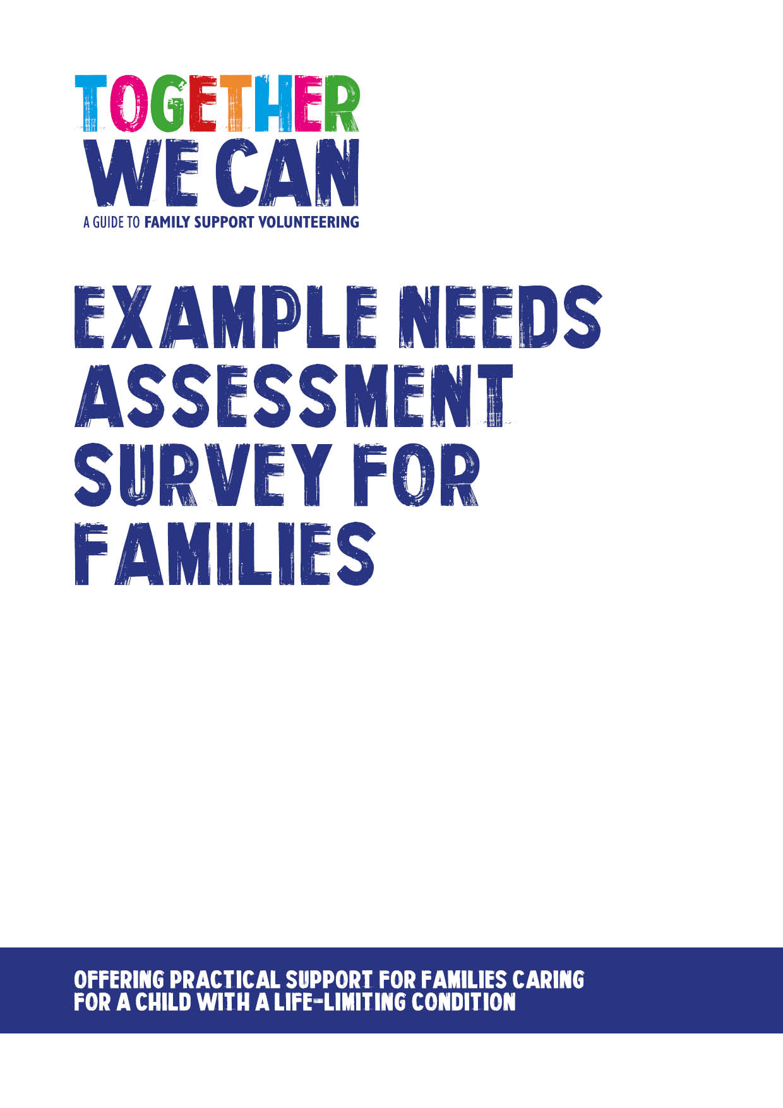
Together We Can is a collection of resources for organisations developing a service where volunteers support families of a child with a life-limiting or life-threatening condition. The resources were developed and tested specifically for this purpose with volunteers working in the homes of a child with a life-limiting condition, but might be useful for any organisation developing volunteer services.

Survey: Volunteer support for families in the community

You may have been asked by [name of organisation] if you would like some extra support in your home from a trained and appropriately skilled volunteer.

Families have told us that the volunteers can be a valuable source of practical help and social support. They can help in a number of practical ways like housework, gardening, cooking, helping siblings with homework and supporting them by taking them out. They may also be able to offer companionship by being someone who can visit, listen and chat.

We want to make sure that volunteers can respond to the real needs of individual families. The aim of this survey is to find out from you what sort of volunteer support might be helpful to you.

All information that you give us is confidential and will only be used for the purposes of developing a new service.

If you would like to know more please contact [named person in organisation] who will be happy to discuss in more detail.

Name of Service

1. | Please tell us a little about yourself
Do you have a child or young person currently receiving care?

If so what age is the child/young person?

 | If not are you a bereaved family?
 | Now many other children do you have?
 | What ages are they?
 | Do you have a good network of family and friends close by?
2. | How much practical support do you have at home at the moment?
 | Lots of support |  | A reasonable amount |  |  | Very little |  | None
3. | Would you find it helpful to have practical support at home from a volunteer? |  |  |  |  |  |  |  | Y | N
4a | Below are some ideas drawn from support already offered to families in some services. Please select the help that you might find most useful. (You can tick as many as you like).
 | Shopping |  |  |  | Helping siblings with homework
 | Ironing |  |  |  | Playing activities with siblings
 | Housework |  |  |  | Taking siblings to/from school
 | Cooking |  |  |  | Helping with social outings
 | Gardening |  |  |  | Signposting to advice on finance
 | Driving to appointments |  |  |  | Supporting you at appointments
 | Collecting prescriptions |  |  |  | Helping to find local support for you
 | Dog walking/pet care |  |  |  | Helping with IT
 | Someone for you to talk to |  |  |  | Sharing hobbies
5. | Is there anything else that we have not thought of that could help?
6. | How often would this type of support be helpful  (Please tick)
 | Weekly | Fortnightly |  |  | Monthly |  | Occasionally as needed

Thank you for taking time to complete the survey

