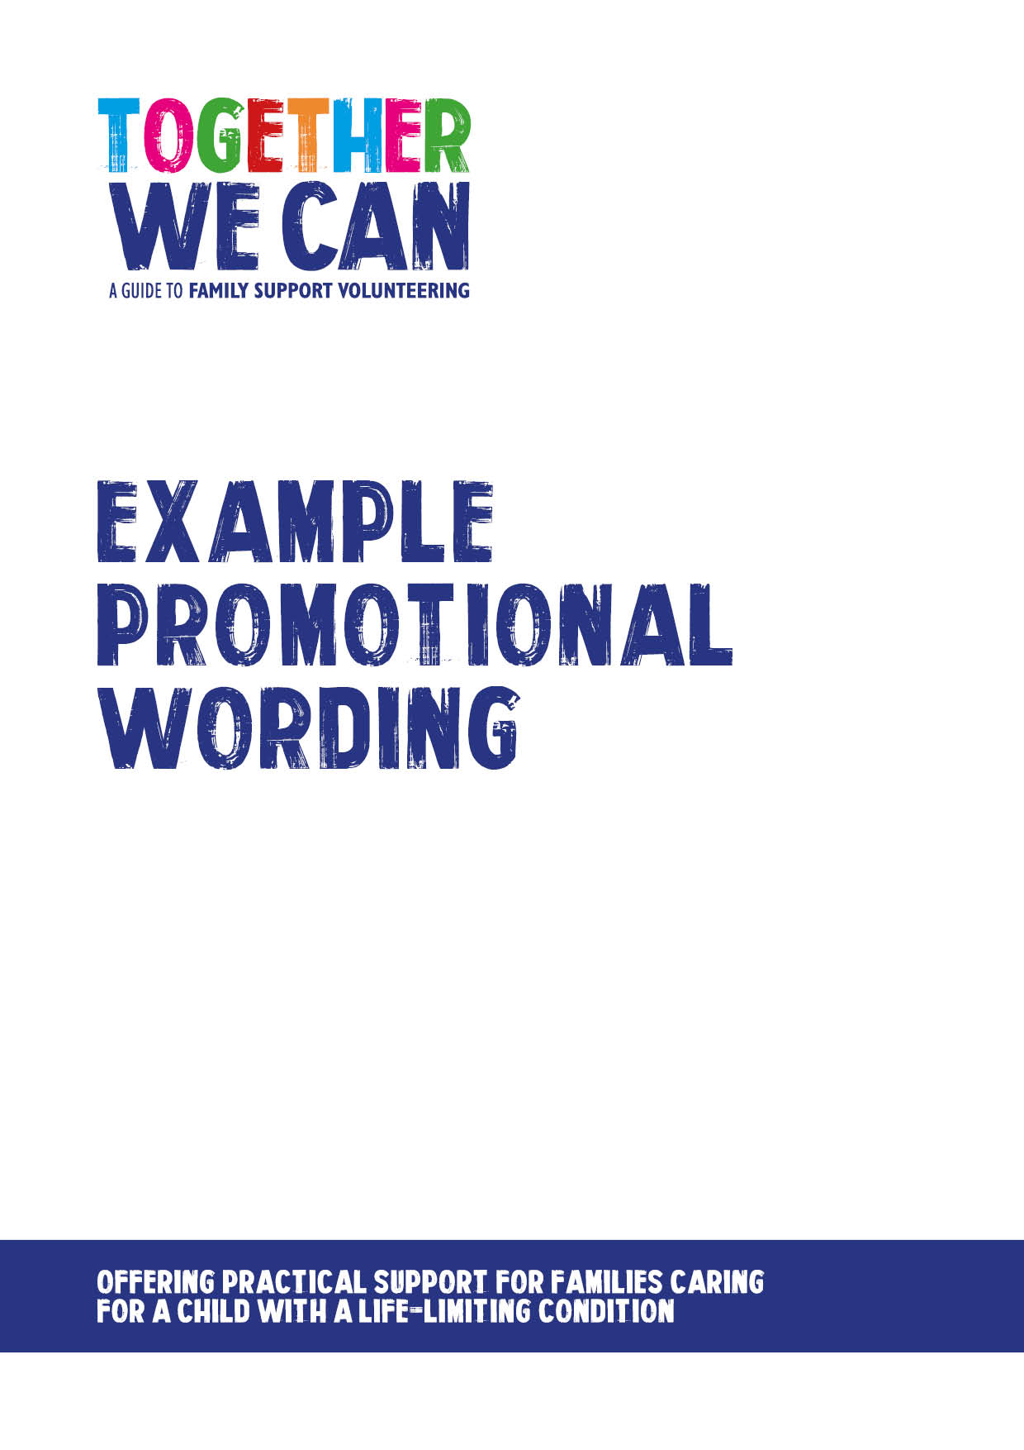
Together We Can is a collection of resources for organisations developing a service where volunteers support families of a child with a life-limiting or life-threatening condition. The resources were developed and tested specifically for this purpose with volunteers working in the homes of a child with a life-limiting condition, but might be useful for any organisation developing volunteer services.
#

Example of simple promotional wording for family support volunteering services

Using very simple wording can work well to encourage people to find out more about volunteering. Such text can be posted on websites, on noticeboards, used in emails and on volunteer recruitment bulletin boards. You might want to adapt something along the following lines:

An exciting opportunity to volunteer with [insert team name]

We are recruiting volunteers to support families who are caring for a child with complex healthcare needs at home.

All volunteers will be given training to enrich them with the skills and knowledge needed to support families.

We are looking for people over 18 years who are willing to carry out any of the following:

Social support

- Providing an extra pair of hands such as helping children with reading, homework or playing games.
- Helping a parent to manage outings during the school holidays.
- Providing support on hospital visits or occasional shopping trips.

Befriending support

- Providing companionship to a sibling by taking them to the cinema or park.
- Providing a listening ear for a parent.

Practical support

Examples might include help with:
- gardening
- decorating
- ironing
- driving a family member to the hospital or the shops
- helping to pack boxes when moving home

Volunteers might want to volunteer just every so often or more regularly such as a few hours every week, fortnight or month.

For further information, contact [insert contact details]

