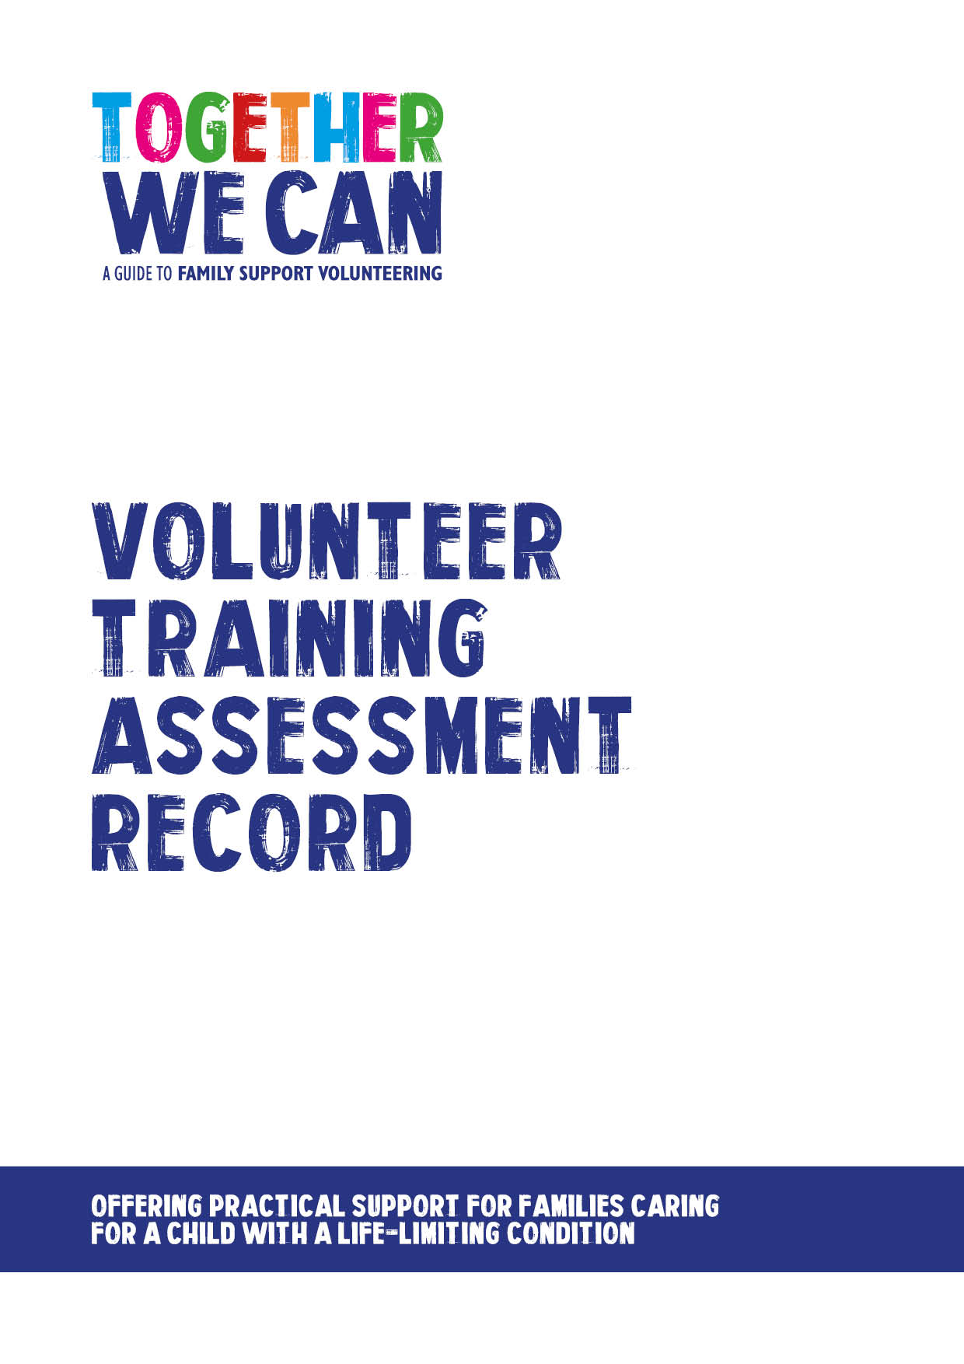

Together We Can is a collection of resources for organisations developing a service where volunteers support families of a child with a life-limiting or life-threatening condition. The resources were developed and tested specifically for this purpose with volunteers working in the homes of a child with a life-limiting condition, but might be useful for any organisation developing volunteer services.

Family support volunteer training assessment record

Guidance notes for facilitators

It is important for both facilitators to make time to discuss and complete the assessment sheet for each volunteer soon after the end of each training unit.

Try to be as objective as possible giving examples from the training sessions to support your assessment wherever possible. All assessments should be open and transparent and shared with the volunteer in full and you should be prepared to share everything that you write on the assessment form with the volunteer.

If it becomes apparent that the volunteer is clearly unsuitable for the role, this should be addressed sensitively and supportively in a face-to-face meeting with the volunteer as early as possible at the end of the relevant unit. It is unfair to the volunteer concerned, the facilitators and the others in the group to continue to the next unit.

For volunteers who complete all training units, a second interview date will be arranged in advance. At this interview you should explore their experiences of the training programme, discuss their assessment fully and sensitively with them, being clear with them whether they have been accepted into the project as a volunteer or not. If they have been successful, explore with them how they feel about now being matched with a family and getting started, address any outstanding questions or concerns. Be clear about what will happen next and the timescale for this.

It is important when turning volunteers down for a particular role at any stage in the process to recognise the skills that they have to volunteer in other contexts and support and encourage them to seek opportunities better suited to their skills and abilities (e.g. referral to volunteer centre, alternative role in the organisation where appropriate).

Family support volunteer training assessment record

Volunteer Name: ___________________________________ Site: ___________________________ Unit Number: ______

 | Competence  Demonstrated during training: |  | ND | DL | DA | DW | Comments  (Please be as objective as possible giving examples from training sessions).
1 | Commitment to the project and wellbeing of children, young people and families.
2 | Good self-awareness, ability to reflect on actions and experience.
3 | Good listening and communication skills.
4 | Respect for others at all times.
5 | Non-judgemental approach, sensitivity to the needs of people of all ages and backgrounds.
6 | Clear understanding of confidentiality during activity sessions.
7 | Clear understanding of boundaries during activity sessions.
8 | Clear understanding of safeguarding requirements during activity sessions.
9 | Willingness and flexibility to undertake a range of activities.
10 | They are reliable, organised and can use initiative.
11 | Ability to work effectively as part of a team.
12 | A commitment to self-care and to engage in support and supervision.
ND: Not demonstrated |  | DL: Demonstrated a little |  |  |  |  | DA: Demonstrated adequately | DW: Demonstrated well

Additional comments/ final assessment decision

Facilitator Name: _____________________________________ Signed: _____________________ Date: _____________________

Facilitator Name: _____________________________________ Signed: _____________________ Date: _____________________

Date assessment completed: ____________________

