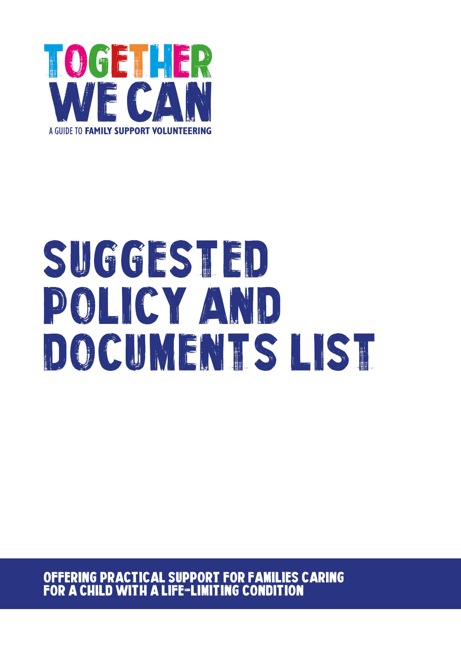
Together We Can is a collection of resources for organisations developing a service where volunteers support families of a child with a life-limiting or life-threatening condition. The resources were developed and tested specifically for this purpose with volunteers working in the homes of a child with a life-limiting condition, but might be useful for any organisation developing volunteer services.

This document provides a list of policies and documents that teams growing volunteering services will probably want to have in place. Some organisations will already have these policies and will just need to check that they explicitly cover volunteers. Others might need to develop some of the policies. Examples of selected policies are included within the Together We Can resource kit.
You can use this checklist to tick whether your organisation has the various documents and policies so you can easily identify any gaps.

Documentation | What does it do? | What should it cover? | Have | Don’t have
General assessment of support needs | Collects information about the potential support families in your area might want.  This is NOT an individual family needs assessment. | - Context to the questionnaire.  - States confidentiality of responses.  - Gathers basic information about the family and the support they have in place (without identifying them).  - Presents potential types of support that might be needed (using a standardised list).  - Provides an opportunity for additional kinds of support needed to be noted.  - Asks about the preferred frequency of support.
Staff job descriptions | Provides a job description for the main roles required for developing and delivering volunteer support eg coordinator. | - Job descriptions should follow local protocols.  - A good job description should cover:  - Post details (title, location, whom the post is responsible to, tenure, salary and hours of work).  - Purpose of the post.  - Key relationships.  - Duties and responsibilities (in detail).  - Person Specification; including essential and desirable qualifications, experience, skills & abilities and personal qualities. The need for previous volunteer management experience should be considered as important.  - If a criminal records disclosure is required, this should be noted.  - Any budgetary responsibility should be noted.  - Any vehicular requirements should be noted.  - Any requirement for working outside of office hours should be noted.
Staff list or chart | Gathers into one place information about staffing for the programme. | - Gather information on who is part of the development team for the creation of the service, to whom they report, and from where they are resourced.
Volunteer role description | Provides an outline of the role each volunteer will undertake. | - A good role description should cover:  - An overview of the role.  - Its main location.  - Activities to be undertaken.  - Boundaries.  - Skills and abilities.  - Training that will be provided.  - Support and supervision processes.  - Information on claiming expenses incurred in the role.
Risk assessment form | Requires an assessment of risks and hazards for elements of the role. | - The risk assessment procedures should follow your organisation’s protocols. It is important that, as far as possible, all potential risks and hazards are considered for the tasks involved.  - Separate risk assessments should be considered for the following and any other setting:  - All volunteer roles within the project.  - Volunteers visiting family homes.  - Volunteers supporting family members in public spaces, such as trips to local parks or entertainment venue.  - Volunteers undertaking tasks requiring machinery (such as gardening).
Volunteer guidance / handbook | Provides volunteers with an overview of your organisation, volunteering and how their role helps the organisation meets its aims. | Example is included in the resource kit.
Organisational volunteering policy | Provides an overview of how to engage volunteers in your organisation. | Example is included in the resource kit.
Training programme | Provides volunteers with the required skills and knowledge base to ensure safe support for all involved. | Example is included in the resource kit. A separate facilitators guide is provided to help to support the delivery of the training and to ensure training is appropriate and adequate.
Volunteer assessment record | Creates a record of assessment of volunteers, outlining their suitability for the volunteer role. | - A suitable volunteer should develop and demonstrate competencies relevant to the role they are to undertake.
Family referral form | Provides a record of an assessment of the families’ suitability for engagement with the project. | - Should fit with organisational protocols and, where possible, should be pre-populated with information to avoid seeking the same information from families too frequently.  - Should record the preferred desired support the family would welcome, and the frequency of this support. It should also provide space for additional notes to aid with matching volunteers to the family.  - If additional risk assessments are required for the family setting, perhaps due to the presence of family pets or similar, then reference should be made on this form.
Social media | Provides volunteers with clear guidance on boundaries associated with social media and their voluntary role. | - Volunteers should be made aware of organisational approach to use of social media. There is benefit in making an explicit policy for volunteers, to avoid ambiguity around employed / non-employed status.  - A policy should explicitly state that volunteers should not establish or otherwise enable social media contact with families, family members or other key people involved in receiving support from the programme.
Lone working policy | Provides volunteers with clear guidance on lone working procedures. | - Lone working policy and procedures for volunteers should fit with local protocols. There is benefit in describing how these protocols apply directly to the volunteer role.  - The Suzy Lamplugh Trust provide resources that may be of use in developing a suitable policy.
Safeguarding policy & procedure | Provides all involved in the project guidance on local safeguarding policies and procedures. | - Safeguarding policies and procedures should be those used by your organisation. Material should be adapted to make clear the relevance to and responsibilities of volunteers.
Complaints procedure | Provides volunteers guidance on how to raise a complaint, and how these will be managed. | - Local policies should be used.
Coproduction policy | Provides an overview of how the project will empower service users in the design and delivery of the services afforded to them.
Moving and handling policy | Provides clear guidance on lifting and handling in relation to the project. | - The policy should interpret local policies in a way relevant to the project. This might include reference to likely scenario, with directions as to how the policy applies eg – movement of wheel chairs, lifting and moving medical equipment.
Driving | Provides clear direction on processes and responsibilities. | - This policy should fit with organisational policies.  - Explicit advice should be given regarding:  - Transportation of families and family members.  - Lone working in a vehicle.  - Transportation of equipment (including loading and unloading).  - Driving responsibilities.  - Driving in bad weather.  - Additional guidance is available from ROSPA.
Infection control | Provides clear direction on steps to take to reduce infection risks. | - This policy should be tailored to the setting volunteers are likely to be working in, such as family homes, visits to public spaces, and medical settings.  - Guidance on respecting family wishes regarding infection control procedures.
Confidentiality | Provides clear guidance on the maintenance of confidentiality. | - This policy should reflect local policy, being adapted to the circumstances the volunteer is likely to encounter, such as working in a family environment.  - Clear guidance should be given regarding the relationship between the confidentiality policy and safeguarding policy.
Volunteer recruitment material | Promotes opportunity for participation in the project. | - Materials should be designed for attracting and informing potential volunteers. Additional materials should be aimed at informing families who may be considered for referral.

