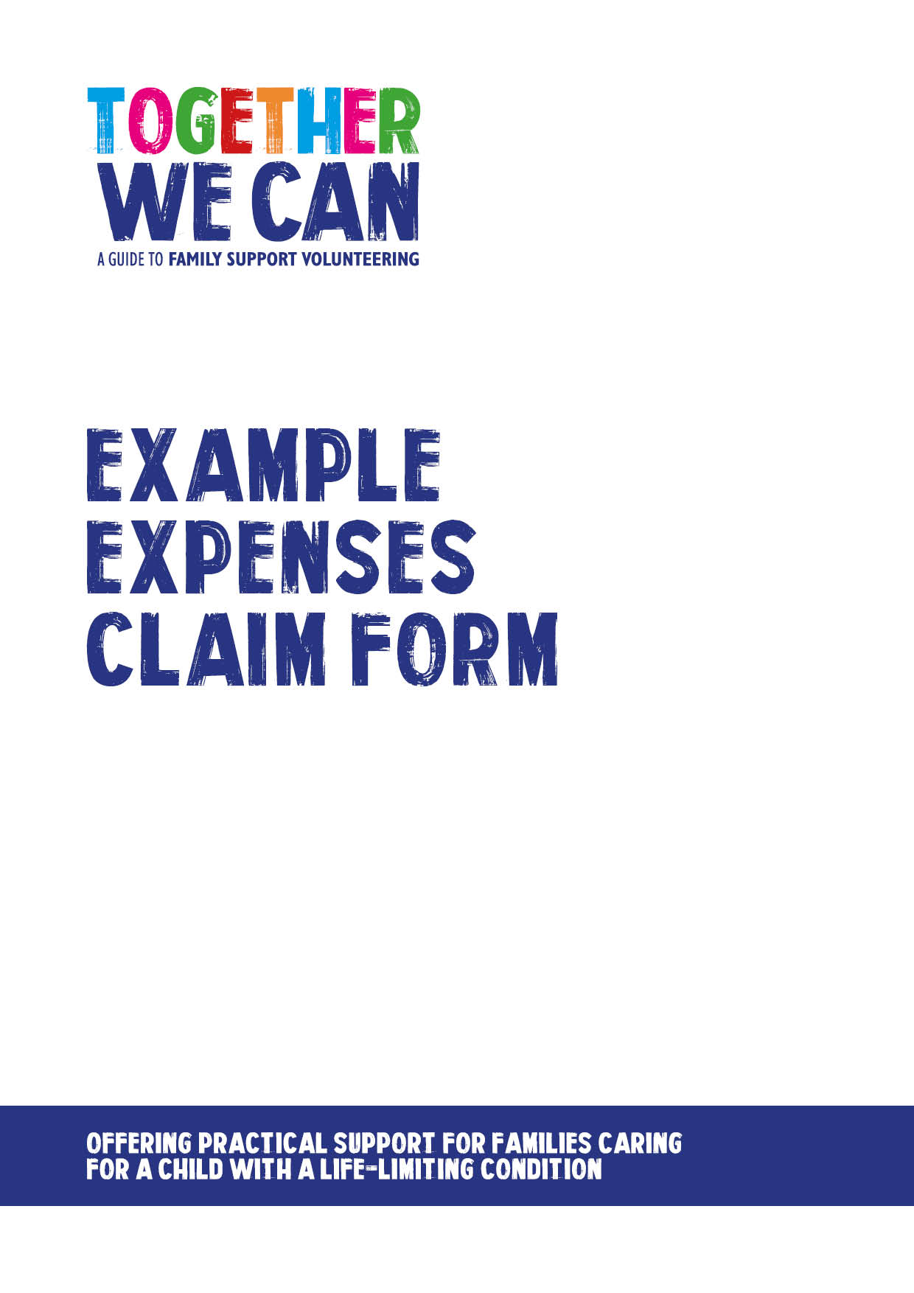

Together We Can is a collection of resources for organisations developing a service where volunteers support families of a child with a life-limiting or life-threatening condition. The resources were developed and tested specifically for this purpose with volunteers working in the homes of a child with a life-limiting condition, but might be useful for any organisation developing volunteer services.

Donated by South Warwickshire NHS Foundation Trust

Volunteer Name:
Address:
Date Submitted:
 | Travel Claims Only
 | Claimed at least each month
Private Car:
Date Attended | Daily Mileage @ 38.4p per mile |  | Total
 | x 38.4p per mile
 | x 38.4p per mile
 | x 38.4p per mile
 | x 38.4p per mile
 | x 38.4p per mile
Total:
Car Details:
Make/Model: | Registration: |  | Engine Size:
Requested By: | (print) |  | (sign)
Authorised By: | (print) |  | (sign)
For Finance Use:

