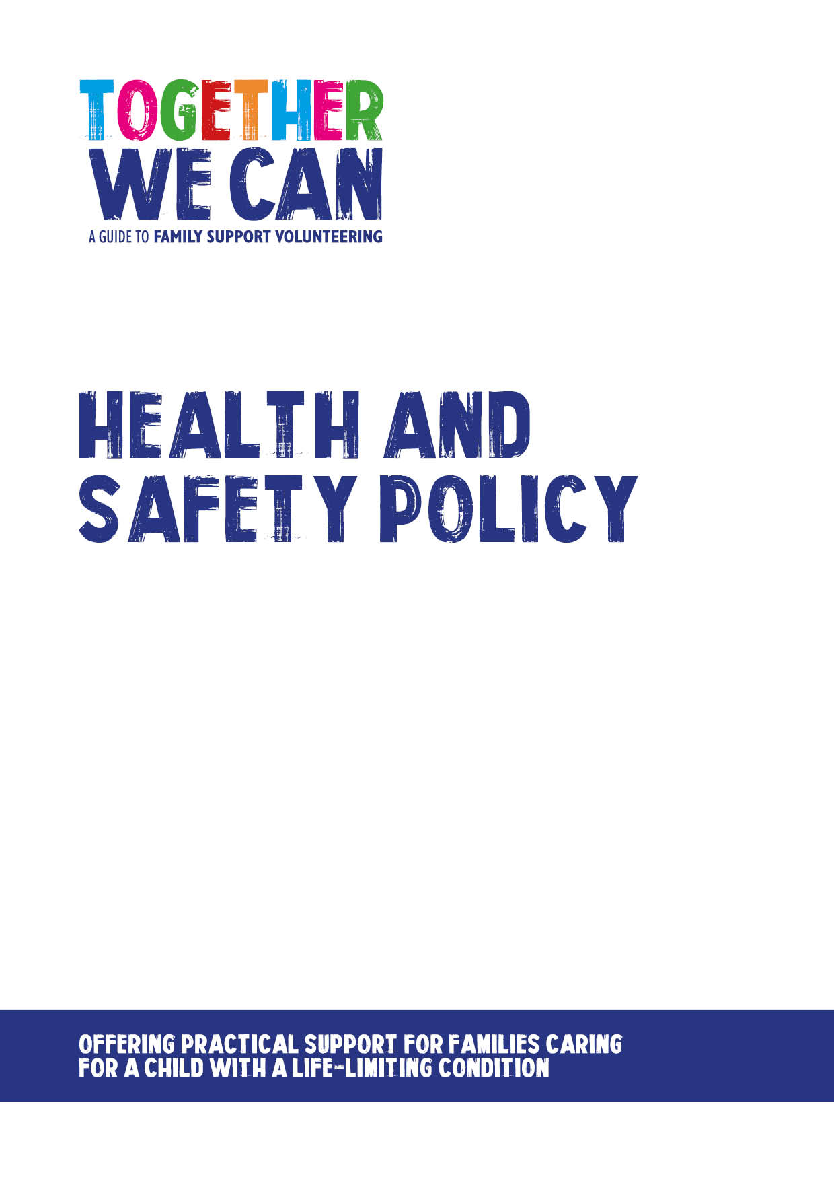
Together We Can is a collection of resources for organisations developing a service where volunteers support families of a child with a life-limiting or life-threatening condition. The resources were developed and tested specifically for this purpose with volunteers working in the homes of a child with a life-limiting condition, but might be useful for any organisation developing volunteer services.

Health and Safety Policy

This policy has been written to support our volunteers to make sure that everyone stays as safe as practicably possible. All volunteers should be familiar with this policy.

The Health and Safety at Work etc Act 1974 is written to cover paid employees but as an [organisation] we have an ethical responsibility to ensure that, as far as possible, volunteers (as well as others) are protected from physical, financial and emotional harm arising from volunteering. The concept of duty of care is regarded as common law across the UK, and requires [ORGANISATION] to take reasonable care to minimise the risk of harm to volunteers.

[ORGANISATION] recognises its responsibility to ensure that all reasonable precautions are taken to provide and maintain working conditions that are safe, healthy and compliant with all statutory requirements and codes of practice.

[ORGANISATION] is committed to ensuring the health, safety and welfare of its staff, so far as is reasonably practicable, and of all other persons who may be affected by our activities including clients and their relatives. [ORGANISATION] will take the following steps to ensure that its statutory duties are met at all times.

- Each member of staff should be given such information, instruction and training as is necessary to enable the safe performance of work activities.

- All processes and systems of work should be designed to take account of health and safety.

- Adequate facilities and arrangements will be in place for staff to raise issues of health and safety.

- Competent persons should be appointed to assist in meeting statutory duties including, where appropriate, specialists from outside the organisation.

- This document will be regularly monitored to ensure that its objectives are achieved. It will be reviewed and, if necessary, revised in the light of legislative or organisational changes.

[ORGANISATION] recognises its responsibility under the Health and Safety at Work, etc Act 1974 and the Management of Health and Safety at Work Regulations 1999 (MHSWR) to ensure that all reasonable precautions are taken to provide and maintain working conditions which are safe, healthy and compliant with all statutory requirements and codes of practice.

To maintain appropriate levels of health and safety, staff and volunteers should be an integral part of procedures for raising and addressing health and safety issues.
Volunteers should flag up any health and safety issues and any possible solutions at the earliest opportunity with the volunteer organiser.

As an organisation we take the safety of our volunteers very seriously and the volunteer coordinator works to these guidelines to ensure all aspects of the safety of volunteers.

In the event of a health and safety issue being identified, volunteers should communicate this as soon as possible to the volunteer coordinator to ensure that we address the issue and amend policies or procedures as necessary.

[ORGANISATION] should:

- ensure that volunteers understand the health and safety policy and how it applies to their role

- review practices regularly to ensure that when new risks are identified appropriate steps are taken to address them

- ensure that volunteers are working in as safe an environment as possible

- consult with volunteers where necessary on health and safety issues that they raise

- ensure that all volunteers are aware of the procedures for reporting any incidents

Volunteers should:

- ensure that they have read and understood any risk assessments undertaken that affect them in their role

- take reasonable steps to assure their own safety and that of others

- report any hazards as and when they identify them

- inform the volunteer coordinator of any incidents or concerns

- report any incidents or concerns using the appropriate procedures / forms.

[ORGANISATION]’s policy will be, so far as is reasonably practicable, to:

- make a risk assessment of every client’s home before a volunteer is allocated to that home

- put in place risk management measures to reduce any identified risks or hazards to an acceptable level

- communicate agreed risk management measures to volunteers and ensure regular monitoring of risk levels

- ensure that equipment in client’s homes is only used if it is safe

- provide relevant protective equipment or clothing required by staff to perform their role safely

- provide information, training and supervision to ensure health and safety of volunteer

- in the event of any accident or incident (such as a near miss) involving injury to anybody to make a full investigation and to comply with statutory requirements relating to the reporting of such incidents

Training

All volunteers undergo training in health and safety as part of their induction programme and must read this policy on health and safety as part of their induction process.

