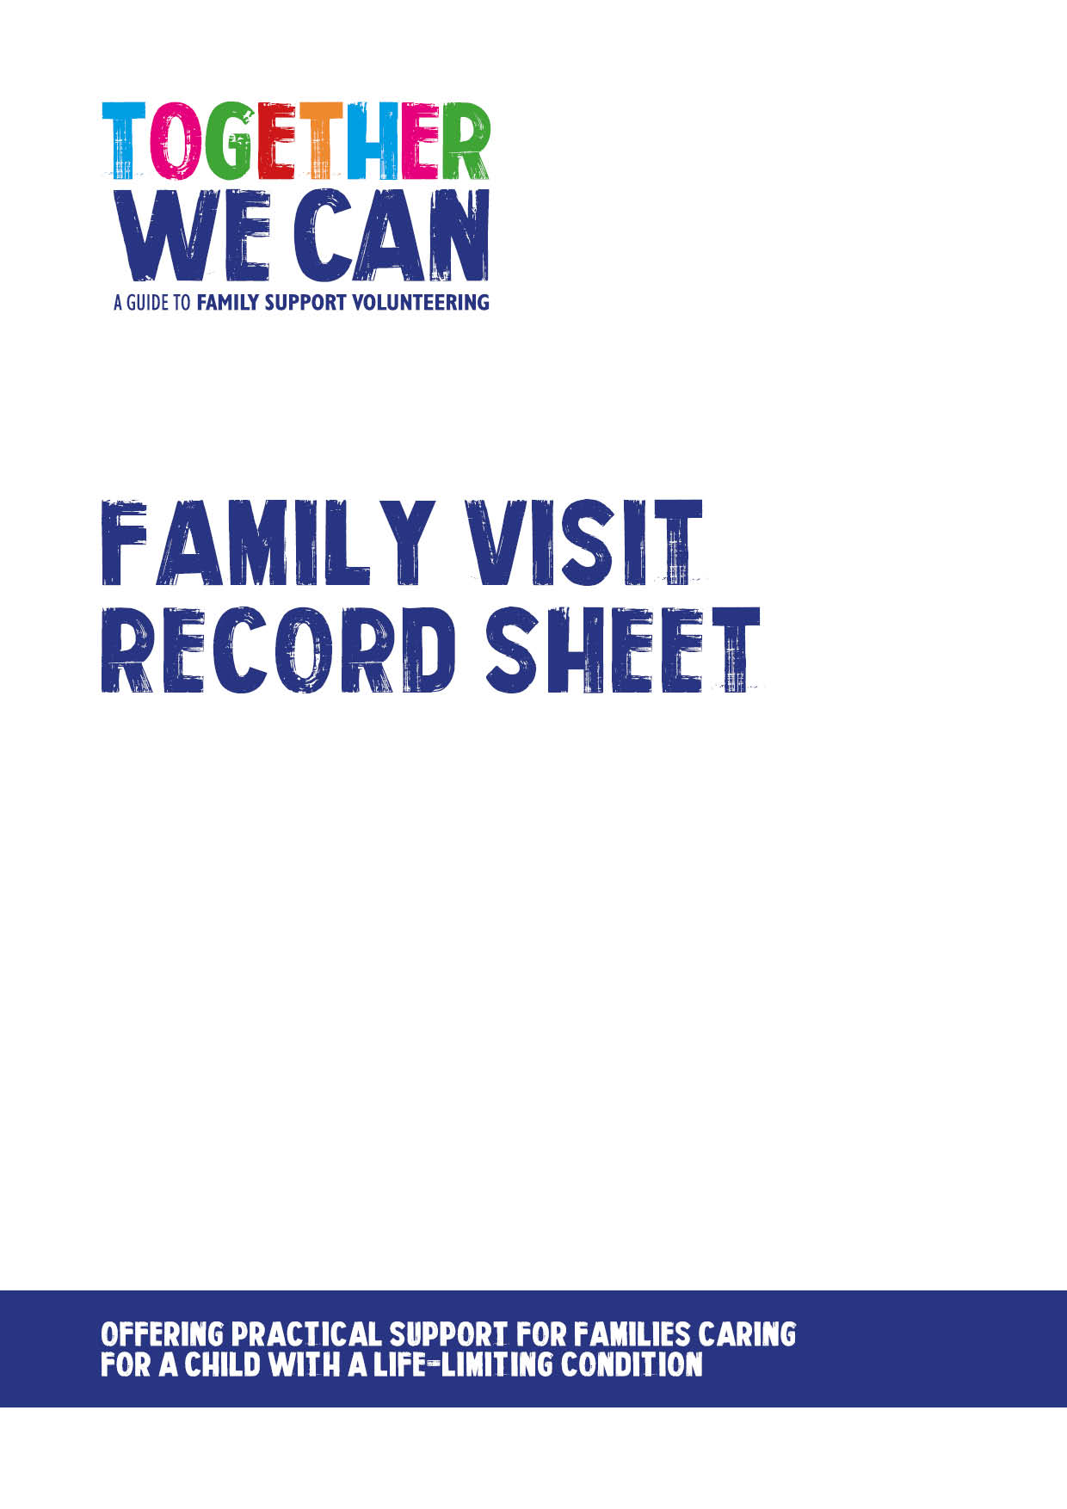
Together We Can is a collection of resources for organisations developing a service where volunteers support families of a child with a life-limiting or life-threatening condition. The resources were developed and tested specifically for this purpose with volunteers working in the homes of a child with a life-limiting condition, but might be useful for any organisation developing volunteer services.

Please note - this form must be completed on every visit.

Volunteer name:

Family name:

Date of visit: | Arrival time: | Departure time:
Comments about visit (eg type of activity undertaken; engagement with family members; progress and achievements):

Any additional relevant information:

Volunteer signature:  Date: |  | Volunteer coordinator signature:  Date:

This form should be sent to:

[INSERT DETAILS]

