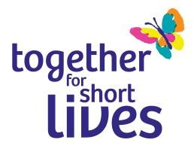
Guaranteed Interview Scheme

We are committed to Equal Opportunities and actively encourage applications from disabled people

What does the scheme offer?
The aim of the Guaranteed Interview Scheme (GIS) is to provide disabled applicants with the opportunity to demonstrate their abilities beyond the initial application stage. All disabled applicants who meet the minimum criteria for the job will be offered an interview.

By ‘minimum criteria’ we mean that you must provide us with evidence in your application form which demonstrates that you meet the essential criteria required for the role, including meeting any of the qualifications, skills or experience defined as essential (these can be found in the Person Specification, within the Job Description document). To qualify for the GIS you must declare your disability, however this is your decision and is entirely voluntary.

Who is eligible for the scheme?
To be eligible for the Guaranteed Interview Scheme you must be considered as disabled under the Equality Act 2010. This means you must have a physical or mental impairment that has a ‘substantial’ and ‘long-term’ effect on your ability to do normal daily activities.

If you want to apply for the Guaranteed Interview Scheme, please indicate here:

Yes / No

Name:

Post applied for:

Please submit this form along with your completed application form, Summary details form and Equal opportunities form to recruit@togetherforshortlives.org.uk

