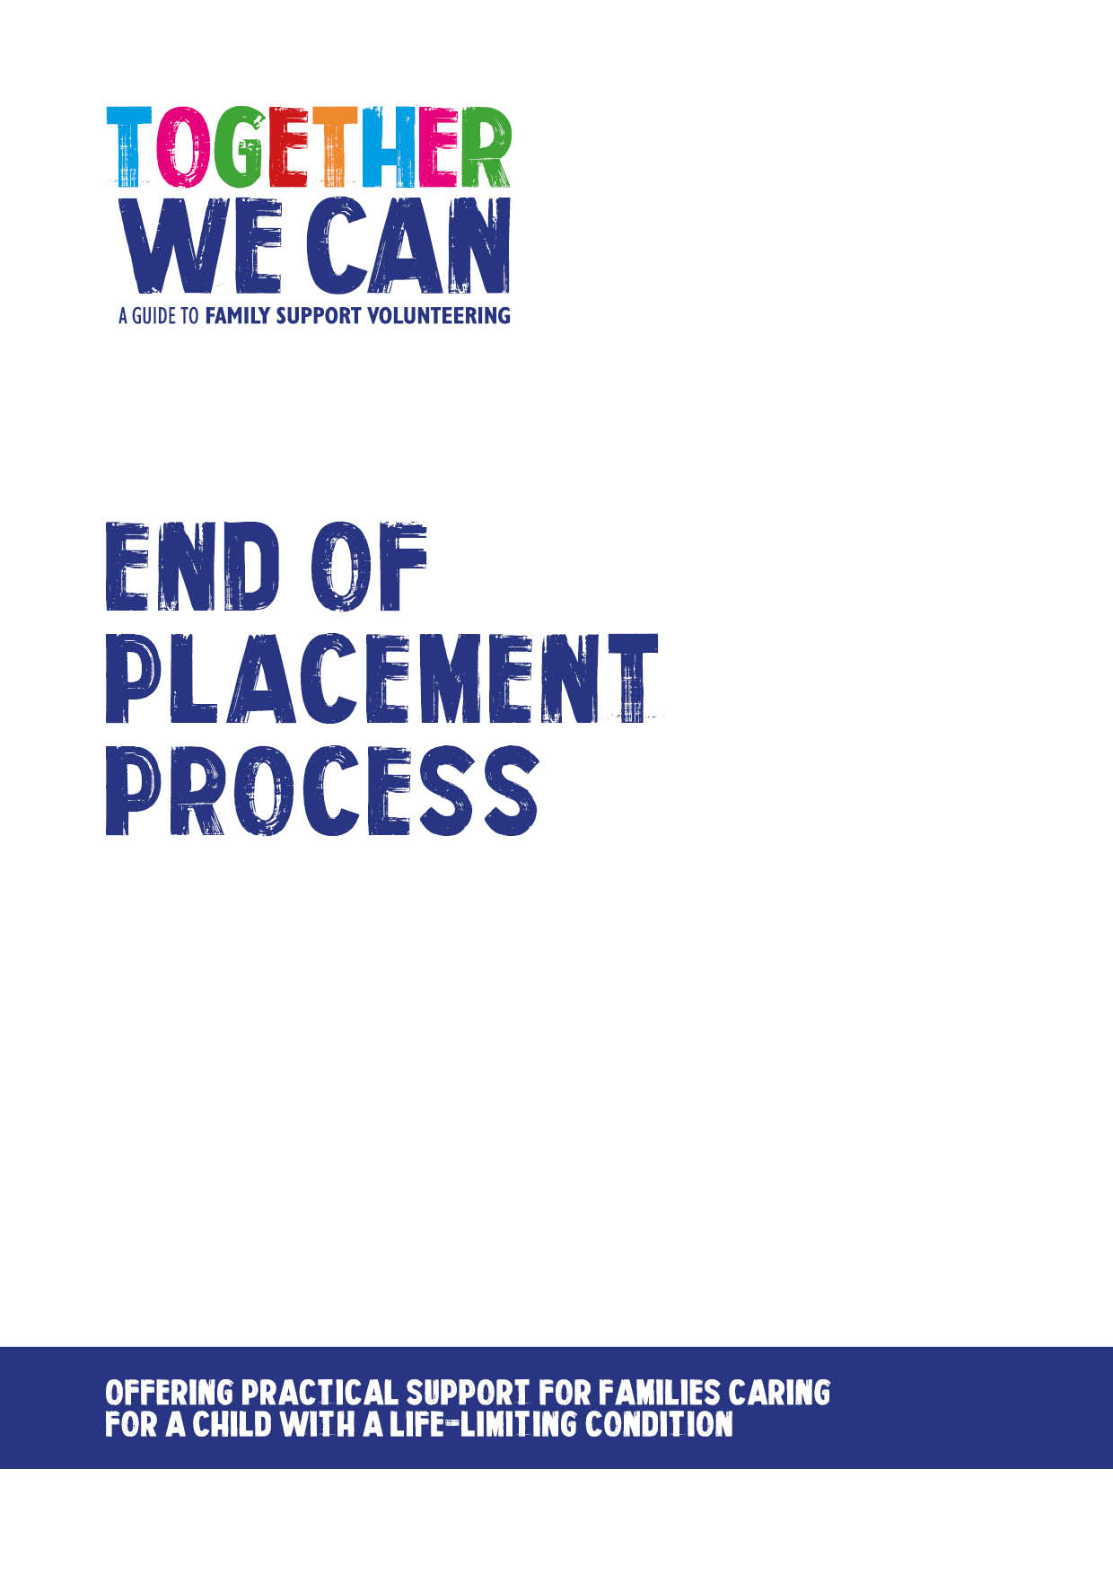
Together We Can is a collection of resources for organisations developing a service where volunteers support families of a child with a life-limiting or life-threatening condition. The resources were developed and tested specifically for this purpose with volunteers working in the homes of a child with a life-limiting condition, but might be useful for any organisation developing volunteer services.

End of Placement Process for Family Support Volunteers

