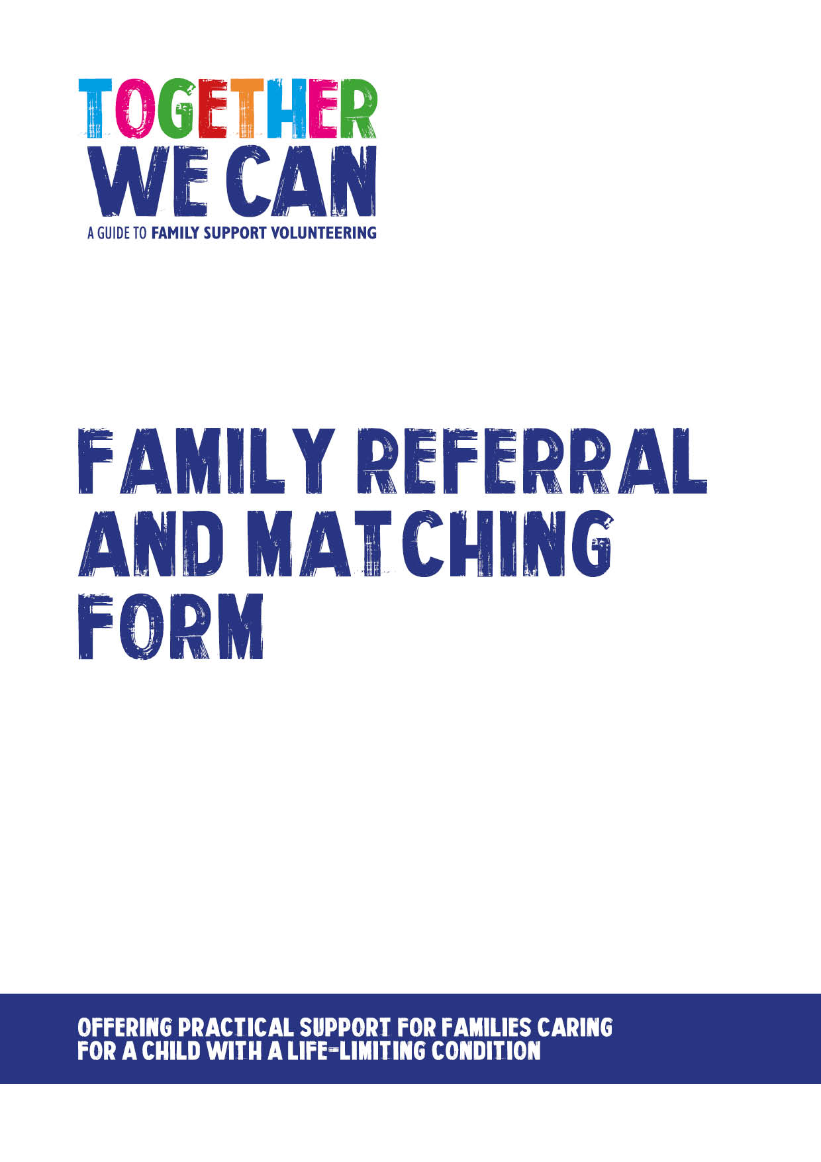
Together We Can is a collection of resources for organisations developing a service where volunteers support families of a child with a life-limiting or life-threatening condition. The resources were developed and tested specifically for this purpose with volunteers working in the homes of a child with a life-limiting condition, but might be useful for any organisation developing volunteer services.

Family referral and matching form

Name of pilot site/service:

1. Please tell us a little about the family
Parent/carer’s name(s):

Name of affected child: |  |  |  |  |  |  | Age:
Child’s condition:
Number of siblings: |  |  |  |  |  |  | Ages:
Family address:

Postcode: |  |  |  |  |  | Contact phone number:
2. Please give a little information about the family home/access
(Please circle)
Flat:  Floor no: | House: |  | Is there easy parking?  Y/N |  |  |  | Is there a dog?  Y/N
3. Please indicate the volunteer support requested. NB these are examples of support that could be provided – needs may differ
Shopping |  |  |  |  | Help siblings with homework
Ironing |  |  |  |  | Play activities with siblings
Housework |  |  |  |  | Taking siblings to/from school
Cooking |  |  |  |  | Helping with social outings
Gardening |  |  |  |  | Signposting to advice on finance
Driving to appointments |  |  |  |  | Supporting you at appointments
Collecting prescriptions |  |  |  |  | Help to find local support for you
Dog walking/pets |  |  |  |  | Help with IT
Someone for you to talk to |  |  |  |  | Sharing hobbies
Other support:

4.How often would this type of support be helpful (Please tick)
Weekly |  | Fortnightly |  |  | Monthly |  | Occasionally as needed
5. Any other information to assist matching:

6. Referring member of staff

Name (please print)______________________________________________

Job Title: _____________________________________________________

Signature: _________________________________ Date: _____________

7. Matching process

Name of volunteer matched: _______________________________________

Role undertaken: ________________________________________________

Frequency of visits: ______________________________________________

Date match made: _______________________________________________

Introduced to family by: ___________________________________________

Date of first visit: ________________________________________________

Staff follow up made with volunteer after first visit (date): ______________

8. Risk Assessment
Risk assessment completed (date): ________________________________

Undertaken by:__________________________________________________

