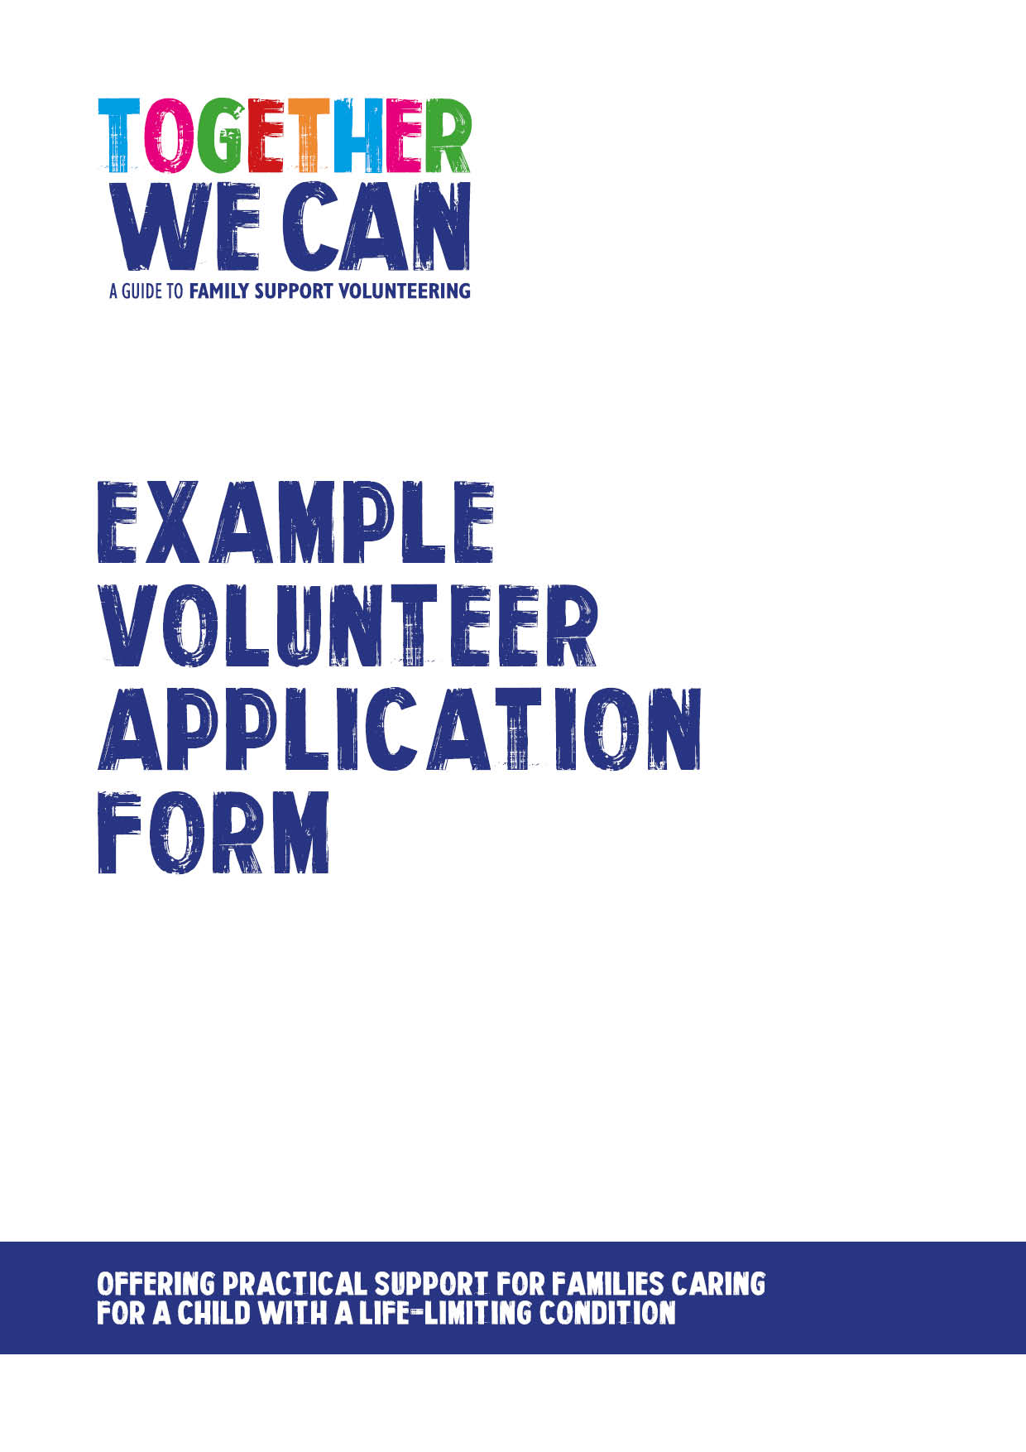

Together We Can is a collection of resources for organisations developing a service where volunteers support families of a child with a life-limiting or life-threatening condition. The resources were developed and tested specifically for this purpose with volunteers working in the homes of a child with a life-limiting condition, but might be useful for any organisation developing volunteer services.

Donated by South Warwickshire NHS Foundation Trust

Covering letter example

Dear

Family Support Volunteer Application

Thank you for your enquiry and your interest in volunteering to help at XXX

The value of the work that volunteers carry out is priceless. Volunteers provide that little extra that can make all the difference to families.

I have enclosed an application form should you wish to be considered as a volunteer. Whilst the form may look a little daunting, I am sure that you will understand the need to ensure the safety and well-being of all members of the community, including volunteers.

Should you have any questions please contact me on XXX.

On receipt of your application we will telephone your references and then arrange an informal discussion, including showing you the documentation necessary for a criminal records check.

I look forward to hearing from you and do appreciate you considering being a volunteer.

Private and Confidential

Volunteer Application Form

Before completing this form please read through the roles and responsibility information sheet.

Please complete this form in BLOCK CAPITALS.

PERSONAL DETAILS
Surname: | Title: Mr / Mrs / Ms / Miss / Other
Forename(s): | Known As:
Address: | Date of Birth:
 | Home Telephone:
 | Work Telephone:
Postcode: | Mobile Telephone:
Email: | National Insurance Number:
Employment Status: Employed / Retired / Higher Education / Other (give details)

EMERGENCY CONTACT DETAILS - Please give the details of someone you would like
contacted in the event of an emergency.
Name: | Relationship:
Address: | Home Telephone:
 | Work Telephone:
Postcode: | Mobile Telephone:
On a successful application, do we have permission to hold these Emergency Contact Details?
Yes □ No □
SKILLS - What skills and attributes do you think you can offer as a volunteer?
HOBBIES - What do you enjoy doing in your spare time?
VOLUNTARY WORK - Why are you interested in becoming a volunteer?
VOLUNTARY WORK - Are there any particular areas where you would prefer to help?
VOLUNTARY WORK - Do you volunteer with any other organisations?
VOLUNTARY WORK - Availability.
Are you able to volunteer regularly for at least six months? Yes □ No □
Are you able to offer a minimum of one 2 to 3 hour session per week? Yes □ No □

Please tick all the times you might be available for voluntary work.

 | Monday | Tuesday | Wednesday | Thursday | Friday | Saturday | Sunday
Morning
Afternoon
Evening

DISABILITY - The Disability Discrimination Act 1995 defines disability as a physical or mental impairment which has a substantial and long term adverse effect on a person’s ability to carry out normal day to day activities. People who have a disability, and people who have had a disability but no longer have one, are covered by the Act.
Do you have or have you had a disability? Yes □ No □

If yes, please describe any adjustments or adaptations you think you would require to assist you to carry out voluntary work.

REHABILITATION OF OFFENDERS ACT 1974 (EXCEPTIONS) ORDER 1975
Having a conviction will not prevent you from being considered for voluntary work but we ask that you provide this information. Any information you give will be completely confidential. In addition, to safeguard the young and vulnerable, a check will be carried out.
Have you any convictions? Yes □ No □

If yes, please give details here.

CONFIDENTIALITY - You may be told personal information. You must promise to keep such information confidential within the organisation, both during and after your voluntary service.

HEALTH & SAFETY, NO SMOKING AND ALCOHOL POLICIES - Volunteers are subject to the regulations of the Health & Safety at Work Act. This means that if you have any accident or see a potential danger while you are carrying out your voluntary duties, you must report it to The CCNT Manager. You must also agree not to undertake any task or activity for which you have not received training or which may cause an injury to yourself or endanger others. Volunteers are also expected to comply with the Foundation Trust’s No Smoking and Alcohol Policies.

SECURITY - You have a personal responsibility to ensure that policies relating to security are adhered to and any evidence of theft or misuse of property must be brought to the attention of the unit/department concerned.
PRE-PLACEMENT HEALTH ASSESSMENT - Occupational Health will carry out a pre-placement health assessment for the purpose of safe volunteer placement.

REFERENCES - Please give details of 2 professional referees who have known you for at least 2 years and are able to comment on your suitability to do voluntary work. If you are working or have worked until recently, one referee should be your manager. Other suitable referees include: present or past employers, higher education tutors, someone from your Church or community, other voluntary work you may have done. Members of your family are not acceptable. Please let them know that you have given them as referees, and that we will be writing to them very soon.

Name: | Name:
Address: | Address:
Postcode: | Postcode:
Telephone Number: | Telephone Number:
Email: | Email:
Number of years known: | Number of years known:
How do you know this person? | How do you know this person?
DECLARATION
I have read and understand my responsibilities as a volunteer. If appointed, I undertake to comply with the conditions set out above. I understand that any voluntary work offered to me is subject to health and criminal records clearance. I certify that the information I have given is correct and understand that any misleading statements or deliberate omissions could result in my dismissal.

I also understand that the information I have given may be entered on a computer under the terms and conditions of the Data Protection Act 1984 and will be treated in a secure and confidential manner.

Signature Date

RETURNING THE APPLICATION FORM
Please return to: XXXX

