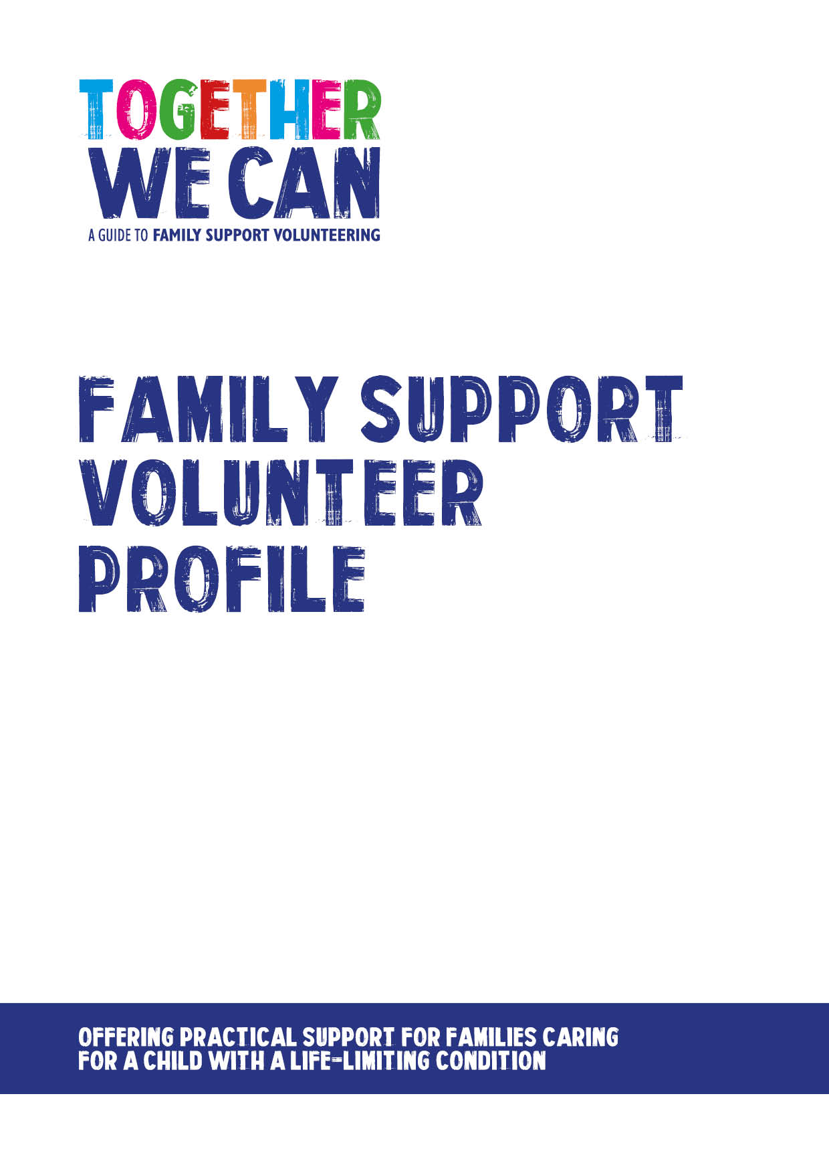
Together We Can is a collection of resources for organisations developing a service where volunteers support families of a child with a life-limiting or life-threatening condition. The resources were developed and tested specifically for this purpose with volunteers working in the homes of a child with a life-limiting condition, but might be useful for any organisation developing volunteer services.

Family Support Volunteer profile

Name
Area where I live

Transport (please tick one) : I have my own transport /
I need to use public transport

My availability is
Day | AM | PM | Evening
Monday
Tuesday
Wednesday
Thursday
Friday
Saturday
Sunday

I am happy to be contacted when a family needs help quickly Yes / No
I am happy to support families with |  | Gardening
 |  | Shopping
 |  | Housework
 |  | Support in hospital
 |  | Sibling support
 |  | Pet care
 |  | Organising paperwork
 |  | Tidying rooms/cupboards
 |  | Cooking
 |  | Decorating
 |  | DIY
I can also offer these skills

If offering sibling support  I prefer to work with children aged  (please tick as many as you wish) | 0-4
 | 5-10
 | 11-14
 | 15-17
 | No preference
My hobbies include

3 words that describe me are

Details of my ‘buddy’ for lone working
Name
Address
Tel No

My age bracket is | 18-25
 | 26-34
 | 35-44
 | 45-54
 | 55-64
 | 65+

What I want to achieve through volunteering is

