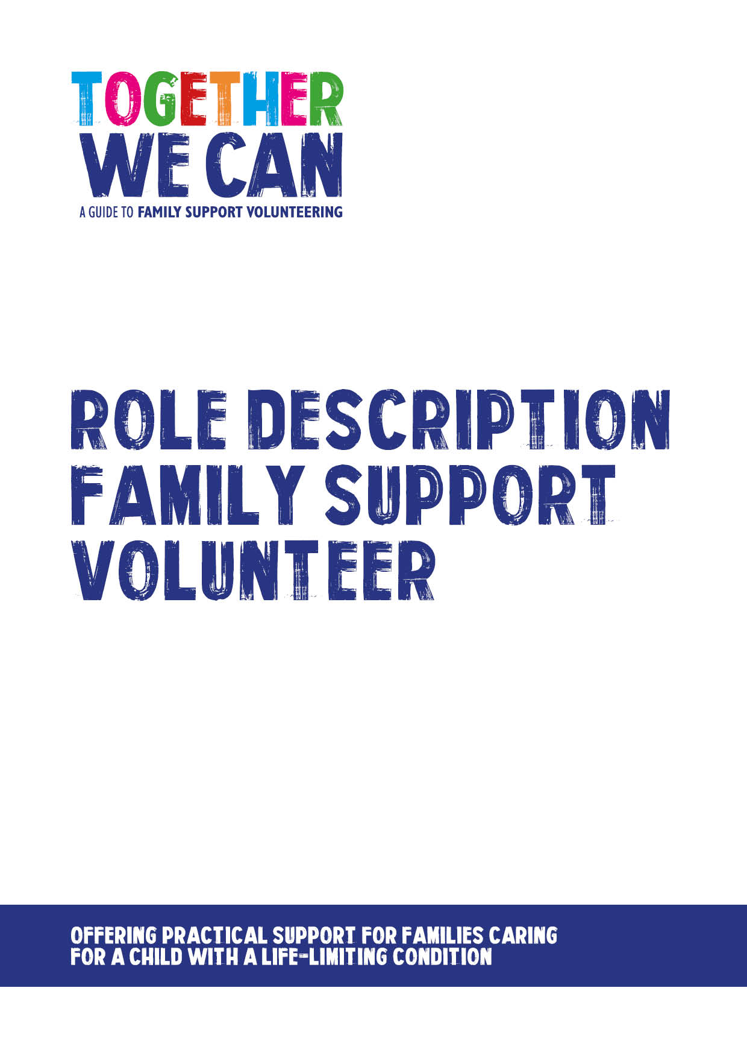

Together We Can is a collection of resources for organisations developing a service where volunteers support families of a child with a life-limiting or life-threatening condition. The resources were developed and tested specifically for this purpose with volunteers working in the homes of a child with a life-limiting condition, but might be useful for any organisation developing volunteer services.

EXAMPLE OF ROLE DESCRIPTIONS FOR FAMILY SUPPORT VOLUNTEERS

This document contains two similar examples of role descriptions for family support volunteers that you might want to adapt.

Example 1

Role description: Family Support Volunteer

The Role
Thank you for your interest in becoming a Family Support Volunteer. This role description will give you an idea what the role will involve. The role of volunteers in supporting families is to provide flexible practical and social support to children, young people and families, to spend time being there in whatever way can help most.

Location
[XXXXXXXXXXXXXXXXXXXXXXXXXXXXXXXXXXXXXXXXXXXXXXXXXX]

Activities of the role

Practical support for families (eg ironing, shopping, gardening, transporting to appointments).
- Social support for siblings (eg supporting interests, play activities, helping with homework, taking out to activities).
- Administrative activities like keeping accurate records of visits to families and ensuring regular feedback to staff.

Boundaries of the role
These are not part of the volunteering role and you will not be asked to nor should you agree to any of the following:

- Being left alone with an affected child - the supervision of a parent or staff member is always required.
- Giving medication or other medical care.
- Giving personal care.
- Lifting.
- Giving financial help – eg withdraw money, handle any money on behalf of the family or sign cheques.

Skills and abilities
These are the skills and abilities that are needed for this role:

- An interest in the wellbeing of children, young people and families.
- A good listener.
- Good at engaging and communicating with people.
- Sensitive to the needs of children, young people and families.
- Ability to use your initiative.
- Reliable, organised and flexible; able to work with changing situations.
- Willingness to undertake training to gain an understanding of the role.
- An ability to recognise the importance of and work within the boundaries of the role and within the organisation’s policies and procedures.
- An understanding of the importance of safeguarding and of confidentiality.
- Warm, friendly and a sense of humour.

Training
- The family support volunteering training programme.
- Induction to the organisation.
- Ongoing training as required.

Time commitment
- Either one half, full day or evening per week for volunteers providing ongoing support to children, young people and families.
- Or more flexible ad hoc time commitments for occasional practical support.

Support and Supervision
[Name, Job title] is responsible for providing overall support and supervision. As part of the role you will be expected to attend regular supervision sessions. These are an important part of the support and will give you an opportunity to reflect on your activities and discuss any ideas or concerns that you may have. [Name, Job Title] is responsible for providing advice and guidance to volunteers and staff and for ensuring that effective support and supervision for volunteers is in place.

Expenses
Volunteers are entitled to claim reasonable actual out of pocket travelling expenses paid at the current mileage rate of [insert rate of involving organisation] per mile for car users and/or through the reimbursement of public transport costs.

Example 2

Donated by South Warwickshire NHS Foundation Trust

Position: Community and Home Support Volunteer

Accountable to: XXX

What we ask of you:

- To be aged over 18 years.
- To be able to commit to volunteer work for at least 6 months.
- To be willing to work for a minimum of 2 hours each week.
- To give one month’s notice in writing to allow alternate arrangements to be made.
- To dress appropriately for the purpose of the particular volunteer work.
- To be motivated, friendly and approachable, and able to work within any community setting.
- To be a good listener and like helping people.
- To be able to work as part of a team with other volunteers and staff, and to make new people feel welcome.
- To be willing to undergo training, where appropriate eg emergency situations.
- To observe the policies and procedures, in particular Confidentiality, Security and Health & Safety.

Activities to support children and young people and their families/carers have 3 tiers of roles starting at level one:

Level 1

All volunteers will be asked to start at level one.

Desirable activities include:

- Organisation of social events and activities allowing families across Warwickshire to get together.
- Arranging and finding out about children and young people’s group activities on behalf of parents/carers.
- Support for other family members, including siblings.
- Supporting activities for young people.
- Any fundraising activities.
- Driving and providing transport.
- Feedback to Volunteer Coordinator of any relevant issues or concerns.
- Activities felt to be appropriate to meet the needs of the family.

Level 2

Duties may include the following:

- Shopping.
- Housework.
- Gardening.
- Decorating.
- Ironing.
- Support for siblings eg taking and picking up from school.
- Any other light duties to support the family under the direction of CCN and Volunteer Coordinator.
- Any fundraising activities.
- Complete the Home Volunteer Support Record form and report to CCN and Volunteer Coordinator and arrange debrief as required.
- Activities felt to be appropriate to meet the needs of the family.

Level 3
Support during end of life care

Activities might include:

- Sibling support, home support and other practical support that can be offered.
- Trips to pick up prescriptions from Pharmacy
- Any other light duties to support the family under the direction of CCN and Volunteer Coordinator.

