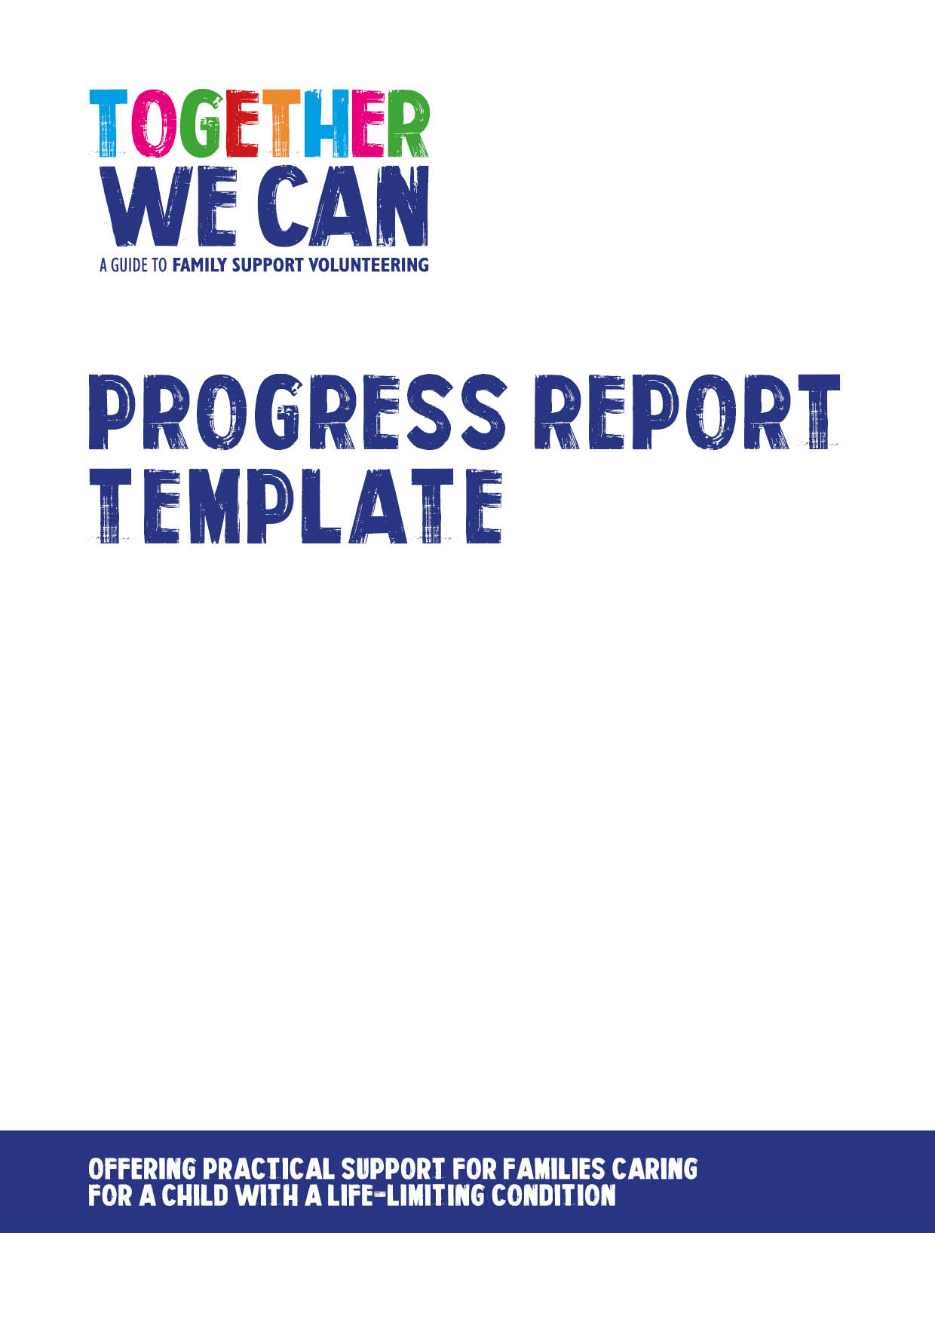

Together We Can is a collection of resources for organisations developing a service where volunteers support families of a child with a life-limiting or life-threatening condition. The resources were developed and tested specifically for this purpose with volunteers working in the homes of a child with a life-limiting condition, but might be useful for any organisation developing volunteer services.

Example of report to keep track of volunteer support progress
This document contains an example of an overview report that can be used to track progress in volunteer support services. This approach could be used on a quarterly or monthly basis.
This example was donated by The Rainbow Trust Children’s Charity for other services to adapt as they wish.
VOLUNTEERING DATA – ALL VOLUNTEERS
Period covered:
Number of volunteers recruited this month / quarter (enrolment and initial interview)
Number of volunteers inducted and fully trained this month / quarter
Number of volunteers for whom end of volunteering form has been completed this month / quarter
Number of volunteers whose files have been archived due to lack of contact/engagement this quarter
Total number of volunteers linked to this team at end of month / quarter
Number of volunteers who have been active this month / quarter
Number of families who had a volunteer this month / quarter

MONITORING DATA – ALL VOLUNTEERS
Number of male volunteers
Number of female volunteers
Number of volunteers aged
18-25 | 26 -3 4 | 35 - 44 | 45 – 54 | 55 -64 | 65+
Ethnicity
White | Mixed | Asian | Black | Chinese or other | Not stated
Volunteer has a disability
Yes
No

FAMILY PLACEMENTS
Number of families referred for a volunteer this month / quarter
Number of families who had an introductory visit from a volunteer this month / quarter
Number of families who received volunteer support this month / quarter
Number of families waiting for a first time volunteer at end of month / quarter
Average waiting time in weeks for first time families this month / quarter
Number of families are waiting for a subsequent volunteer
VOLUNTEER PLACEMENTS
Number of volunteers currently matched and active at end of month / quarter
Number of volunteers waiting for a first placement
Average waiting time in weeks these first time volunteers
Number of volunteers are waiting for a subsequent placement at end of month / quarter

PLACEMENT REVIEWS
Number of placement reviews carried out with families this quarter
Number of placement reviews carried out with volunteers this quarter
Case study for quarter

Key points from review feedback from families

Key points from review feedback from volunteers

ALL VOLUNTEERING HOURS THIS QUARTER
Volunteer activity | Total Number of hours over the Quarter
Travel time
Travel with family
Supervision
Volunteer meeting
Placement visit
Sibling support
Shopping
Housework
Pet care/dog walking
Painting & decorating
DIY
Gardening
Respite support
Support to get out and about
Other
Group support
Ambassador
Events
Admin
TOTAL

Costs for the month / quarter (including extra resources/materials)
VOLUNTEER COSTS FOR QUARTER
Salaries
Venue costs
Total travel costs paid through expenses
Additional costs such as extra resources/materials to support volunteers –list below

TOTAL COSTS | £

