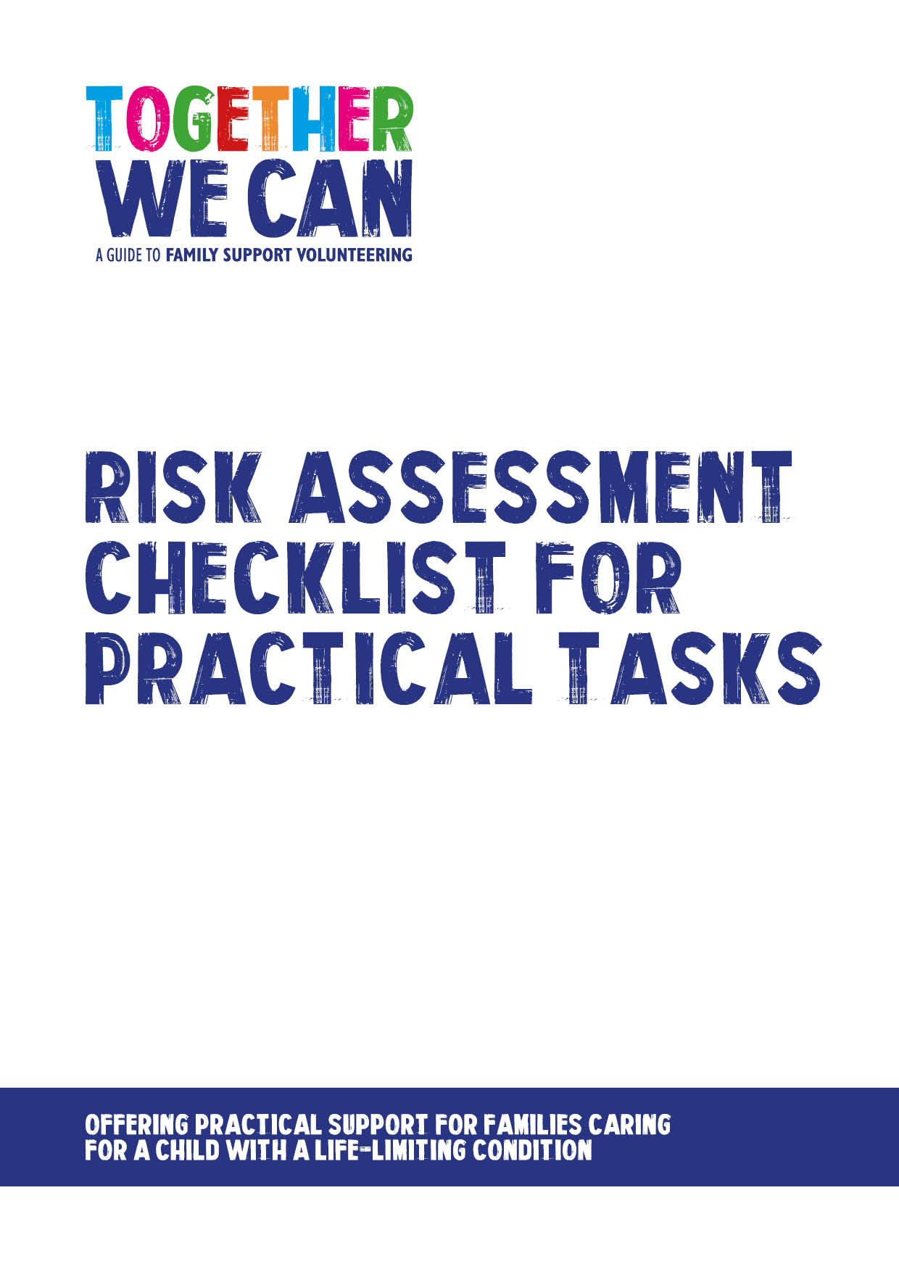
Together We Can is a collection of resources for organisations developing a service where volunteers support families of a child with a life-limiting or life-threatening condition. The resources were developed and tested specifically for this purpose with volunteers working in the homes of a child with a life-limiting condition, but might be useful for any organisation developing volunteer services.

Risk Assessment Checklist for practical task -________________________

Overview of task to be carried out

Tools belonging to family to be used – tick to confirm a visual check has been carried out
Item | Visual Check – please tick | Okay to use? Y/N
Outline any further risk reducing measures in place:

Staff/volunteer signature __________________________

Role_____________________________

Date____________________________

Parent to complete
I confirm that the tools provided as listed above and checked by the project representative are fit for purpose to the best of my knowledge and accept responsibility for any damage caused as a result of faulty or unsuitable equipment provided by me.
Parent signature________________________
Date__________________________________

