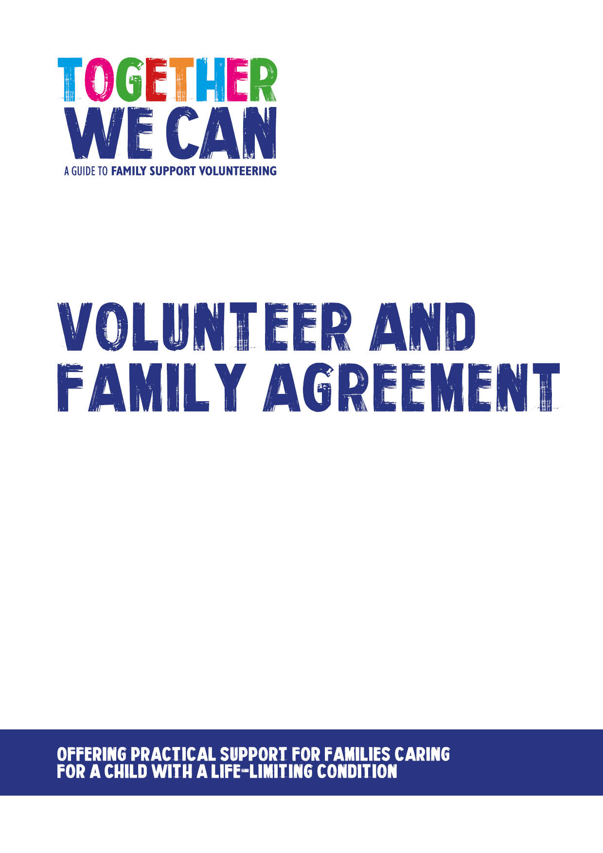
Together We Can is a collection of resources for organisations developing a service where volunteers support families of a child with a life-limiting or life-threatening condition. The resources were developed and tested specifically for this purpose with volunteers working in the homes of a child with a life-limiting condition, but might be useful for any organisation developing volunteer services.

Volunteer and Family Agreement

Please outline below what the volunteer has agreed to do

How often will the volunteer visit?

Weekly fortnightly occasionally one off

Complete this section for regular visits (weekly/fortnightly)

Day of the week when the volunteer will visit ___________________

Time from __________________ to_____________________

Date of first visit______/____/____

Complete this section for occasional/one off visits

Please indicate dates of any planned visits below

(The volunteer will be responsible for ensuring the Project Manager is advised of further arrangements made for visits)
Email address for contacting the family

Volunteer’s email address – please use

How long will the volunteer be supporting you for? (up to 6 months)

Date:
Expected date of last visit:
Date (mm/yy) for volunteering placement to be reviewed
We agree to the following guidelines
- The volunteer is not able to offer any medical or personal care and cannot lift or be left in sole charge of a child who is unwell.
- The volunteer cannot withdraw money, handle money or deal with family finances in any way.
- The volunteer is not allowed to take photos, contact the family through Facebook or social media, or pass on personal details.
- Communication between us will be using the email addresses provided above and if issues arise with this system we will contact the Project Manager
Rainbow Trust confirms that all volunteers in this project have full DBS clearances and have undergone appropriate training for their role. They are covered by public liability insurance through Rainbow Trust.
Please sign below to state that you have read and agree to the content of this document

Parent signature____________________________date__________________________
Volunteer signature_________________________date___________________________

