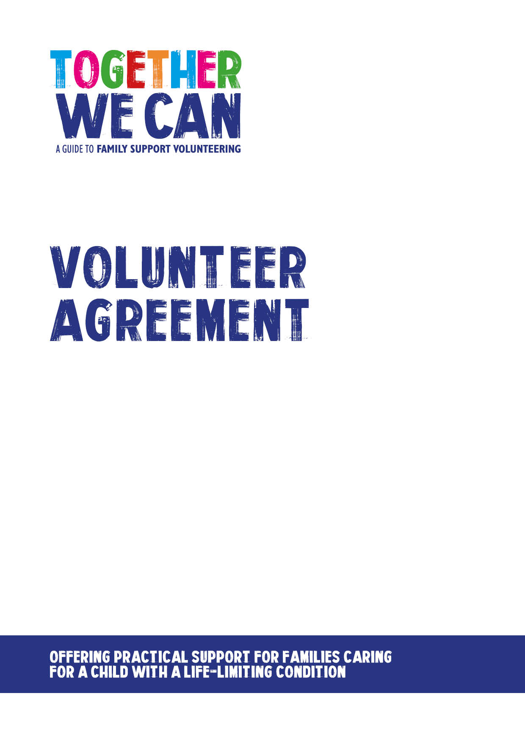
Together We Can is a collection of resources for organisations developing a service where volunteers support families of a child with a life-limiting or life-threatening condition. The resources were developed and tested specifically for this purpose with volunteers working in the homes of a child with a life-limiting condition, but might be useful for any organisation developing volunteer services.

This document was donated by South Warwickshire NHS Foundation Trust.

Family Support Volunteer Agreement

Volunteer:

Review date:

We appreciate your commitment to us and will do the best we can to make your volunteer experience with us enjoyable and rewarding. To make sure you have the best possible experience we have created this agreement which sets out our commitment to you and what we ask of you.

The purpose of this agreement is to make clear what you can expect from us and what agreements we need from you to safely provide the support that the child/young person and their family requires.

[Organisation name] are committed to the following:

- Valuing and respecting your skills, dignity and individual needs.
- Providing support and supervision.
- Providing you with ongoing support throughout your volunteer experience:
    - Volunteer Support Group.
    - 1:1 support with the volunteer coordinator.
    - /named nurse/hospital chaplain/project leaders.
- Providing you with an induction and training programme.
- Explaining the standards we expect and encouraging and supporting you to achieve and maintain them.
- Providing a named person who will be your point of contact whilst volunteering.
- Doing our best to help you develop your volunteering role with us.
- Honouring the time agreement you have agreed to give us and not expecting more from you unless offered and agreed.
- Ensuring you know what to do to stay safe and how to safeguard others, in accordance with our Health and Safety and our Safeguarding guidance.
- Offering you opportunities to feedback and contribute to project developments.
- Offering you opportunities to discuss concerns or problems relating to your role.
- Reimbursing reasonable out-of-pocket expenses following procedures set out in our expenses policy.
- Providing adequate insurance to cover volunteers whilst undertaking volunteering approved and authorised by us.
- Trying to resolve fairly any issues or difficulties you may have whilst you volunteer with us before they become problems. In the event of an unresolved problem, addressing these in accordance with the relevant policies.

We provide an out of hours contact number: XXX

FAMILY SUPPORT VOLUNTEER RESPONSIBILITIES

- Performing my volunteering role to the best of my ability.
- Being open and honest with you.
- Showing commitment to the project.
- Being reliable and punctual.
- Showing courtesy and respect to children, young people, families, fellow volunteers and staff.
- Working as agreed in my volunteer role description and within role boundaries.
- Maintaining personal boundaries, we do not allow staff to share personal details about themselves like mobile phone numbers, home address etc.
- The named nurse will act as your first point of contact for concerns you have about the family you are supporting. However, the on-call nurse is also available at any time.
- Working within our policies and procedures.
- Familiarising myself with policies and guidelines and asking if I’m not sure what to do to.
- Maintaining the confidential information of children, young people, families and the organisation.
- Actively engaging with all support and supervision.
- Attending all initial and any ongoing training.
- Meeting time and other commitments as agreed, but when unable to do so giving reasonable notice so that other arrangements can be made.
- Keeping records and completing any administrative paperwork as required.
- Discussing any concerns with the Project Manager or another member of staff.
- Returning any loaned equipment when ending my volunteering.
- Ensuring that a correct phone number is available to the on-call nurse and that a working mobile phone is with me at all times. This should be always be kept turned on and the on-call nurse informed if there are any changes.
- Providing a further contact number.
- Keeping us informed of any changes to the support you require.

This agreement is not intended to create a legally binding relationship or contractual agreement with the volunteer. Both parties understand and agree that this does not form a contract of employment.

I agree to abide by organisation policies and procedures in all my volunteering.

Signed:

Volunteer Name: __________________________Role: _____________________
(Please print)

Volunteer Signature: _______________________Date: _____________________

Lead Person Name: _________________________________________________
(Please print)

Lead Person Signature: ____________________Date: ______________________

