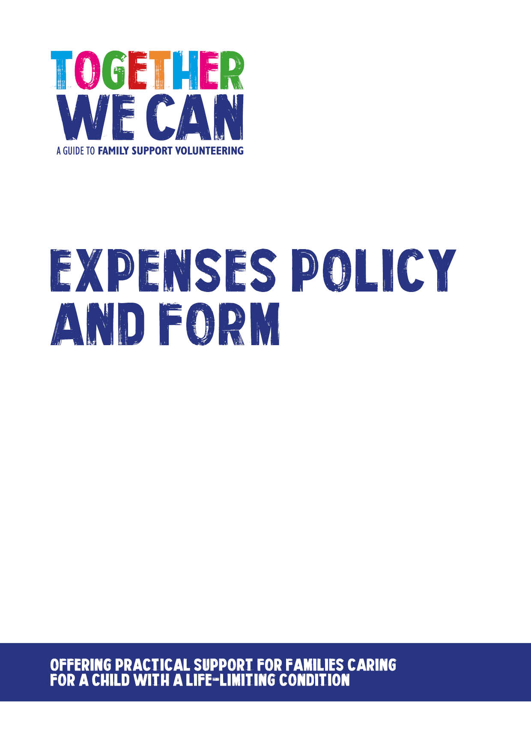

Together We Can is a collection of resources for organisations developing a service where volunteers support families of a child with a life-limiting or life-threatening condition. The resources were developed and tested specifically for this purpose with volunteers working in the homes of a child with a life-limiting condition, but might be useful for any organisation developing volunteer services.

Family Support Volunteer Expenses Policy

Introduction

[ORGANISATION] values its volunteers and we want to ensure that there are no barriers to volunteer involvement. All reasonable out-of-pocket expenses incurred in the course of a volunteer’s role, will be reimbursed, including expenses for travel. In order to claim expenses, an expenses form must be completed and handed into the volunteer coordinator. This process will also be explained during induction process.

Scope

This policy is relevant to all volunteers.

Activity covered by this policy

Any involvement/activity as agreed between the volunteer and [ORGANISATION]/volunteer coordinator.

What expenses will be paid for?

- Travel to include bus, train, taxi or car (car mileage will be paid at the HMRC travel rate of 45p per mile).
- Volunteer subsistence which covers the cost of food and beverages if volunteers have to travel as part of their role (subsistence will be paid in line with HMRC rate – Details are available from the volunteer coordinator).
- Other expenses need to be agreed in advance with the volunteer coordinator in writing.

Where appropriate a valid ticket, receipt or copy invoice will need to accompany a claim for expenses.

Car parking charges, penalties, fines and accidents

The cost of parking whilst volunteering will be reimbursed as long as the claim is accompanied by a receipt totalling the amount.

[ORGANISATION] will reimburse toll charges incurred whilst travelling for the organisation, but volunteers are asked to avoid toll charges where it is practical to do so. Please ensure a receipt is presented as proof of the charge.

Fines and charges incurred whilst driving on [ORGANISATION] business will NOT be reimbursed and should be paid by the driver of the vehicle. Fines and charges include, but are not limited to: penalties for failure to pay congestion charges, parking fines and motoring offences including speeding.

Lost or missing receipts

[ORGANISATION] accepts that it is not always possible to obtain receipts when volunteers are undertaking their volunteering role.

If volunteers fail to produce receipts for a claim they can provide a declaration of “no receipt” for items totalling £10 or less (noted on the claim form) without question. Authorisation of items valued at more than £10 must be discussed directly with the volunteer coordinator.

Making a claim

When a volunteer wants to make a claim they will need to fill out a ‘Volunteer Expenses Form’ which will be provided by the volunteer coordinator.

Expense forms should be completed monthly.

The volunteer coordinator will be responsible for signing and to authorise payments for volunteer expenses.

When an expense form has been completed and authorised a payment will then be made to the volunteer either by cash, cheque or into their bank account (where bank details and permission have been given).

DATE
REVIEW DATE

