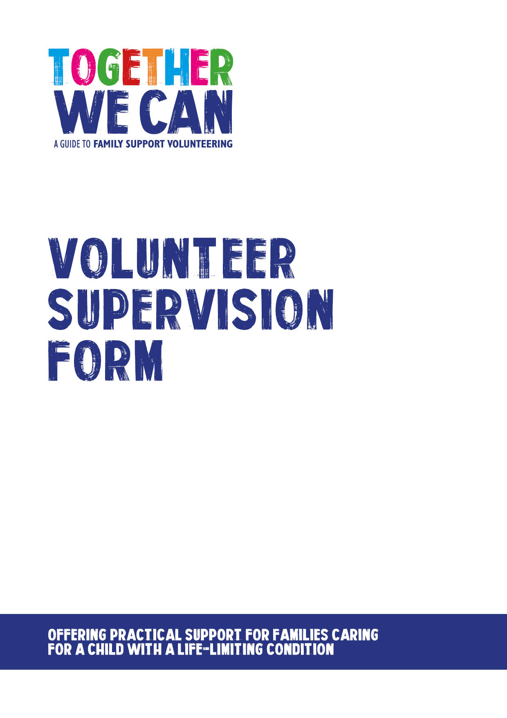
Together We Can is a collection of resources for organisations developing a service where volunteers support families of a child with a life-limiting or life-threatening condition. The resources were developed and tested specifically for this purpose with volunteers working in the homes of a child with a life-limiting condition, but might be useful for any organisation developing volunteer services.

FAMILY SUPPORT VOLUNTEER SUPERVISION FORM

DATE:
NAME:
DATE OF COMMENCING PLACEMENT WITH FAMILY:

What work have you been doing? How are you feeling about your volunteering?

What has been going well for you?

Has anything not gone well for you? If so, what? How did you deal with this?

Do you need extra support or training in any areas?

Are there any other volunteering activities you might like to do?

How do you feel you are getting on with the family you are placed with?

Any other issues? (By Supervisor or volunteer)

Give feedback

NEXT SUPERVISION DATE
VOLUNTEER’S SIGNATURE AND DATE
SUPERVISOR’S SIGNATURE AND DATE

