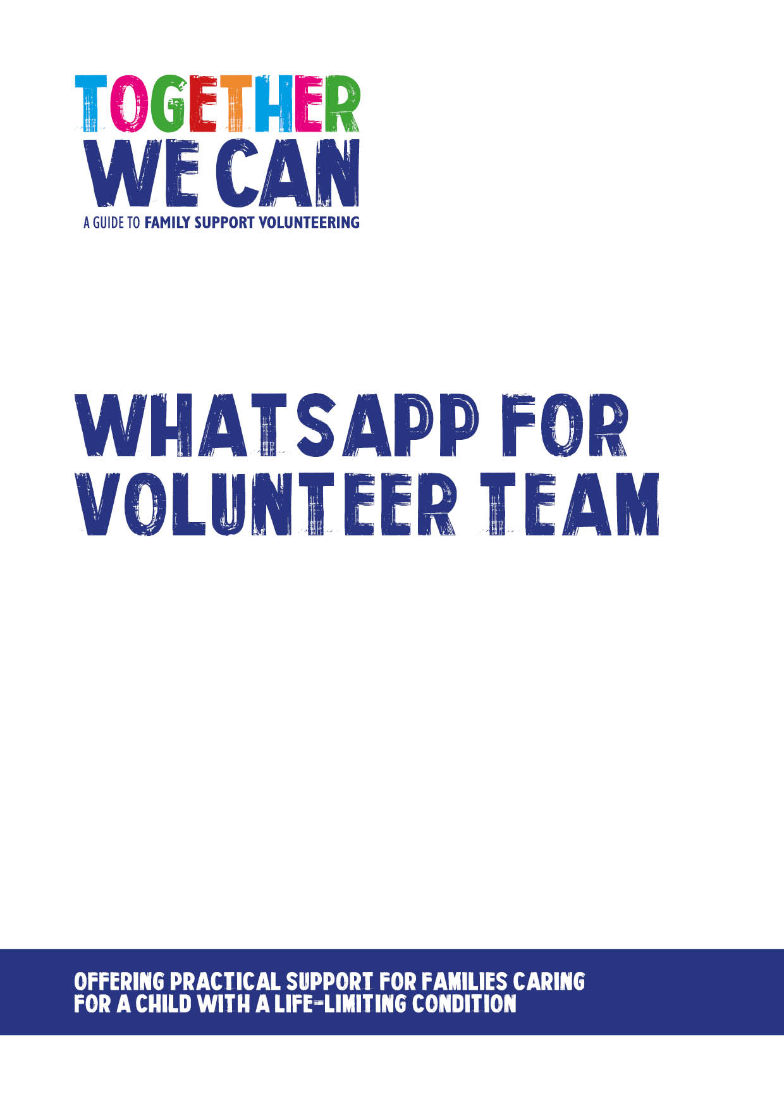
Together We Can is a collection of resources for organisations developing a service where volunteers support families of a child with a life-limiting or life-threatening condition. The resources were developed and tested specifically for this purpose with volunteers working in the homes of a child with a life-limiting condition, but might be useful for any organisation developing volunteer services.

WhatsApp for Volunteer team – Guidance

The WhatsApp groups will be set up solely for the purpose of communicating requests from families in each area asking for specific one off volunteer support. Using WhatsApp should enable us to respond quickly and in an immediate way to such requests and will mean we can offer additional support to families.
The groups will not be used by volunteers to communicate socially with each other, discuss their own activities or make one to one arrangements of any kind.
Messages sent out to the groups either from staff or volunteers, must not contain any family information apart from providing the first part (three or four letters/digits) of a postcode so volunteers can judge whether or not they are within reasonable travelling distance. No family names, addresses or details of any family member should be included
Messages should state the nature of the work required, timescales and proposed dates. An example message is ‘Can anyone help with some gardening for two/three hours in postcode X on 20/5/17?’
The WhatsApp group may also be used by staff to provide reminders to volunteers of upcoming events such as group meetings.
The group will be monitored by the Volunteer project manager and other staff using it. Anyone responsible for misusing the group will be denied access.
Please sign below to give your consent to participating in the WhatsApp groups for X location

I consent to my number shown below being included in the X location WhatsApp group
Number to use
Signed
Date

