# 

# Introduction, Objectives and Key Terminology

Project ECHO® (Extension for Community Healthcare Outcomes) is a movement, whose **mission** is to develop the capacity to demonopolize knowledge and amplify the capacity to provide best practice care for underserved people all over the world.

The **ECHO Institute™** refers to Project ECHO’s physical location and training/technical assistance arm relating to replication efforts. **Replication** of the ECHO model™ is achieved through the creation of ECHO “**hubs**” or regional centres, in which partner sites or “**spokes**” connect through teleECHOTM networks, gaining specialty expertise and knowledge. Effective replication while maintaining fidelity to the model will help us reach our collective goal of improving healthcare delivery all over the world. The ECHO model develops knowledge and capacity among community providers through:

1. **Using technology (multipoint videoconferencing and internet) to leverage scarce resources and create knowledge networks**, which connect a multidisciplinary team of experts located at the hub (figure 1: larger image) with learners at spoke sites (figure 1: smaller images) through regularly scheduled teleECHO sessions.
2. **Improving outcomes by reducing variations in processes of care and sharing best practices.**
3. 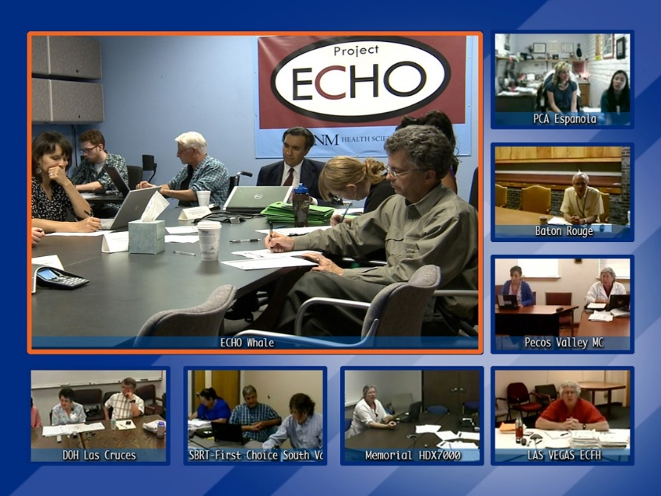**Case-based learning:** guided practice through diverse, real-life cases with subject matter experts to facilitate learning by doing and create **Learning Loops**. Over time, these learning loops create deep knowledge, skills, and self-efficacy.

Figure 1: NEJM : 364: 23, June -2011, Arora S, Thornton K,

Murata G

1. **Programme evaluation and data tracking** (using data protection compliant tools) to measure programmatic activity and program function over time for the purposes of ongoing quality improvement.

By leveraging technology to train those providing care, specialists are also better able to triage patients and attend to the most complex, high-risk patients. This creates additional healthcare efficiencies.

The **ECHO model** is not “telemedicine” where the specialist assumes the care of the patient, but instead a “telementoring” model where the community provider retains responsibility for managing the patient’s care, operating with increasing independence as their skills and self-efficacy grow. Learning and support flows throughout the network from spokes to hub and spoke to spoke as well as from hub to spoke.

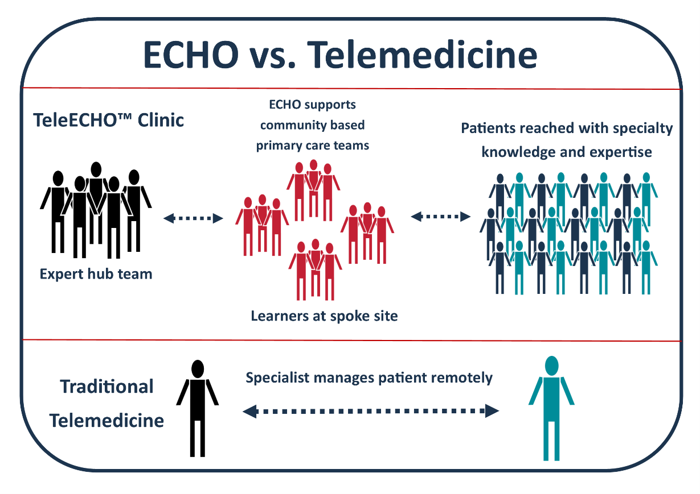

Figure 2: Graphic and visual conceptual framework used with permission from Kent Unruh and Project ECHO.

**ECHO**

* **networks are all different**, based on the focus, style, and individual team members involved,
* works to build expertise at the front lines of care to safely and effectively manage common, complex conditions so that providers can **meet the need for specialty care within their community,**
* is an **educational model**, not a patient care network, and
* is an **ongoing multidirectional learning network** that is not merely consultative and does not develop a patient-provider relationship.

| **GLOSSARY OF TERMS** | |
| --- | --- |
| **Term** | **Definition** |
| Demonopolize | Share freely with others particularly in the case of knowledge to enable others to become equally expert. |
| ECHO® | Extension for Community Healthcare Outcomes |
| ECHO Institute™ | Refers to Project ECHO’s legal entity, faculty and staff as well as headquarters and physical location at UNMHSC in Albuquerque, NM. |
| ECHO Model™ | Developed as a platform for both healthcare service delivery and research in 2003. The ECHO model is based on four core pillars: 1. use technology to leverage scarce resources, 2. sharing “best practices” to reduce disparities, 3. case-based learning to master complexity, and 4. monitoring outcomes to evaluate impact. The ECHO model develops knowledge and capacity among community participants through on-going telementoring and education. |
| ECHO Knowledge Network | Consists of regularly scheduled teleECHO sessions that bring together expert inter-disciplinary specialists and community-based partners. |
| Force Multiplication | Refers to an exponential increase in workforce capacity created through the ECHO model. Utilizing telementoring and guided practice ECHO builds system capacity by empowering primary care providers to gain new knowledge and expertise to treat patients in their own communities. |
| Hub | Regional centre where multidisciplinary team of subject matter experts for an ECHO Network is located. |
| iECHO | Project ECHO’s web-based partner relations management tool that is used to manage and audit teleECHO networks, collect data on ECHO network performance, and provide online resources to partners. |
| IT Officer | Hospice UK employee dedicated to managing participant technological connections to the teleECHO sessions. |
| Learning Loops | The sharing of knowledge between experts and community partners through active participation in teleECHO Networks. |
| MetaECHO™/ MetaECHO™ Community | Refers to the ever-expanding community of individuals and organizations using the ECHO model to help demonopolize expert knowledge. |
| Mock ECHO | Simulated teleECHO sessions that are designed to prepare hub team members for launching live teleECHO networks. |
| Network  Coordinator | Hospice UK employee who is responsible for the administrative and organisational component of a network; as well as provide guidance information to network participants and guest speakers. |
| Network Manager | Hospice UK manager with network experience who assists in curriculum development for the educational and training component of the network, assists in coordinating network functions and provides managerial support to the network coordinators. |
| Project ECHO® | Refers to the overall movement to implement the ECHO model, including the ECHO Institute. |
| Spoke | Community partner site at which individual or team or learners is located and connects to hub via teleECHO sessions. |
| TeleECHO™ Network | Term used to describe regularly scheduled videoconferencing sessions among subject matter experts and learners which use the ECHO model, including didactic presentations and case-based learning to create learning loops. |
| Telementoring | Term used to describe the guided mentoring relationship that develops during a teleECHO network using videoconferencing technology. |
| UNMHSC | University of New Mexico Health Sciences Center, where Project ECHO and the ECHO Institute are based in Albuquerque, NM. |
| VTC | Video teleconferencing; participation in teleECHO networks via video connection. |
| Zoom | Teleconferencing software used for teleECHO sessions. |