**Approaching Symptom Management in Palliative Care**

*Please see Drug Algorithms, the APPM Master Formulary 2015 & the, Children’s BNF etc for further information*

As in all children who are unwell it is important to ensure thorough assessment and regular reassessment of their symptoms. Talk with those involved with the child before assessing to gain as clear a picture as possible:

- Make sure that all symptoms are enquired about – it is not uncommon for only some of the child’s symptoms to be presented as these may have been the initial main problems and remain focused upon at reassessment.

- Ensure all symptoms are addressed as part of a holistic assessment, including physical, psychological, spiritual and social

- Enquire about subjective symptoms such as dyspnoea, nausea, where observation alone will be inadequate.

- Remember that parents know their child well and their observations are key to understanding the child’s symptom progression and it’s impact upon them and the family.

When assessing a child consider:

* What do we know about this condition and its likely presentation in end stage disease? What does the literature tell us about this?
* How have we seen this condition specifically presenting in this particular child over the recent past – what complications have been evident? Take a thorough history, talk with the family, local and specialist staff.
* What are the child’s symptoms at present? Take a thorough history and examination. Are the symptoms being adequately managed or are they becoming increasingly problematic? What has already been tried and with what effect?
* With these points in mind, what might we expect to present as palliative care emergencies in this child?

In the light of this:

|  |  |
| --- | --- |
|  | * Explain the symptoms and their management to the child and their family as appropriate and in a manner that enables them to understand and take some control in their management. * Discuss a plan to manage the symptoms with them that is acceptable to them and takes account of wishes regarding treatment modes etc - dislike of capsules, injections etc. * Talk through the potential complications and their management with the palliative care team, the primary care team, and as appropriate, with the family/carers. Are we prepared to manage such events? It |

is better to be prepared in anticipation to support calm management in the event of their occurrence, than to be unprepared.

* Ensure that family and staff know how to access care including 24hr advice.
* Ensure that you reassess the situation after an agreed time period, listening to the family and staffs concerns.
* Communicate well between professionals and family, ensuring clear documentation of symptom progression and management.

In all of your assessments:

|  |  |
| --- | --- |
|  | * Ensure that you have time to adequately listen and assess * Take each decision with adequate reflection upon the factors involved * Discuss regularly with colleagues * Don’t be afraid to say that you don’t know and be willing to seek advice from others |

In terms of treatment:

* Keep treatment as simple as possible
* **S**tick to one drug per symptom where possible
* **I**nvolve the child & family in decisions re treatment choices
* **M**anage with oral preparations where possible
* **P**lan for anticipated symptoms
* **L**isten to the child & family’s account
* **E**nsure management is reviewed in an agreed manner
* Consider the use of a syringe pump if the child is:

No longer able to absorb oral medication

Vomiting

Having difficulty swallowing and has no NG tube/gastrostomy

Is not fully conscious

* Remember to check compatibility of any drugs in a syringe

pump and never put more than three drugs in any one pump.

For the oncology/haematology children it is useful to agree a protocol

for the administration of blood products support before a crisis is

reached. This should be based on the instructions of the childs

consultant.

Regularly review the overall medications being given. Do all remain

necessary? Consider rationalising drug use, especially in the final days.

**Managing the Spectrum of Symptoms in Palliative Care**

It is essential to assess all possible symptoms. The Symptom Control Aide memoire within the Toolkit and within the Drug Administration Document can be used to support this, ensuring all symptoms are enquired about.

The following outlines key points when considering the range of symptoms that may present.

Further more detailed information can be found in the Toolkit in section 10 in the Rainbow’s Symptom Control Manual.

**1. Pain**

1. The commonest fear in paediatric palliative care expressed by parents is that their child/young person may experience pain.
2. Not all pain can or needs to be controlled with opiates. Non opiate and adjuvant drugs can have a significant role to play either in combination with or instead of opiates. Good nursing and social support can help the child and family cope with pain. Alternative medical practices may also be of help.
3. For children who cannot speak, pain may present as unusual stiffness, irritability, posturing and spasm.
4. The child must be carefully assessed for the cause of the pain and skin integrity, full bladder and constipation should also be considered.
5. There may also be more than one source of pain.
6. Pain control should follow the rules laid down by the WHO pain ladder. If the treatment does not work do not try other drugs of the same level but go up the analgesic ladder. Use adjuvant therapy at any level of the ladder.
7. Children develop opioid tolerance more readily than adults, so, regular reassessment is vital, ensuring that decisions to increment doses are soundly based upon effective responses to break through doses and not confused with possible neuro-excitatory effects resulting from accumulation of non analgesic metabolites.
8. Psychological dependency is not a concern in palliative care. Immediate release morphine is often the best way to start, using it on an ‘as required basis.’ This can be converted over to slow release morphine with additional immediate release morphine for breakthrough pain.
9. If a child becomes unable to take oral preparations consider fentanyl patches (if pain control is stable) or a diamorphine infusion. Opioids need to be given at lower doses and/or less frequent dosing intervals in children with renal and liver failure.
10. For bone pain, non-steroidal anti-inflammatories, where they are not contraindicated because of blood abnormalities, or a short course of high dose steroids, may be considered.
11. Nerve pain may be helped by the use of gabapentin or amitriptyline, but these can take some time for the child to see any effect.
12. Remember to use local anaesthetic creams when siting sub-cutaneous needles.
13. Ensure non-pharmacological pain management is also used e.g.: discussing fears, positioning and warmth.
14. Remember that Entonox may have a role in children with incident pain, enabling them to maintain their dignity by being able to continue to manage to walk to use the bathroom where only short bursts of additional pain relief is required but required immediately.

**2. Nausea and Vomiting**

1. Carefully consider the cause of nausea and vomiting.
2. It may not be appropriate to offer terminally ill children, close to death, enteral feeding.
3. Most children do not require large amounts of fluid and mouth care alone will help them to remain comfortable.
4. Pharmacological Treatments:
5. Levomepromazine is a good broad-spectrum anti- emetic at low doses. It also has an anxiolytic, mild sedative effect (at high doses it is very sedating) and has analgesic properties.
6. Cyclizine, haloperidol and levomepromazine are each compatible with a continuous diamorphine infusion, but always check cyclizine crystallisation concentrations, especially with diamorphine, since crystallisation may not be visible to the naked eye.
7. Levomepromazine is favoured if sedation would be of benefit. Cyclizine is useful if vomiting is centrally induced e.g.: brain tumours.

Metoclopramide is best avoided due to potential dystonia. Haloperidol can also cause this at higher doses.

**3. Sedation**

1. A degree of sedation may be necessary in the final stages of the child’s illness to manage severe, distressing agitation. First ensure that all other potential contributory underlying symptoms have been addressed and that the potential for respiratory depression has been considered. Ensure agitation is not pain related (including full bladder) and explore the child’s fears.
2. Oral diazepam or amitryptyline can be useful, particularly if there is sleep disturbance or an element of depression.
3. A continuous infusion of Midazolam (sedating and anxiolytic) can be used.

**4. Dyspnoea, Coughing and Secretions**

1. Dyspnoea is a subjective sensation of breathlessness, and a very frightening symptom.
2. Try to understand the cause of the breathlessness and treat accordingly.
3. Consider simple measures first e.g, posture, humidity, fresh air and fan. Anxiety is a major component of breathlessness. Diazepam used regularly may help. Whilst a small dose of diazepam can help, be alert to and aware of potential respiratory depression effects where there is respiratory compromise, in neurological conditions and with concurrent CNS depressants.
4. Excess upper airway secretions are common and can be particularly distressing for the child and the family. Hyoscine patches are usually very effective in relieving this symptom preventing fresh secretion production. It will not be able to dry up existing secretions and hence is best started early in the symptoms progression. Hyoscine patches can also be reduced in size to reduce the dose.
5. Drug treatment is more effective if it is started before or immediately the secretions are evident.
6. Provision of portable suction may be necessary. Excessive suction should be discouraged as it is unpleasant for the child and may stimulate production of more secretions.
7. If the cause is due to anaemia because of a haematological malignancy consider a blood transfusion.
8. It may help to prop up the child in the presence of a calm parent with oxygen via a nasal tube. Oxygen may reassure and may not be needed continuously. Oxygen is generally only recommended for children who have benefited from it previously. Remember that not all dyspnoeic patients are hypoxic, that oxygen is a drug and should be prescribed as such, and that oxygen may depress the respiratory drive and therefore be harmful. In toddlers the equipment can be seen as frightening, causing increased anxiety and worsen the breathlessness.
9. Whilst higher than normal flow rates can be acceptable in palliative care, the monitoring of oxygen saturations is not always recommended. It may be better to look at the child and their condition rather than the numbers.
10. Dyspnoea is common in neurodegenerative disorders due to weakened respiratory muscles and the inability to clear secretions. Physiotherapy should be done gently. Thick secretions can be managed with nebulised normal saline. Consider nebulised bronchodilators. Even with no wheeze, nebulised salbutamol or ipratropium can produce symptomatic benefit. Oral morphine or subcutaneous diamorphine, initially given at half the minimum analgesic dose, can help to settle dyspnoea.

**5. Bleeding**

1. The sight of blood is distressing to the child, parent and carer alike. If bleeding is likely to happen, a gentle warning may help to reduce distress and shock for the parents.
2. It is important to agree a platelet transfusion protocol with the family in advance. Generally only if the child is symptomatic with bleeding that is overt and persistent should platelets be given.
3. If bleeding does occur the use of red towels and blankets may help minimise visual the shock.
4. Consider using tranexamic acid orally or topically for oral bleeding.

**6. Infection**

1. Infection is one of the commonest causes of the terminal event in children with a life threatening condition.
2. Infections should be treated when its effect is contributing to symptoms.
3. Always discuss and record the course of action that has been taken with the parents and the child when appropriate.
4. Use of intravenous antibiotics needs to be carefully justified in a terminal setting.
5. Whatever decision is made ensure the parents are comfortable as possible as it may affect their grieving process. Sometimes antibiotics are necessary e.g. pain relief for an acute ear infection to give symptom relief, when parents have otherwise decided on no more treatment.

**7. Skin care**

1. Good hygiene is important, and attention to hair and nail presentation must not be overlooked.
2. Children often become wasted and immobile and their skin becomes very vulnerable to breakdown with poor subsequent healing.
3. It is important to consider the risks of pressure areas and use pressure­relieving devises when necessary.
4. The child/young person needs to be turned regularly and frequently.
5. Hoists and slings may also be needed especially if caring for a bigger child.
6. If the skin breaks down advice should be sort from the tissue viability team regarding the appropriate dressings to use.

**8. Constipation**

1. Liaise with parents, as they know their child’s bowel habits best.
2. There may be a wide variety of causes of constipation, including:
3. Inactivity, especially if in a wheelchair long term,
4. Neurological conditions gut dysmotility
5. Decreased food intake
6. Fear of opening bowels
7. Drugs.

III. Constipation is possible with the use of opioids. Fluid intake and dietary manipulation may help but they are not usually sufficient on their own.

If a prophylactic prescription for a laxative is required, consider:

1. Constipation induced by opiates will require co-danthramer (if oncological) or senokot for stimulant properties.
2. Movicol can be used as an alternative.
3. The child may need a suppository or an enema if these do not work or if they refuse to take the medication, but may not be acceptable to them, needing sensitive discussion.

**9. Bladder**

1. Do not get too concerned about falling urine output in the terminal days.
2. Obstruction may require catheterisation for comfort
3. Retention arising from use of opioids may be transient, and simple manoeuvres such as gentle expression, warm baths etc may be sufficient
4. The loss of bladder function in a child who has previously been continent can be a source of great distress for themselves and their parents. The use of pads is non-invasive and simple, but needs tact and sensitivity to introduce.

**10. Oral Care**

1. Good oral/mouth care can enhance the quality of life of children in the palliative care setting.
2. Signs may include a swollen mouth, ulceration, candida, inability to salivate, painful swallowing, dry tongue and cracked lips.
3. The cause should be identified, discomfort and pain treated. An anti fungal is often needed.
4. If a child is old enough and able to use a soft toothbrush this should be continued as long as possible. The parents may like to help with this part of their child’s care. A finger tooth brush is often needed in the terminal phase.
5. If the child has bleeding gums, tranexamic acid may be used as a mouthwash. If the toothbrush is too sore they may like to use cotton swabs soaked in water or mouthwash swabbed around the mouth.

VI. The enzyme effect of pineapple juice can be effective when saliva is not being produced. They may also like to use Benzydamine spray or mouthwash as analgesia and Vaseline (unless contraindicated by the use of oxygen) or lip balm for cracked lips. Biotene is a useful saliva replacement gel. It is helpful to start this early, preventatively, before they need it to improve acceptability.

**11. Nutrition**

1. Parental anxiety around nutrition is very common. Effective control of nausea and vomiting, constipation and mucositis will help to maintain some degree of dietary intake.
2. Try to give fluids as the child tolerates. Interesting drinks, jellies, ice­ lollies and ice cream can all help, and if the child is still eating, offer small portions.

**12. Fits**

1. Fits are most commonly seen in the palliative care setting in children with neurodegenerative disorders or intracranial malignancy.
2. Those with neurodegenerative disorders will often already be on anticonvulsant medications and parents/carers will be knowledgeable about recognising and treating fits. For these children fits are often variable in type and may become frequent and severe and more difficult to control towards the end of life.
3. Children with intracranial malignancy will not necessarily develop fits. For those who do, it is a frightening new symptom. Prophylactic anticonvulsants should be considered, parents should be warned as to what to expect and they should have rectal diazepam or buccal midazolam at home and know how to administer it.
4. If the child has a nasogastric tube or a gastrostomy this is the obvious route for anticonvulsants to be given.
5. In the terminal stages seizures tend to become more severe and frequent. The child may not be able to absorb medications at this stage so subcutaneous midazolam or phenobarbitone may need to be considered.

**13. Sleeping difficulties**

1. Try to address the child’s fears. Whilst sleep patterns may be very disrupted, try to optimise the bedtime routine.
2. Consider complimentary therapies to aid relaxation. Try to disturb the child as little as possible overnight, for example, if possible, reschedule medication.

**14. Restlessness/Agitation**

1. Try to nurse in a calm, peaceful, familiar environment. A parent or trusted adult being present may help.
2. Try to address the fears and remove pain or other symptoms.
3. Try to exclude pain or inadequate positioning.

**15. Gastro Oesophageal Reflux**

1. This is a very common problem and is under recognised in neurologically impaired children. Symptoms are particularly significant if they occur during or after feeds.
2. Non-drug treatment should include adjusting posture, altering feed regime to frequent small volumes, check for overfeeding, and consider thickening the feed.
3. Drug treatment, including antacids may help. Omeprazole reduces the noxious effects of reflux. Ranitidine can be used as second line treatment but it can give problems with nocturnal acid hypersecretions. Domperidone may be useful as an upper gut propulsant.

**16. Muscle Spasms**

1. This is common in neurodegenerative disease.
2. Listen to the parents and watch the child. They may be very distressed when having repeated spasms.
3. Early involvement from a physiotherapist can be useful and they can give advice on positioning, seating, handling that may prevent positioning that can cause muscle spasm.
4. An increased muscle tone and spasm may be the only thing that allows the child to sit or stand up. Certain treatments may therefore decrease their mobility, head control, airway management and general posture and medications can cause unnecessary sedation.

**17. Psychological**

1. Give the family time and be prepared to listen. Providing honest answers to straight questions can allay fears and anxieties.
2. In a child manifesting clinical symptoms of anxiety do not be afraid to use medication as an adjuvant to counselling and support. Symptoms may be very different to adults – younger children tend to regress and develop behavioural problems, older children may have nightmares, insomnia or become introspective. Insomnia is a problem for the child and the parents.

**References and Further Reading:**

Coventry and Warwickshire Paediatric Terminal Care Symptom Control Policy (2010) Terminal Care Symptom Management Policy. Footprints 2nd Edition

Solihull Trust Guidelines for the Care of Children with Palliative Care Needs 2007

Symptom Control and Palliative Care in Children with Cancer. Departments of Haematology/Oncology and Pharmacy. The Birmingham Children’s Hospital Trust. July 2011

Basic Symptom Control in Paediatric Palliative Care. The Rainbows Children’s Hospice Guidelines. 9.5 Edition 2016

The APPM Master Formulary 2015

Paediatric Palliative Care Guidelines (2006) 2nd Edition. South West London, Surrey, West Sussex, Hampshire, & Sussex Cancer Networks

Guidance on Cancer Services. Improving Supportive Care and Palliative Care for Adults with Cancer. A Manual. NICE 2004

World Health Organization.(2002) National Cancer Control Programmes: policies and guidelines. Geneva

Children’s BNF

**The ‘Core 4’ Group of Symptoms and Drugs in Terminal Care**

A range of drugs are available to support symptom control in the final days of life. However it is likely that only a small number will be required to control the most common symptoms as the last days of life approach. These symptoms and drugs can be thought of as the ‘Core 4’ group. It is wise to become very familiar with all aspects of the use of the most commonly used drugs, moving to use other drugs where indicated in the individual child as needed. If the use of these additional drugs is not as familiar to you, then advice on their use should be sought immediately. Where discharging a child, it is wise to check on the receiving teams’ usual practice in symptom control.

**What are the ‘Core 4’ Group of Symptoms & Drugs?**

The child’s drug management will often have been rationalised and reduced in the final days. Symptoms most commonly requiring support will include Pain, Nausea and Vomiting, Terminal Agitation/Seizures and Secretions. As the end of life approaches, medication may need to be given as a 24 hour continuous infusion by syringe driver, although the need for this should always be assessed and patients only transferred from existing treatment if clinically indicated. Often, only one or two drugs will be required in the syringe driver although more may be used as necessary provided that in-solution compatibility permits. The drugs discussed below may be given in combination in solution via syringe driver, although it should be recognised that compatibility should always be confirmed, and may be limited as the number of drugs and their concentration in solution increases. Hyoscine, is usually given transdermally, rather than via syringe driver.

**Pain**

*Diamorphine* is indicated for opiate-responsive pain. Due to its solubility it will be the opiate of choice for administration via syringe driver for children whose pain has previously been well managed with oral, rectal, transdermal or sublingual opiate preparations.

The dose via syringe pump should be based on that previously delivered by other drugs and routes, taking account of the effect of relative potency of both the drugs and routes of administration. Ensure that any increased doses are assessed as being necessary and appropriate.

Breakthrough analgesia should be prescribed. It should be available in the most appropriate formulation and at a dose that reflects the dose delivered via the syringe driver and the potency of the ‘breakthrough opiate’ relative to that of Diamorphine.

Remember to still consider using non-opioid drugs such as paracetamol, or, eg, NSAID for their beneficial combined effect with opiates in neuropathic pain or adjuvant non-opioid analgesics such as anticonvulsants where appropriate and not contraindicated.

See APPM Drug Formulary and Algorithms sections of the West Midlands Children and Young Peoples’ Palliative Care Toolkit and the BNF for Children.

**Nausea and Vomiting**

*Cyclizine* is often considered the anti-emetic of choice for use in a syringe pump. It will often have been previously effective when given orally or rectally during the earlier stages of care. Care should be taken since solubility in combination with Diamorphine is limited. See West Midlands Children and Young Peoples’ Palliative Care Toolkit Syringe Pump Considerations.

Cyclizine is particularly effective in managing nausea and vomiting that is of vestibular origin, and acts at the level of the vomiting centre. This will not always be the underlying cause of the nausea and vomiting, and at times, cyclizine may not therefore be effective or the drug of choice.

*Levomepromazine* is a very useful second line antiemetic when first line treatment has been ineffective. It is however, often considered as *first* choice rather than cyclizine in the terminal care setting. This is due to its broad spectrum of action, allowing it to be effective for nausea and vomiting resulting from all common triggers. This makes it particularly useful when the nausea and vomiting may have several, or unidentified, triggers in what is often complex morbidity in the final days.

Its potential sedative and anticholinergic effects must be considered.

Doses and indications are outlined in the drug doses and algorithms sections of the West Midlands Children and Young Peoples’ Palliative Care Toolkit and BNF for Children.

**Terminal Agitation and Seizures**

*Midazolam* is well recognised as being helpful in managing seizures. It will often be selected to add to the syringe pump when a child has required two doses of buccal midazolam within 24 hours for unremitting seizures, and those doses have had good effect.

It is also helpful in persistent agitation in the terminal stages. In such situations its dose range is lower than for the management of seizures.

Its potential to cause sedation must be considered, both alone and in the light of the other drugs the child is receiving.

Doses and indications are outlined in the drug doses and algorithms sections of the West Midlands Children and Young Peoples’ Palliative Care Toolkit and BNF for Children.

**Excess Secretions**

*Hyoscine hydrobromide* is a useful drug to help control the upper airway secretions that often gather in the final hours of life and can cause noisy, rattly breathing.

It can often be successfully introduced in the early stages of increased secretions using the transdermal patch formulation. It can also be given by continuous infusion by syringe pump if needed.

Alternatively, *Glycopyrronium* may be used to help control the upper airway secretions.

Doses and indications are outlined in the drug doses and algorithms sections of the West Midlands Children and Young Peoples’ Palliative Care Toolkit, and BNF for Children.

**Note:** With the exception of *Diamorphine*, none of the drugs discussed above is licensed for use in children for the stated indications.

**Symptom Care Flow Sheet Aide-mémoire**

Name : NHS Number: Date/time:

|  |  |  |
| --- | --- | --- |
| Appearance:  Distress:  Pain:  Sleep Pattern:  Communication:  Conscious Level:  Convulsions:  Breathing:  Colour:  Cough:  Secretions:  Feeding:  Appetite:  Vomiting:  Mouth:  Abdominal Pain:  Bowels:  Urinary Output:  Posture/Movement:  Sensation:  Skin: | Same Better Worse Well Unwell Ill  Nil Mild Moderate Severe  Controlled Some Breakthrough Uncontrolled  Normal Changed  Normal Fluctuating Deteriorating  Normal Reduced  N/A Controlled Uncontrolled  Normal Abnormal  Normal Pale Mottled Cyanosed Flushed  Nil Occasional Frequent Unable to cough  Normal Productive  Nil Orally Oral Tube Fed  Normal Increased Decreased  Nil Nausea Occasional Frequent  Moist Dry Sore  Nil Occasional Frequent Distention  <1 2 3 4 >5  Continent Incontinent Dysuria Retention Catheter  Good Volume < than usual >than usual  Normal Reduced Spasm  Reduced Normal Hypersensitive  Dry Normal Sore Itchy Oedema  Intact / Broken Risk Assessment Yes/No |  |

**Parents Symptom Control Information**

Parents tell us how important it is to have written information to support their understanding of their child’s condition and its symptoms, actual or anticipated, and of the approach that will be taken to manage them.

A resource developed by CCLG to support parents can be found in the front cover of this toolkit. It is entitled ‘Managing Symptoms at Home’. The relevant sections can be photocopied and given to the parents at their pace, when they are ready to hear more about their child’s symptoms and their management.

Be selective as to the sections you give to the family, as not all will be relevant to all children.

The booklet has been written with Oncology conditions in mind, but there are aspects that will support parents of children with non oncological conditions.

Make sure that you discuss the symptoms and their management with the family. The document is a supportive, supplementary tool, not a substitute for face to face discussion. Used appropriately, families will feel more in control of the situations they may have to face.

**Algorithms**

**to Support Urgent Symptom Management Out of Hours**

The following algorithms have been developed to support urgent decisions that may need to be taken to manage symptoms effectively out of hours when specialist advice is not readily available, in end of life care.

They provide a guide to the approach to the symptom management and to the possibilities for drug choice and other means of symptom management.

Where a drug is to be considered, its dosages can be found in the APPM 2015 or the BNF for children .

Wherever possible symptoms should be anticipated both in terms of how to manage them and in terms of the drugs that would be required to do so. The advice within the algorithms acts as supplementary information at times of unexpected events that may at times occur in end of life care.

Further information on the management of symptoms can be found in this section of the Toolkit and in the APPM Formulary 2015 .

The Algorithms relate to:

Nausea/Vomiting Breathlessness Seizures

Pain

Bleeding and

Agitation

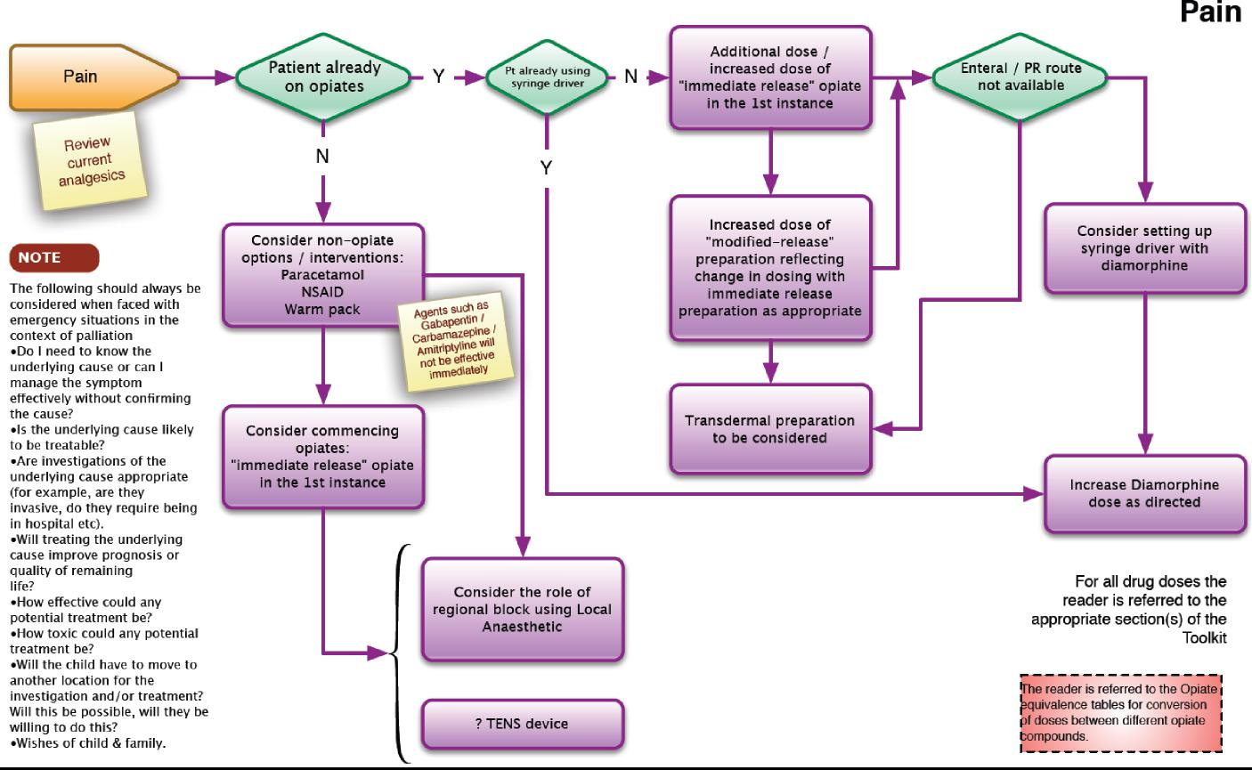

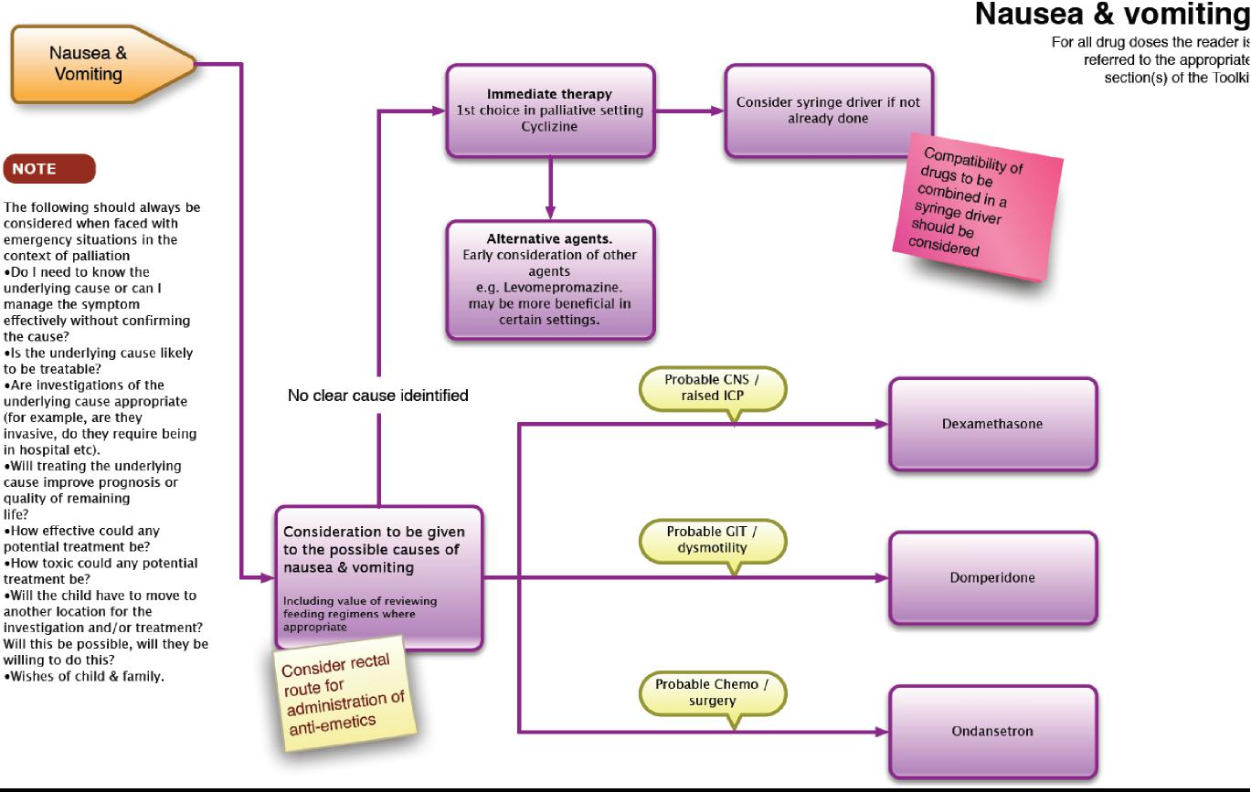

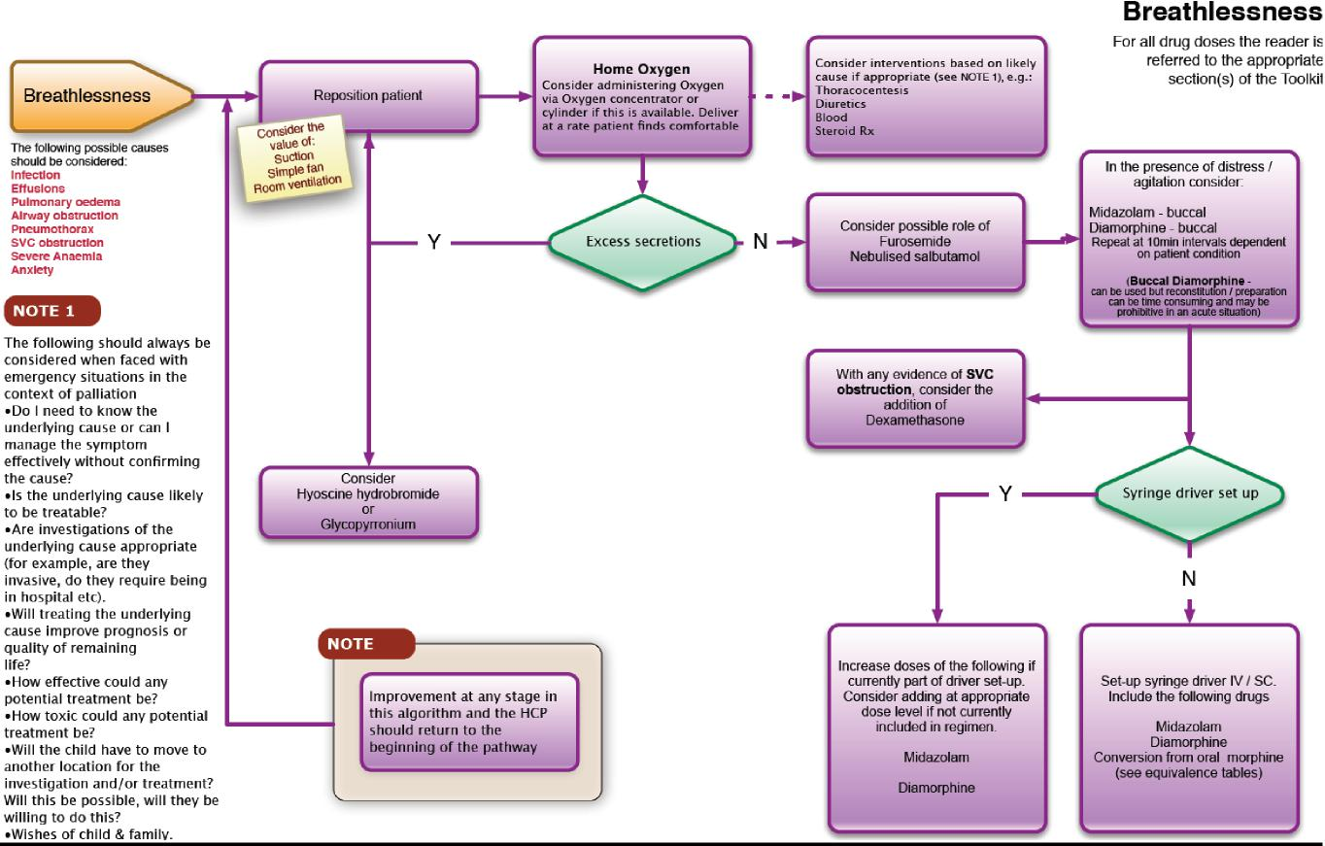

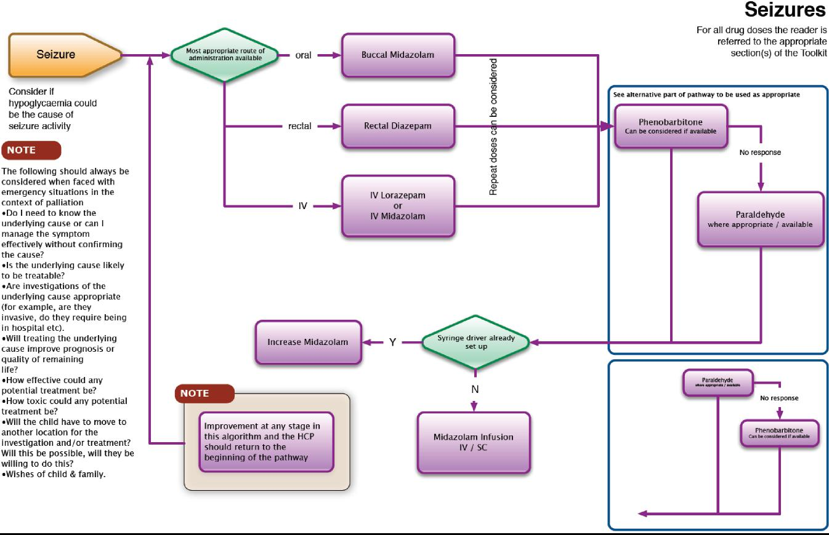

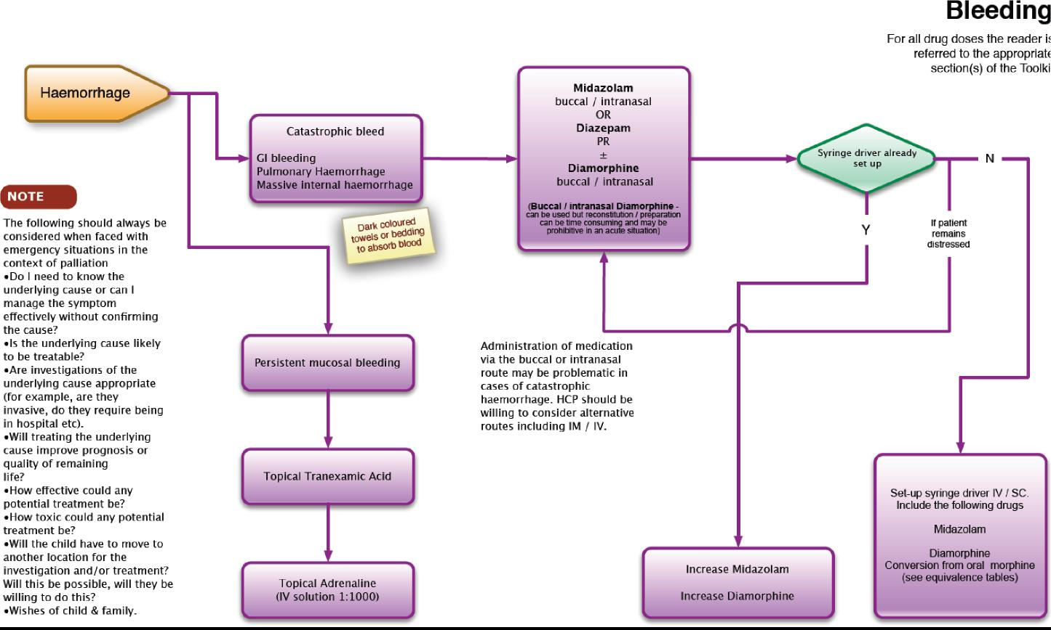

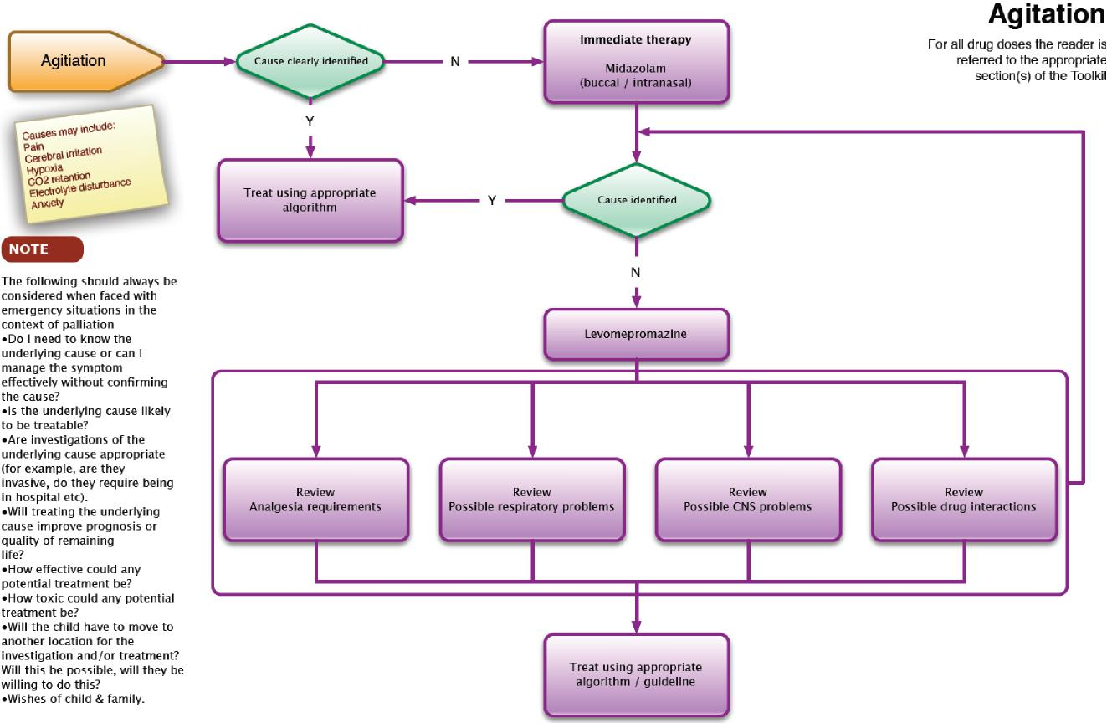

**Writing Prescriptions for Controlled Drugs**

Prescriptions for Controlled Drugs must meet legal requirements.

A prescription for Controlled Drugs (Schedule 2 and 3) must be written so as to be **indelible,** and may be hand-written, typed or computer generated. The use of pre-printed adhesive labels is **not** recommended to reduce the possibility of tampering.The legal requirements for a prescription for a Controlled Drug are as follows:

* The patient’s full name and address
* The patient’s age if less than 12 years.
* The name of the drug and the pharmaceutical form. Use of a brand name (e.g. MST) is acceptable (although the drug name is preferred) but the pharmaceutical form should always be included, even if it is implicit through the use of a brand name (e.g. MST tablets, not MST) or if only one form (e.g. tablet or injection) exists.
* The strength of the preparation (Strictly this is not required if only a single strength exists, but is best included to avoid problems arising from the prescriber being unaware of other available strengths, especially ‘Specials’).
* The dose to be taken. Whilst the dose to be taken (e.g. one tablet or 30mg.) must be explicit, this is not necessary for the frequency (although explicit instructions are preferred). Thus ‘One tablet to be taken twice a day’ is preferred; ‘One tablet to be taken as directed’ is acceptable but ‘To be taken as directed’ is not.
* The total quantity of the preparation, or the number of dose units, to be supplied, written in both words and figures. Since the strength to be supplied will be included (see above) the total quantity on a prescription for ten ampoules of Diamorphine 30mg. may be expressed as either 300 (three hundred) mg. or as 10 (ten) ampoules.
* The signature of the prescriber (this **must** be handwritten) and the date (which need not be handwritten). The date may be the date on which the prescription is signed **or** the date on which it is intended for treatment to start.

Additional good practice:

* Each medication prescribed each on a single prescription , so if a particular pharmacy cannot provide/access all medication .
* Include the patient’s age or date of birth (subject to the requirement noted above)
* Prescriptions for Schedule 2 & 3 Controlled Drugs should state the patient’s NHS number if known.
* The prescriber’s full name, address and telephone number (which should be the address and telephone number at which they can usually be contacted), CCG in which they are working (if in the community), profession and professional registration number should be provided. (Duplication of information already printed on the prescription is not necessary).

Any space on the prescription form that has not been written on must be blanked off, for example by drawing a line through it to reduce the opportunity for fraud.

* It is strongly recommended, although not a legal requirement, that prescriptions for Schedule 2, 3, & 4 Controlled Drugs are limited to a quantity appropriate for up to 30 days.
* If a prescription is written for supply for more than 30 days treatment the prescriber should document the reason in the patient’s notes and be prepared to justify their decision. Typically they may be contacted by the pharmacist dispensing the prescription because that person is required to satisfy themselves that the supply is appropriate.

Further information

* The maximum validity of a prescription (whether NHS or private) for a Schedule 1, 2, 3 & 4 Controlled Drug is 28 days from the date on the prescription (which may be either the date of signing or the date on which treatment should commence (see above)).

*Requirements around controlled drugs continue to change.*

*To ensure that the information is up to date and that it complies with your local Medicines Policies, please refer to:*

*Your local Medicines Policy*

*Children’s BNF*

*Department of Health website*[***www.gov.uk/government/organisations/department-of-health***](http://www.gov.uk/government/organisations/department-of-health)

*National Prescribing Centre is now part of NICE* [*https://www.nice.org.uk/about/nice-communities/medicines-and-prescribing*](https://www.nice.org.uk/about/nice-communities/medicines-and-prescribing)

*And cross reference with other recognised sources of information*

**Taking Controlled and Prescription Drugs to Other Countries**

Some patients receiving palliative care may wish to travel to other countries and need to take medication with them. Two sets of law need to be considered: that of the UK, and that of the country or countries to which you will be travelling, or through.

Because Regulations may change, patients or carers living in the UK are advised to check the latest Home Office guidance by contacting them directly or visiting their website:

**Drug and Firearms Licensing Unit**  
[dflu.ie@homeoffice.gsi.gov.uk](mailto:dflu.ie@homeoffice.gsi.gov.uk)  
Telephone: 020 7035 6330   
Monday to Friday, 9am to 5pm

<https://www.gov.uk/travelling-controlled-drugs>

<https://www.gov.uk/government/publications/personal-import-export-licence-application-form>

If you need to carry certain Controlled Drugs abroad (or in the case of an import licence, into the UK) for short periods for your personal use, or that of your child, may need a personal licence.

A personal import or export licence will be required if:

|  |  |
| --- | --- |
|  | you are travelling for three calendar months or more you carrying more than three months' supply |

You should apply for a personal licence at least ten working days before the intended date of travel.

**Travelling for less than three months**

If you are travelling for less than three months and you are carrying less than three month supply, you will **not** need a personal import or export licence to enter or leave the United Kingdom.

However, it is advisable to obtain a letter from your prescribing doctor which should confirm your name, travel itinerary, names of prescribed Controlled Drugs, dosages and total amounts of each to be carried.

If you are carrying prescribed medication(s) which are not Controlled Drugs you are also advised to obtain a letter to cover these drugs, or ask your doctor to include them with the letter regarding Controlled Drugs.

In either case, the personal licence or doctor’s letter and the medicines should

ordinarily be carried in your hand luggage so as to permit inspection by UK Customs or other officials.

Always check with your airline or carrier in advance of your travel date that carrying the entire amount of your medication in your hand luggage is allowed. This will be particularly important if you need to carry out of the UK volumes of liquid medicines (individually) greater than 100ml.

**Travelling for more than 3 months**

If you or your child are planning to stay away for more than 3 months you are advised to make contact with a doctor in the country in which you will be staying, and to obtain prescriptions for further supplies from that doctor. This will avoid any problems over the quantities of the medicines you intend to take with you.

However, you should be aware that not all medicines that are available in the UK will be available in the country you are travelling to.

Regulations in other countries

Other countries may have their own import regulations for Controlled Drugs and prescription medicines. We strongly advise you to check this with the UK­based representatives of the country or countries that you are travelling to or through.

You can find a list of Embassies, Consulates and High Commissions at:

<https://www.gov.uk/government/uploads/system/uploads/attachment_data/file/98058/embassy-list.pdf>

**For further information:**

Home office website – see above.

[www.palliativedrugs.com/palliative-care-formulary.html](http://www.palliativedrugs.com/palliative-care-formulary.html)

**Drug Compatibility In Syringe Pumps**

**Principles:**

Decisions about the most appropriate method by which to deliver treatment will be dictated not only by the patient’s clinical situation and preferences, but also the nursing support available, and when. As a guiding principle, drugs should not be given by CSCI if practical alternatives exist. Before prescribing or setting up a syringe pump, consider:

* Is the use of the drug merited?
* Can it be given by an alternative route?
* Does it need to be given as a continuous infusion? Will once or twice daily boluses be equally effective?
* Is there evidence, anecdotal as a minimum, that the mixture you propose is compatible?

The fact that it is common practice in palliative care to mix several drugs – typically between 2 and 4 – for delivery as a continuous subcutaneous infusion (CSCI) can mask the fact that this is contrary to the norms for parenteral therapy. These suggest that drugs should be given separately whenever possible.

The reasons for these norms are clear. Drugs are by their nature reactive chemicals and the more complex the mixture the greater the risk of incompatibility. The following factors will influence compatibility:

Properties of individual drugs: Certain drug combinations are clearly incompatible, reacting immediately and obviously through the production of a product that precipitates out of the solution.









Components of the formulation: The complexity of the mixtures created should not be underestimated. Even a solution of morphine in saline will have five components (Morphine and water molecules, and sodium, sulphate and chloride ions). Excipients in the formulations should not be ignored – additives present to enhance the stability of the original formulation of an individual drug will become part of the ‘cocktail’ for infusion with the potential for interaction (and toxicity).

Diluent: Compatibility of the individual drugs with the proposed diluent should be confirmed. Cyclizine is incompatible with Sodium chloride, particularly at higher concentrations, and for this reason Water for Injection (WFI) is commonly preferred as the vehicle for CSCIs.

pH: Whilst Sodium chloride 0.9% and Water for Injection (WFI) have essentially neutral pH (pH 7), Dextrose 5% is a (chemically) acidic solution with a pH of 4 – 4.5. Drugs will be compatible with different diluents according to their relative stability in solutions of different pH.

Concentration: Drugs will often be given in more concentrated solutions for CSCI compared with other parenteral routes. This is due both to the amount of fluid that can be delivered by the route of administration and the restricted volume that can be delivered from the syringe pump. Unfortunately, more concentrated solutions are inherently less stable. Whilst 10ml. syringes are commonly used for CSCI, 20ml. syringes may be more appropriate for more complex mixtures where the greater volume and lower concentration may help avoid compatibility problems.











Temperature: Differences in stability have been demonstrated for certain drug solutions between ITU/HDUs and ‘normal’ wards due to the fact that the ambient temperature in intensive care areas is typically warmer by 2 – 3oC. It is therefore not surprising that the stability of solutions delivered in palliative care will be affected according to whether the delivery device is at ambient temperature or worn under clothing or close to the skin.

Light: Some drug solutions are affected by light, which may require the delivery system to be covered throughout the period of the infusion.

Time: As always, the longer the conditions exist that enable something to happen, the greater the likelihood that it will. So an infusion set up to run over 48 hours is inherently more likely to change in some way than one that will run for only 24 hours.

Components of the drug delivery system: Certain drugs may be incompatible with components of the delivery system, and this may result in:

Loss of drug through binding to the material of the delivery system, and/or



Leaching of components of the plastic into the drug solution – Is the patient reacting to the drug or to one of these chemicals?

**Indicators of stability:**

The common assumption that a mixture is compatible if:

* No precipitate forms
* There is no colour change
* No gas is formed

**is entirely false!**

All that can be said with certainty about a solution that remains clear and colourless is that whatever is dissolved in it is soluble in the volume of diluent available. What the solution actually contains is unknown. The only way to ensure that any mixture is compatible is through laboratory assay using appropriate analytical techniques. However, a moment’s consideration of all the variables – not just the number of potential drug combinations, but also all the issues discussed above – makes it clear that such information will never be comprehensive.

Because it is impossible to confirm the stability of all the possible mixtures used in palliative care, a clear, colourless solution and apparent clinical efficacy have become accepted as proxies for compatibility. Given the difficulties noted above this is not completely unreasonable, but the potential pitfalls should be understood and considered:

*Scenario 1.*

Consider a mixture of two drugs. Drug A is potentially toxic and the dose requires careful titration. Drug B interacts with Drug A, reducing the amount available in the mixture by up to 30%. The patient is well controlled, and eventually Drug B is no longer required. The syringe is then made up with the same amount of Drug A alone, but now that the effect of Drug B has been removed the patient experiences toxicity.

*Scenario 2.*

A patient is generally well controlled on a mixture of Drugs C & D, but family report that symptom control is less good for several hours before the syringe is changed each day. Is this evidence of the cyclical nature of symptom severity or a result of a lack of stability or interaction between Drugs C & D such the amount of one or both is reduced to a sub-therapeutic level towards the end of a twenty four hour period?

**Useful references:**

PCF 3 Palliative Care Formulary, 2007. Ed. Twycross R and Wilcock [A. Pub. Palliativedrugs.com](http://A.Pub.Palliativedrugs.com). ISBN 978-0-9552547-1-0

The Syringe Driver: Continuous subcutaneous infusions in palliative care. 2nd. ed. 2005. Dickman A, Schneider J and Varga J. Oxford University Press. ISBN 978-0-19-856693-9

[**www.palliativedrugs.com**](http://www.palliativedrugs.com), PCM Palliative Care Matters, www.pallcare.info

**Drug Compatibility Charts**

Drug Compatibilities in syringe pump charts are available:

|  |  |
| --- | --- |
|  | ) From NAPP Pharmaceuticals at [www.palliativedrugs.com](http://www.palliativedrugs.com) |

Further information in the Toolkit re drug compatibilities in the syringe pump can be found in the ‘Drug Compatibility In Syringe pumps’ general guidance section (previous pages).

**CME T34 Syringe Pump**

**Syringe Pumps**

In palliative care the subcutaneous route of drug administration is often the most convenient. It has many advantages, including being seen as less invasive than intravenous therapy, not requiring venous access where such access may be difficult or impossible, being easily monitored for local irritation, and being easily relocated if such problems occur.

The network of small blood vessels provide good absorption of medication and parenteral drugs are often absorbed more rapidly than oral drugs. The subcutaneous tissue lies between the skin and the underlying muscle, it is made up of loose connective tissue and varying amounts of fat. It also contains cutaneous nerves, small lymph vessels and blood vessels.

When central venous lines are available syringe pumps such as the CME T34 can also be used so the medication is given intravenously.

It is also widely acceptable in the community setting, making it possible to manage patients at home when more invasive devices would preclude this.

Definition

A Syringe Pump is a portable battery-operated infusion device used to deliver drugs at a pre determined rate via the prescribed route.

Aims

To control symptoms in children and young people during terminal care.

Indications for use

|  |  |
| --- | --- |
|  | Child/Young person is unable to tolerate oral medication for whatever reason eg nausea and vomiting, dysphagia, intestinal obstruction, local disease  Other routes of medication ineffective or inappropriate  Child/Young person is unconscious or there may be a risk of inhalation if given orally  Paediatric terminal care – symptom management. |

**Contraindications**

In paediatric palliative care the CME T34 syringe Pump will be set to deliver the prescribed amount over a 24 hour period. If any other time is programmed into the device the person operating the syringe pump should consult CME **before** using the device.

**The device should not be used until advice has been sought and the device has been reprogrammed for 24 hours.**

**Advantages of using a syringe pump:**

 Delivers drugs at an even rate continuously, maintaining plasma concentration at an optimum therapeutic level therefore improving symptom control



Increases patient control, removing the fear and pain of regular injections

Allows delivery of drugs through a single site for a period of time Allows for combination of drugs via one route

Portable and light weight device therefore allows for independence and mobility

Accurate infusion timing

When used in conjunction with the locking box, it minimises the risk of syringe tampering/displacement (this is usually mandatory in some trusts/community teams)

**Disadvantages of using a syringe pump:**

Local site reactions from irritant drugs



Negative impact upon body image

Potential of technical problems.

Dose titration not possible without renewing whole infusion

Potential for psychological dependence on device

Barrel clamp arm on pump vulnerable to damage with rough handling

**Infusion Sites**

N.B: Check preferred method of wearing pump before selecting infusion site.

Anterior chest wall (above nipple line)

Anterior abdominal wall

Anterior aspect of thighs

Scapula region

Anterior aspect of upper arms (avoid in bed bound patients who

require regular turning).

**Sites to avoid:-**

Areas of broken skin



Areas of inflammation

Lymphoedematous limbs



Any area that has undergone radiotherapy should be avoided

Apply anesthetic topical cream as prescribed and/or required as clinical assessment indicates

Correct positioning of the needle is essential

***Cleansing and decontamination of the syringe Pump***

Cleansing should be carried out with a damp disposable cloth (use warm water and general purpose detergent only.) Dry thoroughly. If any additional cleansing is required e.g. threads of the screws the actuator moves along, contact the manufacturer for advice. The pump must not be submerged in water and if accidentally dropped in water it must be immediately withdrawn from use and sent to the a Service Department .

**The pump must not be cleaned with spray detergents. Clean with mild detergent and a damp cloth (preferably lint free)**

**Description of CME T34 Syringe Pump**

**The T34 syringe Pump must not be used unless the practitioner has attended and completed the appropriate self assessment competency training.**

The T34 is a small, lightweight, battery powered ambulatory syringe pump. It weighs approx 210g excluding battery and measures 169mmx53mmx23mm.

In paediatric palliative care the CME T34 syringe Pump will be configured to infuse over a 24 hour period and is set in mls/hour. If not do not use until advice has been sought from CME. The syringe pump will automatically calculate the rate of administration according to the volume in the syringe. **Please note this guidance should be used in conjunction with the CME T34 instruction sheet.**

Care of the skin site

The infusion site should be checked by a registered nurse at least every 24

hours for:

Pain/discomfort



Swelling/induration

Erythema/reddening

Leakage of fluid

Bleeding

**Setting up the Syringe Pump**

**Before commencing the syringe pump**

The child/ young person if appropriate and their parents should be prepared firstly to help understand the rationale for the syringe pump use, they also need to be educated on the functioning and safety of the device.

**Choice of syringe**

The T34 syringe pump is calibrated in mls/hour. The pump can be used with most brands of syringe. *Historically with the previous Graseby syringe drivers the most common size of syringe has been 10 and 20ml, however it has been more recently advocated that a 20ml syringe be the recommended minimum for several reasons (Dickman 2005)*

Larger dilution will reduce the risks of adverse site reactions and incompatibility



Larger doses of drugs can be administered where previously 2 x 12 hourly infusions would have to be administered

20ml and 30ml, luer lock syringes (in order to avoid leakage or accidental disconnection) are recommended for use with the CME T34 syringe pump and lock box.. These can be filled to a maximum of :

18ml in a 20ml



24mls in a 30ml

(due to the expansion of the actuator to accommodate the syringe)

**Equipment required**

CME T34 pump



9v alkaline battery,

Luer lock syringe, minimum 20ml e.g. Becton Dickinson (BD)

Administration device and extension set

Drug labels

Transparent adhesive dressing e.g. tegaderm

Prescription chart

Prescribed medicines/diluents

Filter needle to draw up drugs to avoid drawing up glass spicules which

have potential to cause abscesses

Lock box

Dressing pack

Sharps box

 Record of administration of drugs- WMPPCN Drug Administration Document

 Personal protective equipment (PPE)

 Hand decontamination equipment

**CME T34 syringe Pump feature recognition Keypad**

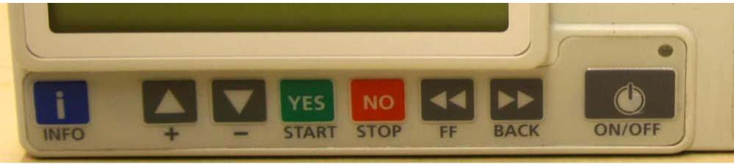

1. INFO Key use to access event log, set up, volume infused, battery status and activates keypad lock on/off
2. UP/DOWN arrow keys use to increase/decrease parameters/scroll options
3. YES/START key- confirms selection/start
4. NO/STOP- step back a screen/stop
5. FF (forward)-moves actuator forward
6. BACK-moves actuator back
7. ON/OFF

**Syringe Loading**

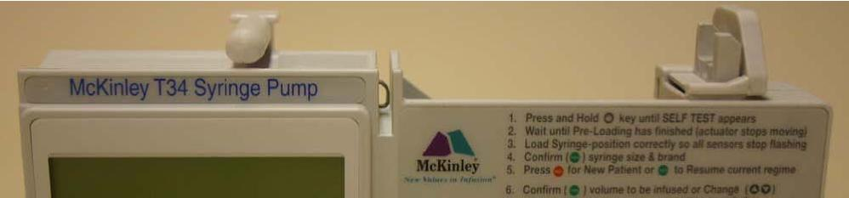

1. Barrel clamp arm- (detects syringe size/width of barrel/secures)
2. Syringe ear/collar sensor (detects secure loading of syringe collar)
3. Plunger sensor (detects secure loading of syringe plunger)

**NB : Procedure for first infusion or when changing the line – please note that the infusion will be completed in less than 24 hours as the line needs to be primed after the rate has been set to ensure the patient receives the correct dose of the drug prescribed.**

Step 1 - Prepare syringe

 Decontaminate hands as per local policy and apply PPE







Use a luer lock syringe of at least 10ml

Check compatibility of prescribed medications

Draw up and check prescribed medication. Transfer medication to l syringe size of choice. Invert syringe several times. Use diluent as per patient prescription to make up required amount for infusion

Label the syringe (name of patient, date and time of preparation, name quantity and batch number of all drugs and diluent, total volume of the contents to be infused, time they are to be infused over, initials of person(s) preparing infusion).

Attach label to syringe ensuring it doesn’t obscure visual scales or interfere with the mechanism of the infusion device i.e. where there is contact with the barrel clamp

Step 2 - Check battery life

 Switch pump on and allow the pre-loading programme to complete (movement of actuator on screw mechanism). Flashing syringe icon will appear on the screen.



Press the INFO key once, followed by single press of YES key battery level **will** appear on the display after a few seconds, screen will default to flashing syringe icon,

Verify that there is sufficient battery power for the programme (note a fully charged battery lasts approx 3-4 days). In the community, should the battery life read 35-40% at the start of a 24 hour infusion, change

the battery

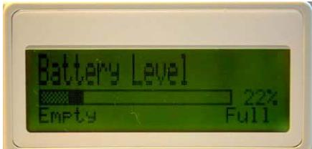

Step 3 - Pre loading and syringe placement

Install the battery into the syringe pump

Ensure the barrel clamp arm is down and press/hold the on/off key to turn the pump on. The LCD display will show “preloading” and the actuator will start to move.



When it stops moving “load syringe” will appear on the display (note the actuator always returns to the start position of the last infusion programmed)

If the actuator is not in the correct position to accommodate the syringe leave the barrel clamp arm down and use the FF or BACK buttons on the keypad to move the actuator.

Lift the barrel clamp arm

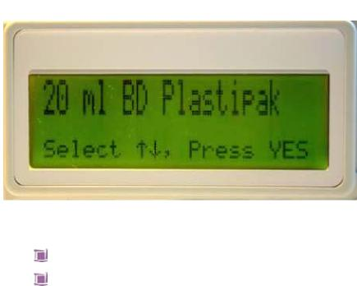

Seat the filled syringe collar/ear and plunger so the back of the collar/ear sits against the back of the central slot. The syringe collar/ear should be vertical.



Lower the barrel clamp arm

Confirm the syringe size and brand by pressing the YES button or use the up/down arrows to scroll through the other options for brand/size and press YES

The volume in the syringe will be displayed, press YES to confirm If the volume displayed does not match the volume in the syringe (allow +/- 5% system accuracy – pump & set combined), remove the syringe and start again

Step 4 - Setting infusion parameters

After the syringe confirmation the 1st screen which appears is the volume screen. Upon confirmation of the volume with the YES key, the screen below will appear



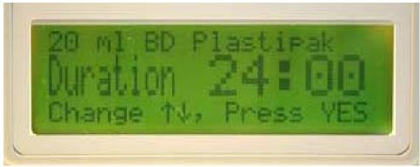

Press YES to confirm the duration of the infusion is to be 24 hours. Use the up/down arrows to scroll down if a different time of infusion is required. The syringe pump will automatically default to 24 hours the next time it is used.





The pump calculates and displays the rate of infusion, press YES to confirm

Step 5 – prime line

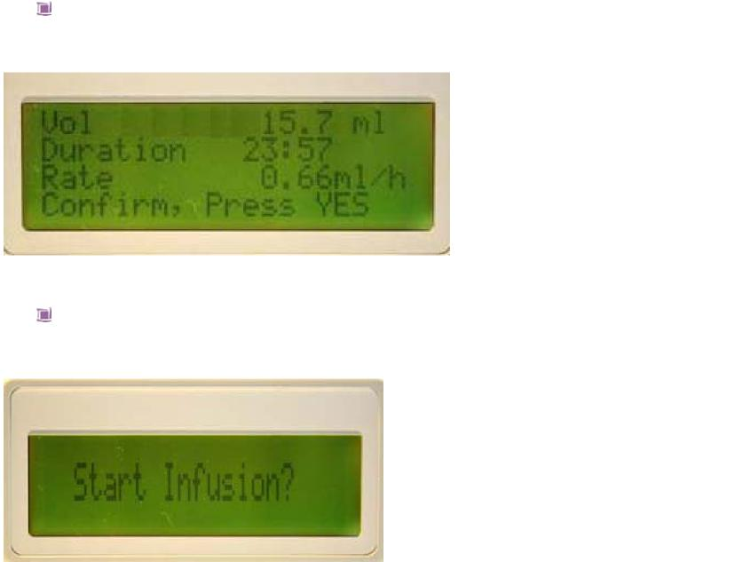

The summary screen confirms the volume to be infused, duration of infusion and rate in mls/hour. Press YES to continue

Pump prompts to START INFUSION?

Lift barrel clamp and remove syringe – **do not** switch the pump off

Place the barrel clamp arm back into the down position



Prime line

Re-adjust the actuator with FF key to accommodate new syringe

volume/syringe size

Lift up the barrel clamp arm

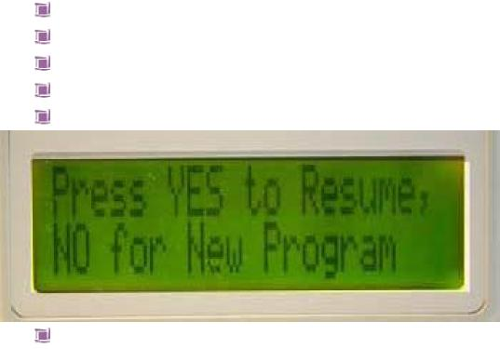

Re insert syringe

Lower the barrel clamp

Re confirm syringe size/brand

The following screen will be displayed



Press YES. The volume, duration and rate will be displayed (note the rate will remain the same but the duration of infusion will be less to take account of the amount in the primed line. Press YES

Pump prompts to Start infusion?

Step 6 - Connect syringe pump to patient



Insert the administration device into the subcutaneous tissue at the selected site

Secure with a transparent dressing. Include a loop of the infusion set under the dressing to avoid direct pull on the administration device Document drugs, diluent administered and time infusion commenced in patient record as well as medical devices information e.g. serial number

Step 7 – Start infusion

* The pump will still be displaying ‘start infusion’ Press YES (in the event that the ‘pump pause too long’ alarm has commenced, press YES key) this will return you to the ‘Start Infusion’ screen
* The pump will display the following screen which will remain throughout the infusion
* The Green LED indicator flashes

**NB** It can take up to 4-6 hours for drugs to reach therapeutic blood plasma levels therefore a breakthrough dose may be required during this initial period

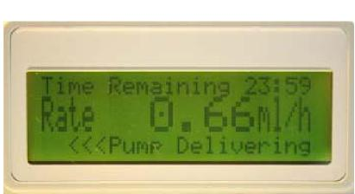

**NEVER TAKE A SYRINGE THAT IS NOT EMPTY OFF THE PUMP IF IT IS STILL CONNECTED TO THE PATIENT**

Key pad lock



The CME T34 allows all users to lock the operation of the keypad during the infusion. This function prevents tampering with the device and should be routinely used (most trusts/community teams make this a mandatory requirement)

To activate – press and hold the ‘INFO’ key while the pump is infusing until a chart is displayed showing a ‘progress’ bar moving from left to right. Do not remove your finger until a beep is heard otherwise the keypad will not have locked/unlocked

* Hold the key until the bar has moved completely across the screen and a beep is heard to confirm the lock has been activated. **NB** The YES/START, NO/STOP and INFO keys are still active
* To deactivate repeat the procedure. The bar will move from right to left and a beep will be heard

Step 8 – Infusion complete

* As the pump nears the end of the infusion it will alarm intermittently to alert you that it is almost complete
* When the infusion is complete and the syringe is empty the pump will stop automatically and the alarm will sound
* **If the syringe pump is no longer required** press ‘OFF’ then disconnect the infusion from the patient. - - Remove battery from syringe pump Clean the pump and lock box (do not immerse in water)
* **If the patient requires a further infusion** – switch pump off
* Remove syringe
* Repeat steps 1-4 as above
* At the **‘start infusion?’** prompt connect syringe to existing

set if site shows no signs of inflammation/irritation and then press ‘YES’

**Temporary interruption of infusion e.g. bathing**

Press ‘STOP’







Press and hold off button until beep is heard and screen will go blank Do not remove the syringe from the pump

**CME would recommend that the pump be taken down before entering the shower or the bath and that you do not secure the pump in plastic bags!!**

Neria needle -subcutaneous

Disconnect the line from the syringe and cap both the line and the syringe if using a needle/needle safe device. Give consideration to breakthrough medication whilst the child/ young person is disconnected from the syringe pump.

Via central line

If a central line is being used with the T34 syringe pump, check with your local policy and use all usual precautionary methods to protect the central line during a shower or bath. Reconnect the syringe pump to the central line using the ‘non touch technique’ as per policy as soon as the shower or bath is complete. Reassess child/ young persons pain after the shower or bath and consider the need for breakthrough medication.

Press and hold the ‘ON’ key until a beep is heard, the screen will request a conformation of syringe size and brand, press ‘YES’ to confirm

The screen will display –

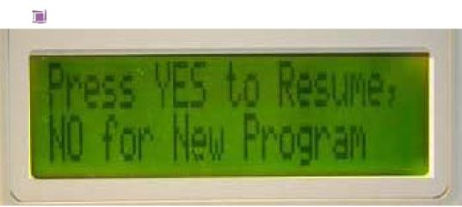

Press ‘YES’ - the screen will display volume, duration and rate of infusion, press ’Yes’ to confirm





**NB** if you press ‘NO’ the pump interprets this as a completely new 24 hour period and you would need to commence a completely new prescription from the start

Screen will display ‘start infusion?’

Press ‘YES’

The ‘pump delivering’ screen will now be displayed again

**What to do if a patient dies whilst the syringe pump is running.**

Leave the pump insitu until the child/young person’s death has been



verified by an appropriately trained person

Following verification of death - Press ‘STOP’

Record date, time and amount of solution remaining to be infused left in

syringe

Switch pump off

Remove syringe from pump, destroy contents as per policy .Document

and sign in the patient’s record.

Remove any needle/needle safe device from the patient

Remove battery from pump and clean pump/ lock box

***Care of infusion site***

|  |  |
| --- | --- |
|  | Transparent dressing should be used to enable visible monitoring of the site  If there is evidence of inflammation or poor absorption (hard subcutaneous swelling) the site should be renewed  The administration device/line should be renewed if there are signs of irritation/inflammation/device displacement |

**Care during infusion**

Explain care of the pump to the child/young person if appropriate and carers, including when the pump will alarm and procedure to be followed



Check battery each visit

Disconnect when taking a bath or shower and cap the ends of the syringe/line (see previous entry in guidelines re disconnecting the lines.) Record on the monitoring chart the length of time the infusion was stopped for.

***Checks whilst syringe pump is in use***

 Assess symptom control regularly



Check site for redness, inflammation, infection or administration device

displacement

Check syringe and line for signs of precipitation, crystallisation,

cloudiness or colour change of contents or leakage

Check the display – pump is delivering and infusion rate is as

programmed and record rate setting

Check the LED is flashing green

Press ‘INFO’ key to check

Single press – infusion summary – record VTBI (volume to be

infused) and VI (volume infused)

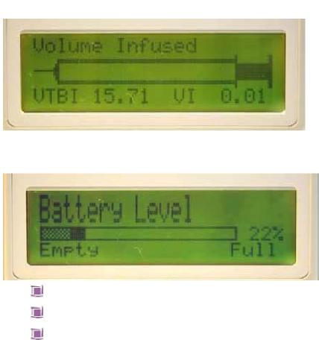

Double press – battery life remaining

**Visual** check of fluid remaining in syringe compared with pump reading Monitor patient for any signs of drug toxicity Record in child/young person record

***Reducing the risks of complications***

|  |  |
| --- | --- |
|  | Ensure child/young person has no allergies  Rotate the site of needle insertion  Ensure all drugs to be mixed are compatible  Be aware that certain drugs can be irritant to the skin  Try not to use more than 3 drugs in one infusion, if necessary set  another syringe pump infusion up and mark contents of each syringe  pump accordingly.  Ensure the administration device and lines are secured to reduce drag  and risk of disconnection |

**Troubleshooting**

|  |  |  |
| --- | --- | --- |
| **Problem:** | **Possible cause:** | **Action:** |
| The pump will not start | No battery present Battery inserted incorrectly  Battery is depleted/very low  Pump is faulty | Fit a battery  Re-align battery terminals Fit a new battery Service required |
| Infusion ended  early/going too quickly | Incorrect rate set Wrong syringe brand selected during set up  Pump faulty or incorrectly calibrated | Check displayed rate against  prescription change if necessary  Ensure correct understanding of user Service/calibration required |
| The pump has stopped before emptying syringe | Exhausted battery Faulty pump | Fit new battery, turn pump on,  confirm syringe size and brand  select to resume infusion Return for service |

**CME T34 Pump Alarms**

When the pump detects a problem four things occur

The infusion stops



An audible alarm is activated

A message appears on the display screen indicating the cause of the

alarm

The LED indicator turns red

The following table indicates the appropriate actions to be taken

|  |  |  |
| --- | --- | --- |
| **Alarm:** | **Possible cause:** | **Action:** |
| Occlusion or syringe empty | Patient access device blocked, kinked, clamped or occluded  Actuator has reached minimum travel position | Remove occlusion and restart or re-load syringe  Flush or replace access device  Release clamp  End of program, turn pump OFF |
| Syringe displaced | Syringe has been removed or displaced | Check & confirm syringe seated correctly and resume |
| Pump paused too long | Pump left or no key presses detected for 2 minutes | Start infusion, continue programming or switch off |
| Near end | 15 minutes from end of infusion | Prepare to change syringe or switch off |
| End program | Infusion Complete | Pump will either default to KVO (keep vein open) or it will alarm in which case switch pump off and await nurse to replenish/remove |
| Low battery | Battery is almost depleted (30 minutes left) | Prepare to change battery |
| End battery | Battery is depleted | Change battery |

This page is intentionally left blank

**Symptom Control Support Bag/box**

**For Use With a CME T34 Syringe Pump**

In addition to the ‘Just in Case Drug Boxes’ provided to support symptom control in end of life care in the community, it is also helpful to provide a ‘Symptom Control Support Bag’ that can be kept in the home containing items that might be required when delivering end of life care.

This list can be printed off and used as a check sheet when preparing the support bag.

It is useful to sign and date the sheet when contents are checked and correct.

**Equipment and Disposables**

CME T34 syringe pump

Spare battery 9V (6LR61) type X2 or rechargeable battery

Pump lock box

T34 Administration Sets:-

Length 100cm, prime vol 0.5ml with Anti-siphon valve x5

Dressing packs x 5

10ml Luer Lok syringes x 10

20ml Luer Lok syringes x 5

1ml syringes x 10

2ml syringes x 10

Red filter needles x 20

Blue needles x 20

Needle/needle safe device x 5

IV bungs x 10

Tape x 1 roll

Film dressing x 5

Hydrocolloid Thin dressing x 2

70% v/v Isopropyl alcohol and 2% w/v Chlorhexidine gluconate swabs x 40

bandage x 3

Gauze squares 5 x 5 cm x 5 packs

Drug additive labels x 10

Sterile gloves x 2 size 7/large

Sterile gloves x 2 size 5.5/medium

Small sharps bin

Plaster remover swabs x 10

Liquid soap

Hand decontamination equipment

Calculator

Post It notes

Pens x 2

Mouth care finger cots x 2

Dark coloured cotton hand towels x 2

Checked by Date

**Drug Administration Document**

The Drug Administration Document has been produced primarily to support symptom control in the final days of life within the community where a syringe pump may be required. It is for medical and nursing staff use only.

This document should be completed by the doctor or Independent Prescriber managing the child’s symptoms where a child is being discharged from hospital and is anticipated to need a syringe pump. When the document is initiated in the community, the doctor with responsibility for the child’s symptom control should complete the documentation. This would usually be the Paediatrician. GP’s would not normally be expected to write the initial instructions for the syringe pump use nor prescribe initial opiate doses in children.

The document enables the prescribed just in case syringe pump medications to be written in the document and instructions on their delivery to be given to provide authorisation for nursing staff to commence and continue the infusions when agreed as indicated. It also allows for increased doses, should symptom control require increased doses.

It provides for the documentation of all controlled drug use including stock taking of all strengths required.

Additional just in case medications and breakthrough medications can also be written up to provide authorisation for nursing staff to administer when needed Sheets follow this, along with a ‘Carer’s/Self Record’ for medication taken.

Example symptom control flow sheets are within the document to remind staff of the breadth of symptoms to be enquired of, and can be photocopied for daily use and handover support. (This sheet is also available separately in the Toolkit for ease of access).

Likewise, Pain control assessment tools are located within the Drug Administration Document and also, for convenience, in the Toolkit.

An important aspect of the Drug Administration Document is that it allows for all drugs in the syringe pump being administered at any one time to be able to be viewed together, so that safe interpretation of drug dose changes and symptom control measures being employed can be supported.

Please note carefully the requirements for its completion as indicated on the back page of the Drug Administration Document.

For further information contact : Sue Davies on : 07768930402

Patient’s Name: ____________________NHS No: _________________

Weight and date of weight: _______________________

**'Breakthrough' Medication Authorisation**

In case of___________________________________________________

______________________________________ (state symptom indication)

Please administer (drug, dose and frequency):______________________

__________________________________________________________

______________________________________ by ____________ route.

Further instructions: ____________________________________________

__________________________________________________________

Prescriber's signature: ____________ ___ Date: ________________

Print Name:

|  |  |  |  |  |
| --- | --- | --- | --- | --- |
| Date | Time | Dose | Signature | Was administration effective? |
|  |  |  |  |  |
|  |  |  |  |  |
|  |  |  |  |  |
|  |  |  |  |  |
|  |  |  |  |  |
|  |  |  |  |  |
|  |  |  |  |  |
|  |  |  |  |  |
|  |  |  |  |  |
|  |  |  |  |  |
|  |  |  |  |  |
|  |  |  |  |  |
|  |  |  |  |  |
|  |  |  |  |  |
|  |  |  |  |  |
|  |  |  |  |  |

Patient’s Name: ____________________NHS No: _________________

Weight and date of weight: _______________________

**'Just in Case' Medication Authorisation**

In case of___________________________________________________

______________________________________(state symptom indication)

Please administer (drug, dose and frequency) :______________________

__________________________________________________________

______________________________________ by ____________ route.

Further instructions: ____________________________________________

_________________________________________________________

Prescriber's signature: ____________ ___ Date: ________________

Print Name:

|  |  |  |  |  |
| --- | --- | --- | --- | --- |
| Date | Time | Dose | Signature | Was administration effective? |
|  |  |  |  |  |
|  |  |  |  |  |
|  |  |  |  |  |
|  |  |  |  |  |
|  |  |  |  |  |
|  |  |  |  |  |
|  |  |  |  |  |
|  |  |  |  |  |
|  |  |  |  |  |
|  |  |  |  |  |
|  |  |  |  |  |
|  |  |  |  |  |
|  |  |  |  |  |
|  |  |  |  |  |
|  |  |  |  |  |
|  |  |  |  |  |

**Ca­­­rers/Self Record of Medication Taken**

|  |  |  |  |  |  |
| --- | --- | --- | --- | --- | --- |
| **Date** | **Name of Medicine** | **Amount Given** | **Time Given** | **Reason Given** | **Effective Yes/No** |
|  |  |  |  |  |  |
|  |  |  |  |  |  |
|  |  |  |  |  |  |
|  |  |  |  |  |  |
|  |  |  |  |  |  |
|  |  |  |  |  |  |
|  |  |  |  |  |  |
|  |  |  |  |  |  |
|  |  |  |  |  |  |
|  |  |  |  |  |  |
|  |  |  |  |  |  |
|  |  |  |  |  |  |
|  |  |  |  |  |  |
|  |  |  |  |  |  |
|  |  |  |  |  |  |
|  |  |  |  |  |  |
|  |  |  |  |  |  |
|  |  |  |  |  |  |
|  |  |  |  |  |  |
|  |  |  |  |  |  |
|  |  |  |  |  |  |
|  |  |  |  |  |  |
|  |  |  |  |  |  |
|  |  |  |  |  |  |
|  |  |  |  |  |  |
|  |  |  |  |  |  |
|  |  |  |  |  |  |
|  |  |  |  |  |  |
|  |  |  |  |  |  |
|  |  |  |  |  |  |
|  |  |  |  |  |  |
|  |  |  |  |  |  |
|  |  |  |  |  |  |
|  |  |  |  |  |  |
|  |  |  |  |  |  |
|  |  |  |  |  |  |
|  |  |  |  |  |  |

*page intentionally left blank*

**End of Life Care Drug Box Contents Guide – Oncology Conditions:**

When a child is to receive their end of life care in the community, it is important that the appropriate drugs that may be required to support that child’s symptom control are readily available if needed, both in and out of hours. These drugs are prescribed in quantities to cover commencement over a weekend (+/- bank holiday) if needed, and are then replenished in the community as needed. They are known as the contents of the ‘Drug box’ or ‘Blue box’, and often as their ‘just in case medicines’. Children will not require all the following as contents of their drug boxes. However, the drugs that they may require in end of life care in oncology conditions are more likely to be drawn from within the following list. It can be used as a template to agree appropriate drugs to prescribe for an individual child, according to their presenting and anticipated symptoms.

|  |  |  |  |
| --- | --- | --- | --- |
| **Drug approved name** | **Generic name** | **Strength** | **Quantity** |
| Crotamiton Cream | Eurax |  | 1 x 30g. |
| Cyclizine | Valoid | 50mg. in 1ml. | 1 x 5 |
| Cyclizine suppositories |  | 25mg. | 1 x 12 |
| **Diamorphine.** |  | **10mg.** | **1 x 5** |
| **Diamorphine.** |  | **30mg.** | **1 x 5** |
| Diazepam. | Stesolid Rectal Tubes | 2.5mg. | 1 x 5 |
| Diazepam. | Stesolid Rectal Tubes | 5mg. | 1 x 5 |
| Glycerin suppositories |  | 1g. (Infant) | 1 x 12 |
| Glycerin suppositories |  | 2g. (Child) | 1 x 12 |
| Haloperidol |  | 5mg. in 1ml. | 1 x 10 |
| Heparin | Canusal | 100 units in 1ml | 1 x 10 |
| Hyoscine patch |  | 1.5mg. | 1 x 2 |
| Lidocaine | EMLA | 2.5% cream | 3 x 5g |
| Levomepromazine | Nozinan | 25mg. in 1ml. | 1 x 10 |
| Midazolam, injection | Hypnovel | 10mg. in 2ml. | 1 x 10 |
| Midazolam, buccal |  | 10mg in 1ml | 1 x 5ml |
| Morphine oral solution | Oramorph | 10mg/5ml | 1x 100ml |
| Ondansetron | Zofran | 4mg. in 2ml. | 1 x 5 |
| Relaxit enema |  |  | 4 |
| Sodium Chloride |  | 0.9% | 4 x 10ml. |
| Tetracaine | Ametop | 4% cream | 3 x 5g |
| Urokinase | Syner-kinase | 10,000 units | 1 |
| Water for Injection |  |  | 4 x 10ml. |

In addition, Tranexamic acid should be considered, along with hyoscine for infusion or glycopyrronium.

**End of Life Care Drug Box Contents Guide – Non oncology Conditions:**

When a child is to receive their end of life care in the community, it is important that the appropriate drugs that may be required to support that child’s symptom control are readily available if needed, both in and out of hours. These drugs are prescribed in quantities to cover commencement over a weekend (+/- bank holiday) if needed, and are then replenished in the community as needed. They are known as the contents of the ‘Drug box’ or ‘Blue box’, and often as their ‘just in case medicines’. Children will not require all the following as contents of their drug boxes. However, the drugs that they may require in end of life care in non-oncology conditions are more likely to be drawn from within the following list. It can be used as a template to agree appropriate drugs to prescribe for an individual child, according to their presenting and anticipated symptoms.

|  |  |  |  |
| --- | --- | --- | --- |
| **Drug approved name** | **Generic name** | **Strength** | **Quantity** |
| **Diamorphine.** |  | **10mg.** | **1 x 5** |
| **Diamorphine.** |  | **30mg.** | **1 x 5** |
| Diazepam. | Stesolid Rectal Tubes | 2.5mg. | 1 x 5 |
| Diazepam. | Stesolid Rectal Tubes | 5mg. | 1 x 5 |
| Glycerin suppositories |  | 1g. (Infant) | 1 x 12 |
| Glycerin suppositories |  | 2g. (Child) | 1 x 12 |
| Hyoscine injection |  | 400 [microgram.in](http://microgram.in) 1ml. | 1 x 10 |
| Hyoscine patch |  | 1.5mg. | 1 x 2 |
| Lidocaine | EMLA | 2.5% cream | 3 x 5g |
| Levomepromazine | Nozinan | 25mg. in 1ml. | 1 x 10 |
| Midazolam, injection | Hypnovel | 10mg. in 2ml. | 1 x 10 |
| Midazolam, buccal |  | 10mg in 1ml | 1 x 5ml |
| Morphine oral solution | Oramorph | 10mg/5ml | 1x 100ml |
| Relaxit enema |  |  | 4 |
| Sodium Chloride |  | 0.9% | 4 x 10ml. |
| Tetracaine | Ametop | 4% cream | 3 x 5g |
| Water for Injection |  |  | 4 x 10ml. |

In addition, glycopyrronium and phenobarbitone should be considered.

Where the child is a **neonate** please consider access to drug concentrations (eg morphine) and formulations (eg, omeprazole) that may be required as special orders. Where possible the neonate should be discharged from the neonatal units with the relevant concentrations. In particular, consider making available oral morphine sulphate solution 2mg in 5ml.

**Operational Policy For Children’s Symptom Control Drug Cases**

Children’s Symptom Control Cases and syringe pumps are the property of the NHS or Hospice and will be clearly marked as such. The Community Children’s Nursing Team will supply disposables and cases. Drugs will be placed in them when dispensed by the relevant pharmacy.



Once the decision has been made to implement terminal care at home/in the community for a child, the paediatrician will complete the prescription forms for the symptom control drug case and for a starting dose of Diamorphine infusion and any other infusion drugs that may be required. These will be taken to Pharmacy for the drugs to be dispensed and placed in the symptom control case, to be then kept at the family home (if place of care).



A member of the Community Children’s Nursing Team may bepermittedto collect the drugs from the appropriate pharmacy during normal working hours, but only do so for controlled drugs *if the family are unable to collect the controlled drugs themselves. Refer to Local Policy.*



On collection **of controlled drugs**, the quantities of drugs should be checked and signed for by the pharmacist and nurse in the space provided on the drug prescription sheet.



During delivery, the drug case should be locked in the car boot and not left unattended at any time. The drugs must be delivered from the pharmacy to the child/young person’s home and stops should not be made en route. *Where the nurse has delivered the controlled drugs, then on arrival at the child’s home, the nurse and a parent will sign to confirm the quantities of controlled drugs received in to the home.*



Copies of the Drug Administration Charts will be kept in the box and used for any drugs within the case. Drugs will be given only to the child named on the prescriptions and cannot be given to other children.



The Community Children’s Nursing Team will comply at all times with their local Trust policies and procedures for the administration of controlled drugs, including keeping a record of stock.



After the symptom control case has been used, the cases will be cleaned and restocked with disposables by the Community Children’s Nursing Team or the issuing hospital team. Any unused drugs will be destroyed by the appropriate pharmacy and the nurse and pharmacist should sign on the nursing disposal of unused drugs form to confirm that this has happened. Records of unused and destroyed drugs will be used periodically to review the list of contents.



**Paediatric Event Monitoring Form**

Prescriber or health care professional arranging medication

|  |  |
| --- | --- |
| GP/Nurse Name: | Date List 1 drug(s) were required: |
| GP/Nurse Address: | Drug(s) required from List 1:  (please also state quantities required) |

What time were drug(s) from List 1 requested?

* 9.00am to 6.00pm
* 6.00pm to 10.00pm
* 10.00pm to 9.00am

Did the first pharmacy/pharmacist contacted supply the drug(s)?

* Yes
* No

If NO, how many pharmacies/pharmacists were contacted before the drug(s) were supplied? .............................

Please indicate why the drug(s) could not be supplied

* Drug(s) were out of stock
* Insufficient quantities were in stock
* Pharmacist was unavailable
* Unknown
* Other (please state details)

Please give information about any other relevant details, or add any additional comments

Signature of Dr/Nurse: Date:

*Please return this form to: Lead Clinician*