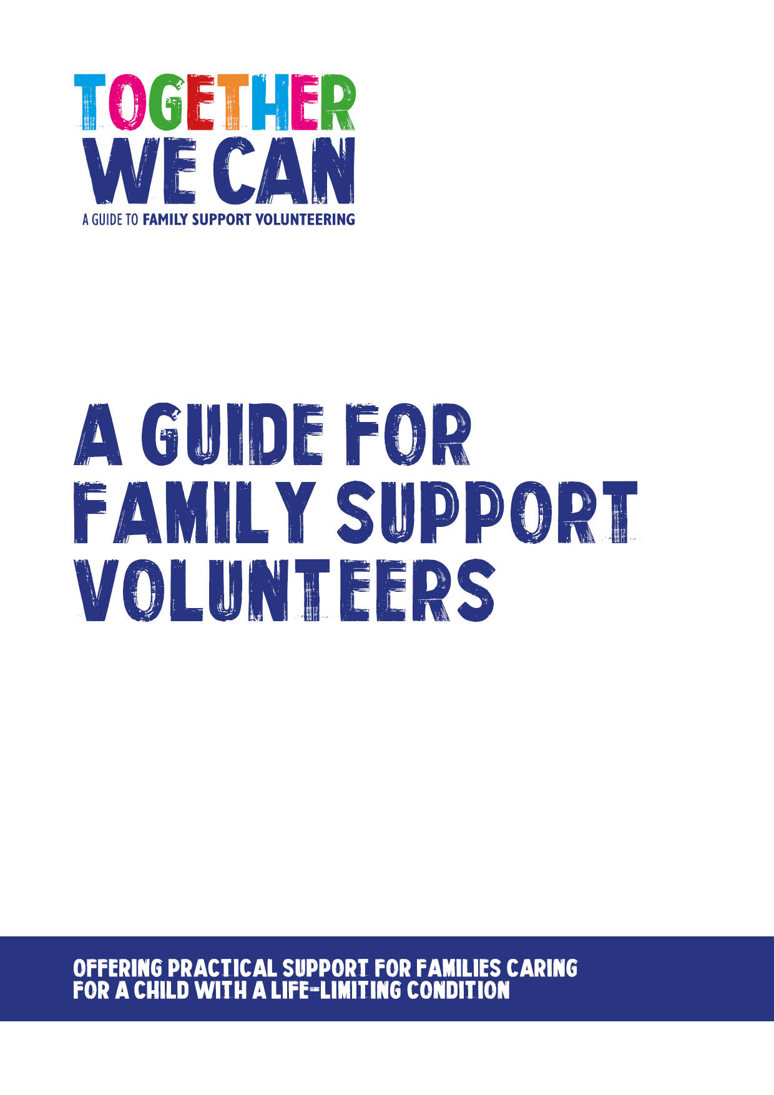
Together We Can is a collection of resources for organisations developing a service where volunteers support families of a child with a life-limiting or life-threatening condition. The resources were developed and tested specifically for this purpose with volunteers working in the homes of a child with a life-limiting condition, but might be useful for any organisation developing volunteer services.

A guide for Family Support Volunteers

Beginning in 2014, Volunteer Support for Families was a pilot project which aimed to test the feasibility of using volunteers to provide practical support to families accessing children’s palliative care services. The project aimed to test different models of volunteering in a range of voluntary and statutory services and encourage us all to re-think the role of the volunteer in this sector. It involved 9 UK organisations with expertise in children’s palliative care, volunteering or both, as follows: Children’s Hospices Across Scotland (CHAS), East Anglia’s Children’s Hospices (EACH), Jessie May Children’s Hospice at Home, NHS South Warwickshire Foundation Trust, NHS Whittington Health Trust, Noah’s Ark Children’s Hospice, Rainbow Trust Children’s Charity, Together for Short Lives and, Volunteering Matters. The pilot was initiated and co-funded by The Royal Foundation of the Duke and Duchess of Cambridge and Prince Harry, and the True Colours Trust.

Disclaimer

While great care has been taken care to ensure that the contents of this document are correct and up to date at the time of publishing, neither its authors nor its publishers can guarantee its correctness and completeness. The information contained in the document is intended for general use only and users should take appropriate steps to verify such information and as necessary obtain legal and/ or professional advice. None of the authors or the publishers accept responsibility for any loss, damage or expense resulting from the use of this information and no actions should be taken in reliance on it without relevant professional advice.

Contents Page

Part 1: Welcome and introduction to family support volunteering 2

1. Welcome 2
2. How to use this guide 2 3. Aim of family support volunteering 2
4. The role of family support volunteers 2-3 5. Becoming a family support volunteer 3
6. Disclosure and Barring 3-4

Part 2: Preparation and getting started 5

7. Expectations of each other 5
8. Organisational guidance and policies 6
9. Confidentiality 6
10. Preparation and training 6
11. Matching with a family 6-7
12. Guidance and support 7
13. Review and feedback 7

Part 3: Practical information - making it work 8

14. Unavailability, illness and time out 8
15. Reimbursement of expenses 8
16. Insurance 8
17. Health and Safety 8
18. Communication 9
19. Social Media 9
20. Problems and concerns 9

Part 1: Welcome and introduction to family support volunteering

- Welcome

Welcome to [Organisation]. We are very pleased that you have decided to offer your time and skills as a volunteer with us.

As volunteers, you bring a wealth of skills and experience and without you we could not offer this extra support to families who have a child with a life-limiting or life-threatening condition. Every volunteer has an important role to play.

[Organisation] aims to offer you the necessary training, induction and support to help you with your voluntary work. We hope you will enjoy your time as a family support volunteer and find opportunities not only to share your skills with us but also to develop these further.

The information in this booklet is intended to provide a helpful guide throughout your volunteering. Please take time now to look through it, ask any questions and keep it to hand as a resource if you need any guidance.

We are keen that this guide meets your needs. If you feel that there is anything that we have missed please let your manager know.

- How to use this guide

We hope this guide will be a useful reference for you during your time with us as a volunteer. It contains a wide range practical information and sets out how [Organisation’s] approach to volunteering is implemented in practice.

People may choose to use the guide in different ways. We would ask that you take time to familiarise yourself with the contents so that you can then use it to check for specific details as required.

- Aim of family support volunteering

The overall aim of family support volunteering is to:

- Enhance the family’s wellbeing and resilience through the provision of volunteer support with practical tasks.
- Help to reduce isolation and help to maintain family integration.
- Help families to connect with local community support networks.
- Raise awareness and increase community capacity and engagement.

- The role of family support volunteers

The role of family support volunteers is to provide flexible practical and social support to children, young people and families, to spend time being with families and to help in whatever way is best for the family. Some families may wish for ongoing support, whilst others may wish for occasional support and so there will be opportunities for volunteers who are able to give a regular commitment and those who can help out on an occasional basis.

Family support volunteering aims to offer a range of support to families. You will receive a role description before you start which outlines some of the activities that you may become involved in.

Some of the possible activities are listed below:

Practical support to families (e.g. ironing, shopping, gardening, transporting to appointments).
- Social support for siblings (e.g. supporting interests, play activities, helping with homework, taking out to activities).
- Administrative activities (e.g. keeping accurate records of visits to families and ensuring regular feedback to staff).

The following activities are not part of the volunteering role and you will not be asked to nor should you agree to:

- Be left alone with an affected child - the supervision of a parent or staff member is always required.
- Give medication or other medical care.
- Give personal care.
- Lift.
- Give financial help – e.g. withdraw money, handle any money on behalf of the family or sign cheques.

- Becoming a Family Support volunteer

[Organisation] welcomes applications from anyone aged 18 or over interested in becoming a volunteer. People who have been recently bereaved are advised to wait for a minimum of six months following the death of their loved one because coming to volunteer within a hospice and palliative care setting can often reopen recent losses and bereavements. This may be varied at the discretion of a senior member of the staff team and will be handled on an individual basis.

Initially we will give you as much information as we can about volunteering with us and ask you to complete an application form. Once you have sent this in, we will invite you for an informal interview with [Name, Job title] and another member of staff from the team. This gives us all an opportunity to get to know each other and make sure that you and the organisation are well suited to one another.

Two references will then be taken from people who have known you for a minimum of two years (e.g. former or current employers; college tutors etc.) and you will be asked to undertake a Disclosure and Barring check.

In order to minimise waiting time, following the interview and if you and the organisation are happy to proceed, you will then be enrolled on the family support volunteer training programme. This gives you another opportunity to see if this type of volunteering is right for you and for us to see if you are right for us. The training will also give you an opportunity to learn more about children’s palliative care, the needs of families, develop the skills that you bring and get to know other volunteers and staff.

- Criminal Records Check
Note: As legislation may change from time to time organisations are advised to check and update this section before issuing to volunteers.

[Organisation] is committed to providing a safe and protected environment for children at all times, therefore those volunteers working with children and young people in roles classed as ‘regulated activity’ will require a criminal records check with the Disclosure and Barring Service (DBS) or equivalent with acceptable vetting information being provided to the organisation where you plan to volunteer.

An unsatisfactory disclosure arising during the volunteer recruitment and selection process will result in the application not being progressed further. An unsatisfactory disclosure arising from an update during a volunteer’s time with [Organisation] will also result in them being unable to continue as a volunteer.

DBS Referral

Organisations with roles which are considered to be ‘regulated activity’ have a legal obligation to notify the DBS or equivalent if a member of staff or volunteer has harmed or posed a risk to a child or vulnerable adult whilst working for the service.

Please do ask your manager if there is anything that you are unsure of.

Part 2: Preparation and getting started

- Expectations of each other

When you start as a volunteer with the [Organisation] we will ask you to complete a Volunteer Agreement. This sets out what you can expect from the us and what we expect from you. We will ask you to sign the agreement once you have completed the family support volunteer training programme. A copy will be kept in your file and you may take a copy for your own records.

[Organisation] is committed to:

- Valuing and respecting your skills, dignity and individual needs.
- Providing support and supervision throughout your volunteer experience.
- Providing you with an induction and training programme.
- Explaining the standards we expect and encouraging and supporting you to achieve and maintain them.
- Providing a named person who will be your point of contact whilst volunteering.
- Doing our best to help you develop your volunteering role with us.
- Honouring the time agreement you have agreed to give us and not expecting more from you unless offered and agreed.
- Ensuring you know what to do to stay safe and how to safeguard others, in accordance with our Health and Safety and our Safeguarding guidance.
- Offering you opportunities to feedback and contribute to organisational developments.
- Offering you opportunities to discuss concerns or problems relating to your role.
- Reimbursing reasonable out-of-pocket expenses following procedures set out in our expenses policy.
- Providing adequate insurance to cover volunteers whilst undertaking volunteering approved and authorised by us.
- Trying to resolve fairly any issues or difficulties you may have whilst you volunteer with us before they become problems. In the event of an unresolved problem, to address these in accordance with the relevant policies.

[Organisation] asks you to:

- Perform your volunteering role to the best of your ability.
- Be open and honest with us.
- Show commitment to the organisation and be reliable and punctual.
- Show courtesy and respect to children, young people, families, fellow volunteers and staff.
- Work as agreed in your volunteer role description and within role boundaries.
- Work within the organisation’s frameworks, policies and procedures.
- Familiarise yourself with policies and guidelines and ask if you are not sure what to do to.
- Maintain the confidential information of the children, young people, families and [the organisation].
- Actively engage with all support and supervision.
- Attend all initial and any ongoing training.
- Meet time and other commitments as agreed, but when unable to do so, give reasonable notice so that other arrangements can be made.
- Keep records and complete any administrative paperwork as required.
- Discuss any concerns with your manager or another member of staff.
- Return any loaned equipment when ending your volunteering.

- Organisational guidance and policies

To ensure that the family support volunteering works safely and effectively there are guidance and policy documents on which all the work we do is based. Your manager will discuss these with you and we would ask that you become familiar with these, ask if there is anything you don’t understand and work within these during your time with us.

- Confidentiality

As a volunteer you are responsible for maintaining the confidentiality of all information relating to children, young people and families, staff, volunteers and the business of the organisation. You should not disclose any information about children, young people and families without their permission. When this agreement is sought, you should explain to the person how the information will be communicated and for what purpose. Failure to keep confidentiality will be considered to be very serious and may result in you being asked to stop volunteering.

In exceptional circumstances, you may disclose information obtained during the working relationship with the children, young people and families in the interests of the safety of the person and/or others. In advance of this disclosure, whenever practicable, you should try to seek the person’s permission and you should also seek advice from your manager.

You must ensure the confidentiality of any records that you keep about your support to families. These records are confidential to you and the relevant organisation staff. If these are stored on a home computer (personal or shared) or other electronic device, these must be password protected to ensure that these cannot be accessed by others in your home. If these are held on paper, secure storage of these is also required. It is advisable to agree a coding system with the organisation to ensure that there are no names on the record.

Confidentiality is covered in more detail in the family support volunteer training programme but do please ask about anything you are not sure of in relation to confidentiality.

- Preparation and training

As previously mentioned as part of recruitment and selection, you will be asked to undertake the family support volunteer training programme as part of the assessment and preparation for the role. In addition you will have a local induction to familiarise yourself with the organisation where you are based.

The training programme will last approximately [XX] hours and will help to prepare you for supporting families and give you confidence in your volunteering role. It will cover areas such as: introduction to the organisation, introduction to children’s palliative care, volunteer roles, responsibilities and relationships, the needs of families caring for a child with a life-limiting or life-threatening condition, loss grief and bereavement, reflection, self-care and resilience. Ongoing training will be provided as required.

Once you have satisfactorily completed all aspects of the training you will then be matched with a family. You may also be asked to shadow a member of staff or experienced volunteer as an observer on one or two home visits and before being matched with a family.

- Matching with a family

The staff will have identified families who would like to have the support of a volunteer. Families will be referred to [Name. job title], who, in conjunction with the member of the care staff team, will make a match with a suitable volunteer. [Job title] will introduce you to the family.

[Organisation] recognises that sometimes families and/or volunteers may feel that the match does not work for them. If you feel that the match does not work for you, you should raise this with your manager as soon as possible so that alternative arrangements may be put in place for you and for the family.

You will be asked to keep a record of your visits to families and will receive an outline of the information required from your manager.

NB There can sometimes be a delay after you have been recruited before you are matched with a family as matching volunteers and families can take time. However, the [Name, Job title] will keep in contact with you during this time to keep you updated.

- Guidance and support

During your time with us as a volunteer it is essential that you feel you have the help and support you need in your role. [Name, Job title] will be your main point of contact but there may also be another member of the team who will also be able to offer you guidance and support.

Support and supervision arrangements will be made to help you in your role, to assist effective working, personal development, self-care and resilience. Support and supervision will also offer opportunities for reflection and learning. It is important that you make a commitment to use of the support networks available and attend supervision sessions.

However, you should feedback to staff immediately about anything that you are unsure of or concerned about.

- Review and feedback

Review and feedback is vital to the smooth running and ongoing development of the family support volunteering. This will happen from the beginning through informal discussion and team meetings. We will ask for your ideas and feedback, in addition to that of families and staff, as part of ongoing evaluation and we will share this with you so that we can continually improve and develop our support to families. You are strongly encouraged to raise any concerns as they arise and not to hold on to these until the next one-to-one or review meeting.

Part 3: Practical information – Making it work

- Unavailability, illness and time out.

Please let [Name, job title] know if you are not going to be available for any reason. It is important to give as much notice as possible so that alternative arrangements for the family may be arranged.

We would also ask you to be thoughtful if you develop any potentially infections conditions. Because many of the children and young people may have lowered immunity and the consequences of infections can be serious. If you should develop sickness and diarrhea or any other potentially infectious condition, please let the [Name, job title] know as soon as you can. You should not have any contact with children, young people and families or attend organisation where you volunteer for at least 48 hours after sickness and diarrhea symptoms have subsided.

There is a wide range of factors which may lead to a volunteer wishing to take time out from working with families. These may include personal or family illness or a significant life event including bereavement. We will support you should you wish some time away from volunteering. Please discuss this with [Name, job title] as soon as you can so that alternative support may be organised for the children, young people and families.

- Reimbursement of expenses

You are strongly encouraged to claim reasonable actual out of pocket expenses incurred in the course of your volunteering. Travel: bus, train or car will be reimbursed, as will any telephone calls made from home as an agreed part of your voluntary role. All receipts or travel tickets must be kept and accompany your completed expenses claim form. Expenses claim forms can be obtained from your manager. Mileage will be reimbursed at the current organisation mileage rate and in accordance with their policy on expenses.

16. Insurance

All registered family support volunteers are covered by [Organisation’s] insurance policies. This cover will include Employers Liability, Public Liability, and Personal Accident policies. Volunteers driving the organisation’s vehicles will be covered by vehicle insurance from the organisation. However, volunteers using their own vehicles must have comprehensive vehicle cover that covers the volunteer for volunteer use; business use is insufficient.

17. Health and Safety

[Organisation] requires that all volunteers and staff exercise a duty of care to themselves and others with regard to Health and Safety. You are required to follow [Organisation’s] Health and Safety Policy and procedures, to co-operate in maintaining healthy and safe conditions and to avoid actions which may be harmful to the health and safety of yourself and others.

You should not undertake any activity where you feel there is an element of risk attached to the task. You should discuss any concerns with your manager or other member of staff and only when the issue is resolved should the volunteer undertake the task/activity.

Please ask about anything that you are unsure of.

18. Communication

Good communication is a shared responsibility and is essential to safe and effective working. Staff will work to ensure effective and regular communication in order to keep you up to date with what is happening in the organisation. You also have a responsibility to make every effort to keep up to date with all information provided and to ask if there is anything that you are unsure about.

Teamwork is key and it is really important that staff and volunteers communicate well with each other to ensure effective team working.

19. Social Media

Social media is a popular and fast developing way of communicating. You should always consider carefully the information you disclose on social networking sites. You should make sure that nothing you do on social media reflects negatively on the organisation.

In order to protect yourself, children, young people and families, and the organisation where you volunteer, you are asked not to feature these children, young people and families on social media and not to accept invitations to be social media friends from the children, young people and families.

Please read and become familiar with the Family Support Volunteer Social Media Policy and ask if there is anything that you are unsure of.

20. Problems and Concerns

[Organisation] is committed to providing high quality support to children, young people and families and to volunteers and staff. It is fundamental to good communications that good working relationships are established and maintained between volunteers, staff and children, young people and families. With a spirit of trust and respect between people working together, the number of occasions when serious problems arise should be minimal. However, if they do, it is important that guidance exists on how to deal with the situation.

If you have concerns about your experience as a family support volunteer you should first speak to your manager. The aim is always to resolve issues locally whenever possible. If this does not solve the issue you should read the [Organisation’s] Volunteer Policy and Procedures document and follow the steps laid out in the section on dealing with problems and concerns.

If your volunteering work does not meet with [Organisation] expectations or standards [Name. job title] and/or a member of the staff team will talk this through with you as laid out in [Organisation’s] Volunteer Policy and Procedures document in the section on dealing with problems and concerns.

There may be times however when the situation is so serious that the volunteer may be asked to stop volunteering at an earlier stage in the process. Situations that would be considered very serious include: fraud, theft, serious breach of confidentiality, inappropriate behaviour towards children, young people and families, fellow volunteers or staff (e.g. harassment, bullying, violence, social media incidents, breakdown of working relationships etc).

Thank you for considering volunteering with [Organisation] and we look forward to talking to you.

Acknowledgements

Author: Dr Ros Scott
Voluntary Sector Consultant

We would also like to acknowledge the contribution to the review and development of these materials from:

Lizzie Chambers Development Director, Together for Short Lives

Paul Crawte National Coordinator for Family Support Volunteers Project Together for Short Lives

Members of the Expert Advisory Group

Emma Aspinall Director of Care Services, Acorns Children’s Hospices

Anna Gill Board Member, Together for Short Lives

Tracy Rennie Director of Care, East Anglia Children’s Hospices (EACH)

Tom Smith People Development Manager, Noah’s Ark Children’s Hospice

Dr Justin Davis-Smith Executive Director of Volunteering, National Council for Voluntary Organisations (NCVO)

