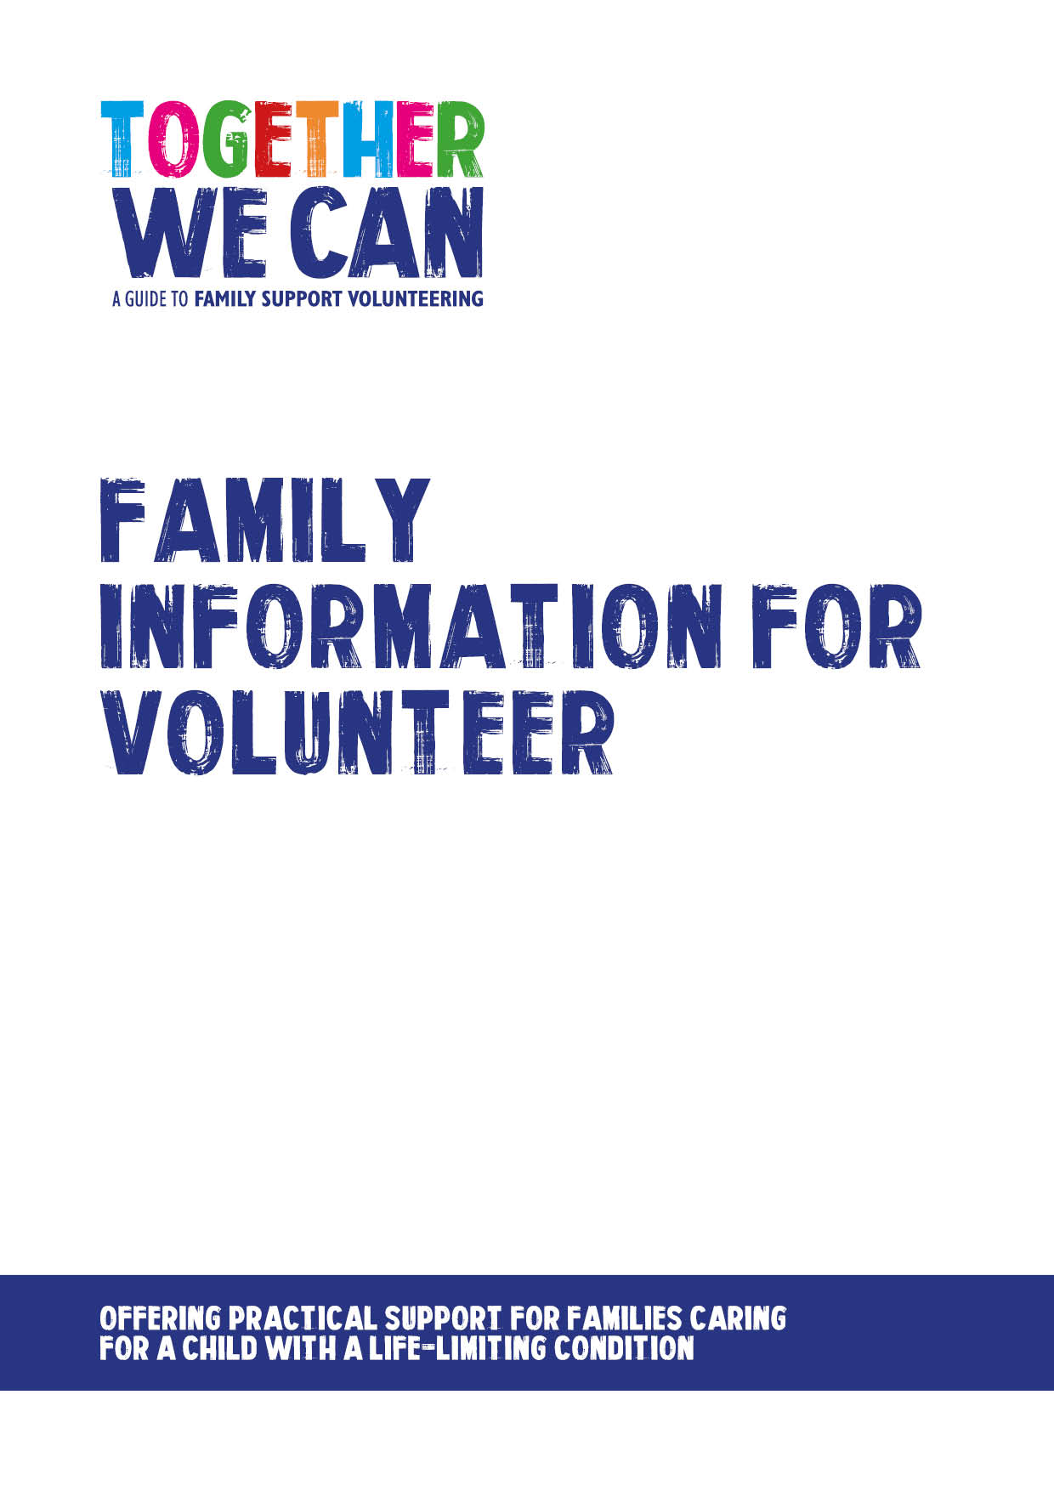This document was donated by Rainbow Trust Children’s Charity as an example. You may wish to adapt it for use in your own programme.
Together We Can is a collection of resources for organisations developing a service where volunteers support families of a child with a life-limiting or life-threatening condition. The resources were developed and tested specifically for this purpose with volunteers working in the homes of a child with a life-limiting condition, but might be useful for any organisation developing volunteer services.

Family Background sheet for Volunteer Placement
This document should be password protected for sending to the volunteer.
Parents/Carers details
Name | Address
Name | Address
Children’s Details
Name | Age | Any relevant information including diagnosis
Family contact tel no. for emergency use only

Are there any risks the volunteer should be aware of e.g. dog/ lack of parking

Are there any safeguarding concerns the volunteer should be aware of?

Is there any further information regarding the family that would be useful and relevant for the volunteer?

Family ID from Ecco for volunteer to use on record sheets

