Children and Young People’s

Palliative Care Toolkit

Chapter Two

Planning for Palliative Care.
West Midlands Children and Young People’s
Palliative Care Toolkit Working Party
On Behalf of the
West Midlands Paediatric Palliative Care Network
A Department of Health Funded Project

Table of Contents – Chapter 2

Facilitating Rapid Discharge from Hospital ………………………………………….. 3

Approaching Symptom Management in Palliative Care …………………………… 4

Managing the Spectrum of Symptoms in Palliative Care …………………………. 6

Parents Symptom Control Information …………………………………………………7

Algorithms to Support Urgent Symptom Management Out of Hours ……………8

Writing Prescriptions for Controlled Drugs ………………………………………….15

Taking Controlled and Prescription Drugs to Other Countries ………………….17

Drug Compatibility In Syringe Pumps ………………………………………………..19

CME T34 Syringe Pump ……………………………………………………………….. 22

Symptom Control Support Bag/box For Use With a CME T34 Syringe Pump ..37

Drug Administration Document Carers/Self Record of Medication Taken ……39

When a Child Dies at Home …………………………………………………………….40

Facilitating Rapid Discharge from Hospital

Many families who find themselves in the terminal care stages with the likelihood that their child may only survive for a few days will want to make choices about their place of care. If the child is in hospital, that choice may be to spend those final days at home if appropriate support can be provided, or to spend the days in a hospice setting.
Some such families will have already considered their wishes for such a time and will have documented aspects around this in their Advance Care Plan. Others will not have been able to reach clear decisions about their child’s management in the terminal days and will need to be helped to determine what is best for them as a family.
Where the families choice is to be at home or hospice for their final days and for the death to take place at home or hospice, and the community team/hospice have confirmed that they are able to support this, then the Discharge for End of Life care document can be used . This will enable the child and family to be discharged home or to a hospice as swiftly as possible to care that will provide the opportunity to remain at home or within a hospice setting with all resources required to meet their anticipated needs.
The Discharge for end of life care document has therefore been developed and along with it, the Guidance to support its effective use. This can be found in Chapter 1 of the toolkit.

Approaching Symptom Management in Palliative Care
Please see Drug Algorithms, the APPM Master Formulary 2017 & the, Children’s BNF etc for further information
As in all children who are unwell it is important to ensure thorough assessment and regular reassessment of their symptoms. Talk with those involved with the child before assessing to gain as clear a picture as possible:
- Make sure that all symptoms are enquired about – it is not uncommon for only some of the child’s symptoms to be presented as these may have been the initial main problems and remain focused upon at reassessment.
- Ensure all symptoms are addressed as part of a holistic assessment, including physical, psychological, spiritual and social
- Enquire about subjective symptoms such as dyspnoea, nausea, where observation alone will be inadequate.
- Remember that parents know their child well and their observations are key to understanding the child’s symptom progression and it’s impact upon them and the family.
When assessing a child consider:
- What do we know about this condition and its likely presentation in end stage disease? What does the literature tell us about this?
- How have we seen this condition specifically presenting in this particular child over the recent past – what complications have been evident? Take a thorough history, talk with the family, local and specialist staff.
- What are the child’s symptoms at present? Take a thorough history and examination. Are the symptoms being adequately managed or are they becoming increasingly problematic? What has already been tried and with what effect?
- With these points in mind, what might we expect to present as palliative care emergencies in this child?
In the light of this:
- Explain the symptoms and their management to the child and their family as appropriate and in a manner that enables them to understand and take some control in their management.
- Discuss a plan to manage the symptoms with them that is acceptable to them and takes account of wishes regarding treatment modes etc - dislike of capsules, injections etc.
- Talk through the potential complications and their management with the palliative care team, the primary care team, and as appropriate, with the family/carers.

It is better to be prepared in anticipation to support calm management in the event of their occurrence, than to be unprepared.

- Ensure that family and staff know how to access care including 24hr advice.
- Ensure that you reassess the situation after an agreed time period, listening to the family and staffs concerns.
- Communicate well between professionals and family, ensuring clear documentation of symptom progression and management.
In all of your assessments:
- Ensure that you have time to adequately listen and assess
- Take each decision with adequate reflection upon the factors involved
- Discuss regularly with colleagues
- Don’t be afraid to say that you don’t know and be willing to seek advice from others

In terms of treatment:
- Keep treatment as simple as possible
- Stick to one drug per symptom where possible

- Involve the child & family in decisions re treatment choices
- Manage with oral preparations where possible
- Plan for anticipated symptoms
- Listen to the child & family’s account
- Ensure management is reviewed in an agreed manner
- Consider the use of a syringe pump if the child is:
No longer able to absorb oral medication
Vomiting
Having difficulty swallowing and has no NG tube/gastrostomy
Is not fully conscious
- Remember to check compatibility of any drugs in a syringe
pump and never put more than three drugs in any one pump.

For the oncology/haematology children it is useful to agree a protocol
for the administration of blood products support, before a crisis is
reached. This should be based on the instructions of the child’s
consultant.
Regularly review the overall medications being given. Do all remain
necessary? Consider rationalising drug use, especially in the final days.

Managing the Spectrum of Symptoms in Palliative Care
It is essential to assess all possible symptoms. The Symptom Control Aide memoire within the Toolkit and within the Drug Administration Document can be used to support this, ensuring all symptoms are enquired about.
The following outlines key points when considering the range of symptoms that may present.
Further more detailed information can be found in the Rainbow’s Symptom Control Manual.
www.togetherforshortlives.org.uk/resource/basic-symptom-control-paediatric-palliative-care/

Parents Symptom Control Information
Parents tell us how important it is to have written information to support their understanding of their child’s condition and its symptoms, actual or anticipated, and of the approach that will be taken to manage them.
A resource developed by CCLG to support parents can be found in the front cover of this toolkit. It is entitled ‘Managing Symptoms at Home’. The relevant sections can be photocopied and given to the parents at their pace, when they are ready to hear more about their child’s symptoms and their management.
Be selective as to the sections you give to the family, as not all will be relevant to all children.
The booklet has been written with Oncology conditions in mind, but there are aspects that will support parents of children with non oncological conditions.
Make sure that you discuss the symptoms and their management with the family. The document is a supportive, supplementary tool, not a substitute for face to face discussion. Used appropriately, families will feel more in control of the situations they may have to face.

Algorithms
to Support Urgent Symptom Management Out of Hours
The following algorithms have been developed to support urgent decisions that may need to be taken to manage symptoms effectively out of hours when specialist advice is not readily available, in end of life care.
They provide a guide to the approach to the symptom management and to the possibilities for drug choice and other means of symptom management.
Where a drug is to be considered, its dosages can be found in the APPM 2017 or the BNF for children.
Wherever possible symptoms should be anticipated both in terms of how to manage them and in terms of the drugs that would be required to do so. The advice within the algorithms acts as supplementary information at times of unexpected events that may at times occur in end of life care.

The Algorithms relate to:

Nausea/Vomiting Breathlessness Seizures

Pain
Bleeding and
Agitation

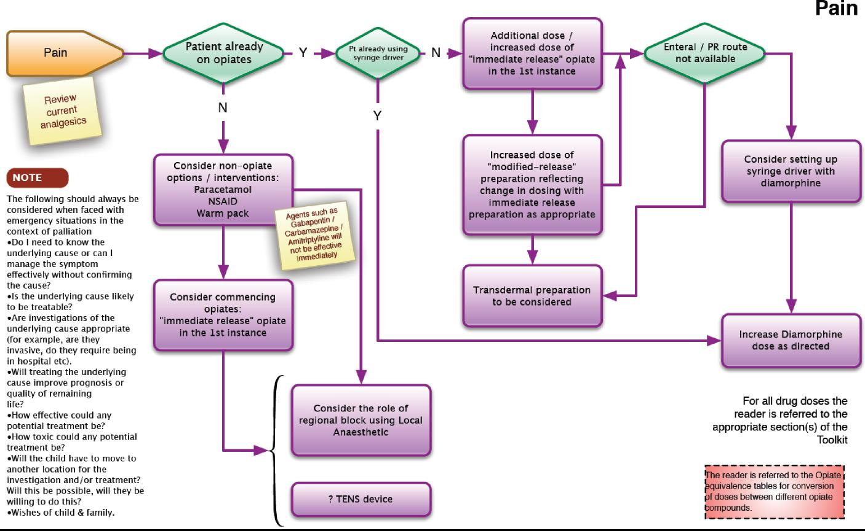

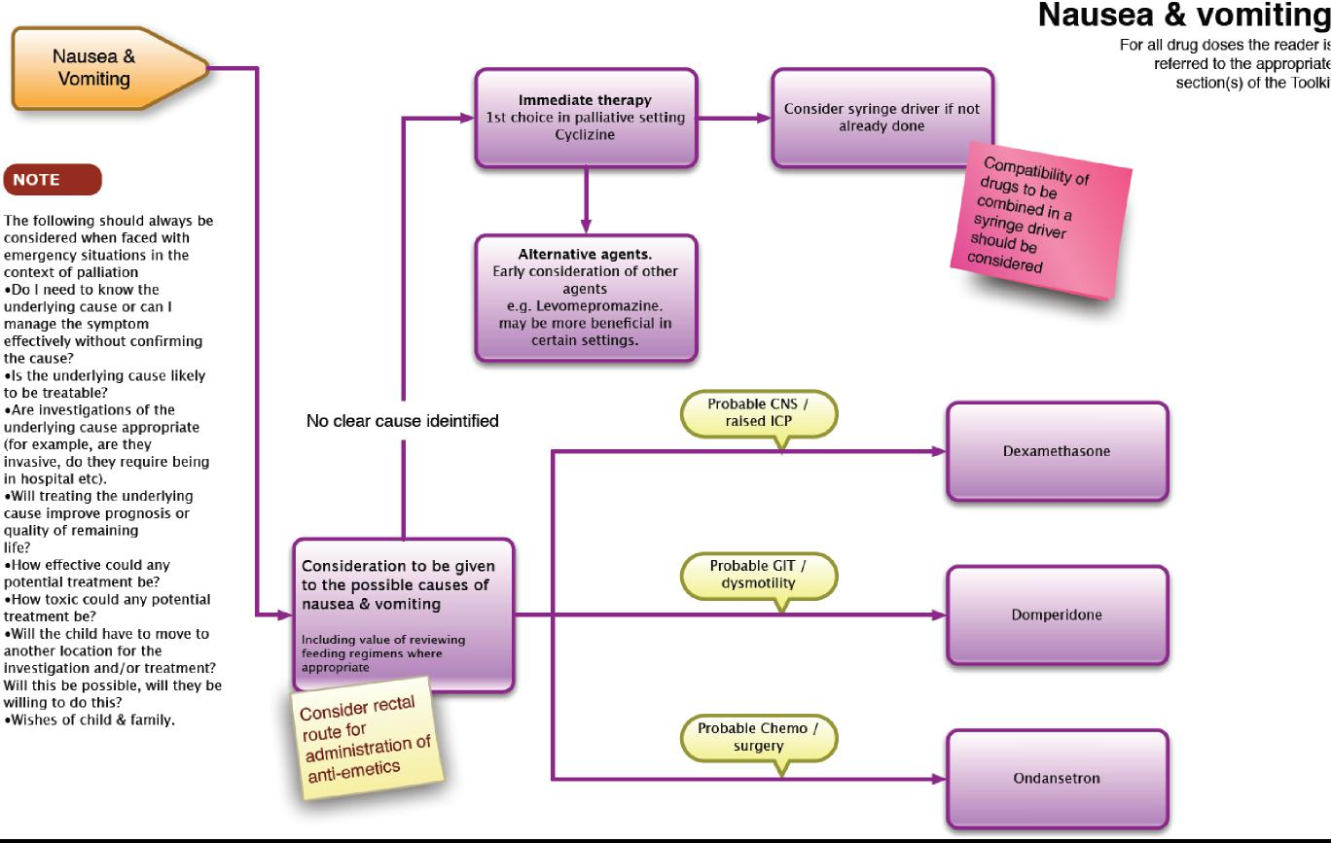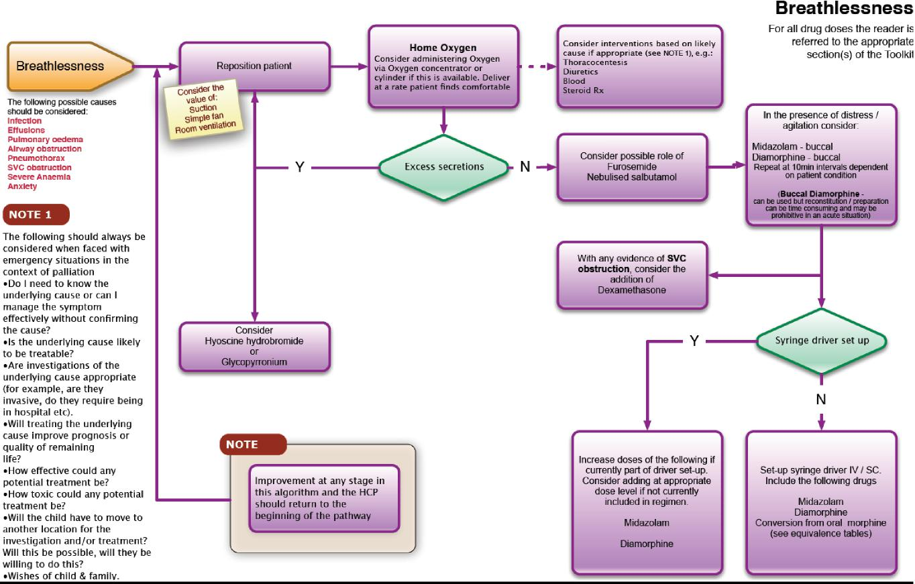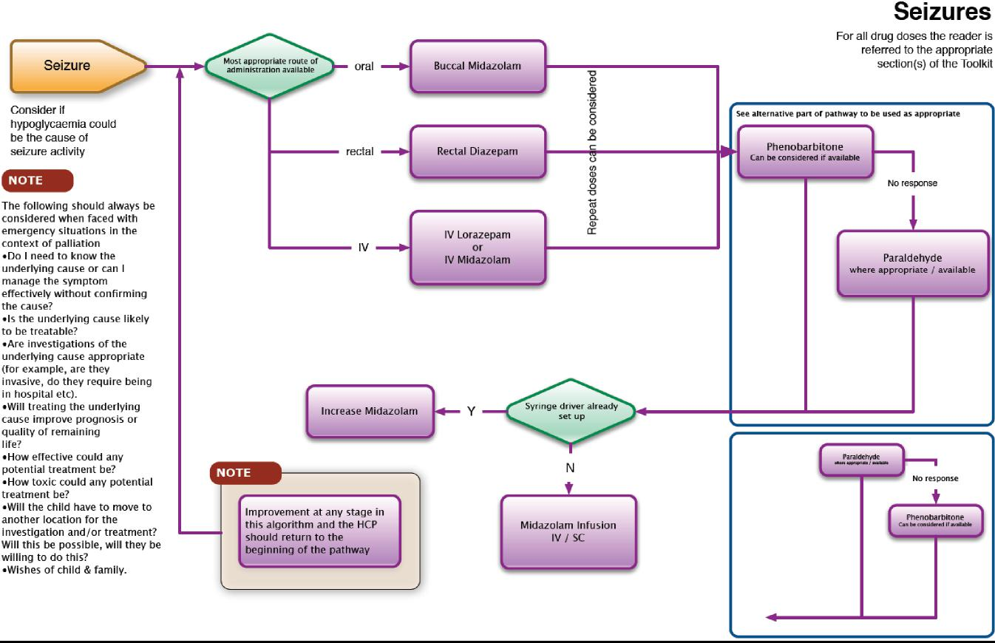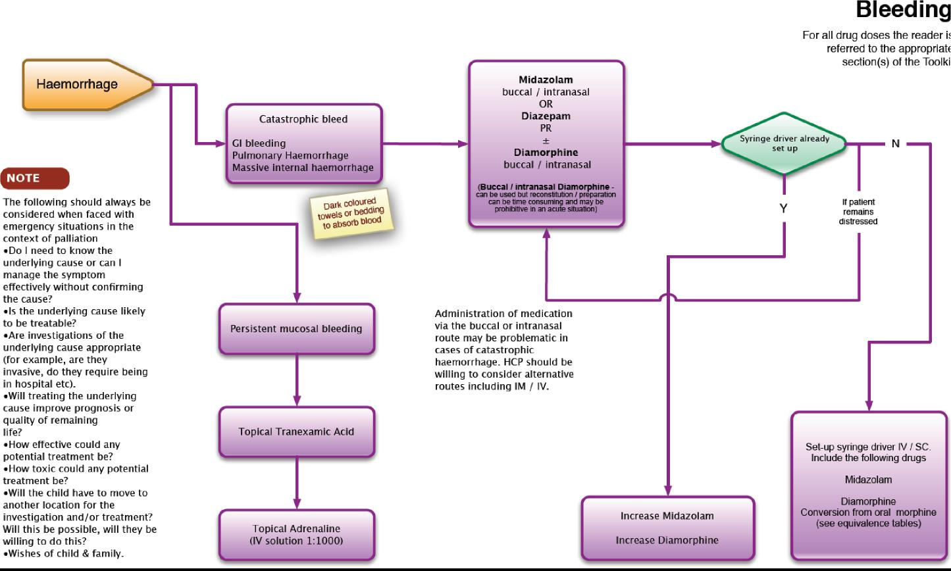

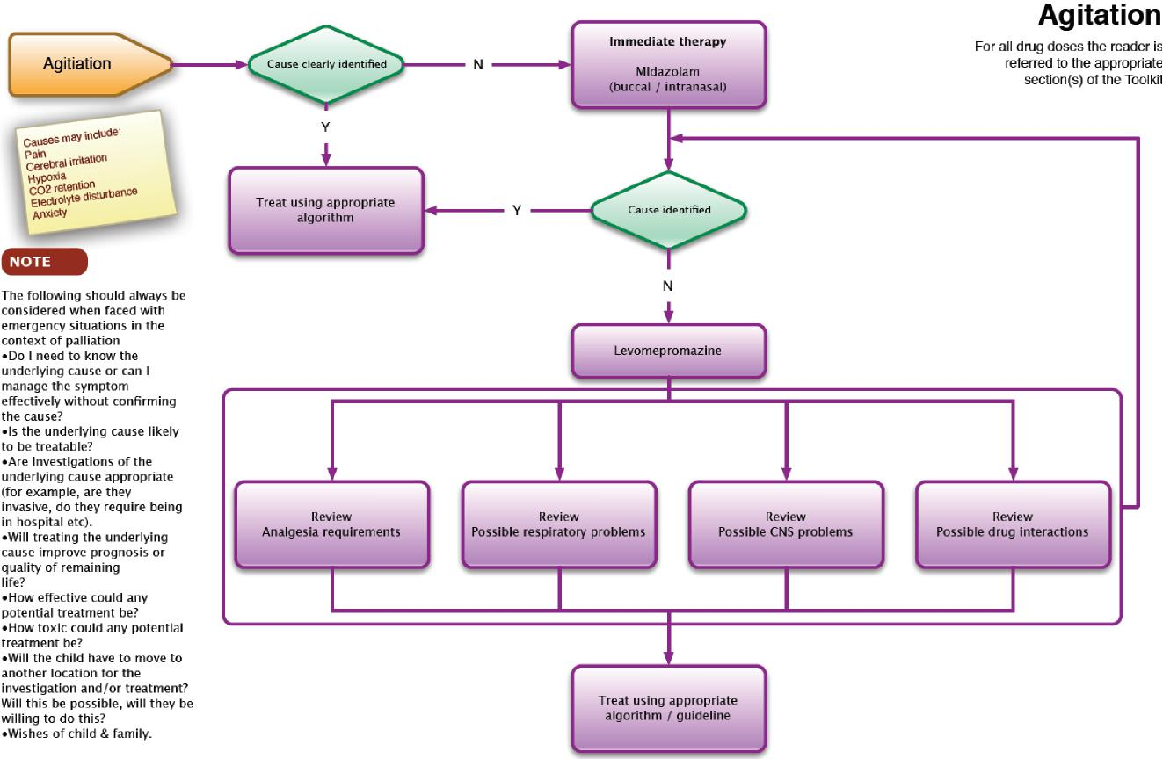

Writing Prescriptions for Controlled Drugs
Prescriptions for Controlled Drugs must meet legal requirements.
A prescription for Controlled Drugs (Schedule 2 and 3) must be written so as to be indelible, and may be hand-written, typed or computer generated. The use of pre-printed adhesive labels is not recommended to reduce the possibility of tampering. The legal requirements for a prescription for a Controlled Drug are as follows:
- The patient’s full name and address
- The patient’s age if less than 12 years.
- The name of the drug and the pharmaceutical form. Use of a brand name (e.g. MST) is acceptable (although the drug name is preferred) but the pharmaceutical form should always be included, even if it is implicit through the use of a brand name (e.g. MST tablets, not MST) or if only one form (e.g. tablet or injection) exists.
- The strength of the preparation (Strictly this is not required if only a single strength exists, but is best included to avoid problems arising from the prescriber being unaware of other available strengths, especially ‘Specials’).
- The dose to be taken. Whilst the dose to be taken (e.g. one tablet or 30mg.) must be explicit, this is not necessary for the frequency (although explicit instructions are preferred). Thus ‘One tablet to be taken twice a day’ is preferred; ‘One tablet to be taken as directed’ is acceptable but ‘To be taken as directed’ is not.
- The total quantity of the preparation, or the number of dose units, to be supplied, written in both words and figures. Since the strength to be supplied will be included (see above) the total quantity on a prescription for ten ampoules of Diamorphine 30mg. may be expressed as either 300 (three hundred) mg. or as 10 (ten) ampoules.
- The signature of the prescriber (this must be handwritten) and the date (which need not be handwritten). The date may be the date on which the prescription is signed or the date on which it is intended for treatment to start.
Additional good practice:
- Include the patient’s age or date of birth (subject to the requirement above).
- Prescriptions for Schedule 2 & 3 Controlled Drugs should state the patient’s NHS number if known.
- The prescriber’s full name, address and telephone number (which should be the address and telephone number at which they can usually be contacted), CCG in which they are working (if in the community), profession and professional registration number should be provided. (Duplication of information already printed on the prescription is not necessary).
Any space on the prescription form that has not been written on must be blanked off, for example by drawing a line through it to reduce the opportunity for fraud.

- It is strongly recommended, although not a legal requirement, that prescriptions for Schedule 2, 3, & 4 Controlled Drugs are limited to a quantity appropriate for up to 30 days.

- If a prescription is written for supply for more than 30 days treatment the prescriber should document the reason in the patient’s notes and be prepared to justify their decision. Typically they may be contacted by the pharmacist dispensing the prescription because that person is required to satisfy themselves that the supply is appropriate.
Further information
- The maximum validity of a prescription (whether NHS or private) for a Schedule 1, 2, 3 & 4 Controlled Drug is 28 days from the date on the prescription (which may be either the date of signing or the date on which treatment should commence (see above)).
Requirements around controlled drugs continue to change.
To ensure that the information is up to date and that it complies with your local Medicines Policies, please refer to:
Your local Medicines Policy
Children’s BNF
Department of Health website www.gov.uk/government/organisations/department-of-health

National Prescribing Centre is now part of NICE https://www.nice.org.uk/about/nice-communities/medicines-and-prescribing

And cross reference with other recognised sources of information

Taking Controlled and Prescription Drugs to Other Countries
Some patients receiving palliative care may wish to travel to other countries and need to take medication with them. Two sets of law need to be considered: that of the UK, and that of the country or countries to which you will be travelling, or through.
Because Regulations may change, patients or carers living in the UK are advised to check the latest Home Office guidance by contacting them directly or visiting their website:
Drug and Firearms Licensing Unit
dflu.ie@homeoffice.gsi.gov.uk
Telephone: 020 7035 6330
Monday to Friday, 9am to 5pm
https://www.gov.uk/travelling-controlled-drugs
https://www.gov.uk/government/publications/personal-import-export-licence-application-form
If you need to carry certain Controlled Drugs abroad (or in the case of an import licence, into the UK) for short periods for your personal use, or that of your child, may need a personal licence.
A personal import or export licence will be required if:
you are travelling for three calendar months or more you carrying more than three months' supply

You should apply for a personal licence at least ten working days before the intended date of travel.
Travelling for less than three months
If you are travelling for less than three months and you are carrying less than three month supply, you will not need a personal import or export licence to enter or leave the United Kingdom.
However, it is advisable to obtain a letter from your prescribing doctor which should confirm your name, travel itinerary, names of prescribed Controlled Drugs, dosages and total amounts of each to be carried.
If you are carrying prescribed medication(s) which are not Controlled Drugs you are also advised to obtain a letter to cover these drugs, or ask your doctor to include them with the letter regarding Controlled Drugs.
In either case, the personal licence or doctor’s letter and the medicines should

ordinarily be carried in your hand luggage so as to permit inspection by UK Customs or other officials.
Always check with your airline or carrier in advance of your travel date that carrying the entire amount of your medication in your hand luggage is allowed. This will be particularly important if you need to carry out of the UK volumes of liquid medicines (individually) greater than 100ml.
Travelling for more than 3 months
If you or your child are planning to stay away for more than 3 months you are advised to make contact with a doctor in the country in which you will be staying, and to obtain prescriptions for further supplies from that doctor. This will avoid any problems over the quantities of the medicines you intend to take with you.
However, you should be aware that not all medicines that are available in the UK will be available in the country you are travelling to.
Regulations in other countries
Other countries may have their own import regulations for Controlled Drugs and prescription medicines. We strongly advise you to check this with the UKbased representatives of the country or countries that you are travelling to or through.
You can find a list of Embassies, Consulates and High Commissions at:
https://www.gov.uk/government/uploads/system/uploads/attachment_data/file/98058/embassy-list.pdf
For further information:
Home office website – see above.
www.palliativedrugs.com/palliative-care-formulary.html

Drug Compatibility In Syringe Pumps
Principles:
Decisions about the most appropriate method by which to deliver treatment will be dictated not only by the patient’s clinical situation and preferences, but also the nursing support available, and when. As a guiding principle, drugs should not be given by CSCI if practical alternatives exist. Before prescribing or setting up a syringe pump, consider:
- Is the use of the drug merited?
- Can it be given by an alternative route?
- Does it need to be given as a continuous infusion? Will once or twice daily boluses be equally effective?
- Is there evidence, anecdotal as a minimum, that the mixture you propose is compatible?
The fact that it is common practice in palliative care to mix several drugs – typically between 2 and 4 – for delivery as a continuous subcutaneous infusion (CSCI) can mask the fact that this is contrary to the norms for parenteral therapy. These suggest that drugs should be given separately whenever possible.
The reasons for these norms are clear. Drugs are by their nature reactive chemicals and the more complex the mixture the greater the risk of incompatibility. The following factors will influence compatibility:
Properties of individual drugs: Certain drug combinations are clearly incompatible, reacting immediately and obviously through the production of a product that precipitates out of the solution.
Components of the formulation: The complexity of the mixtures created should not be underestimated. Even a solution of morphine in saline will have five components (Morphine and water molecules, and sodium, sulphate and chloride ions). Excipients in the formulations should not be ignored – additives present to enhance the stability of the original formulation of an individual drug will become part of the ‘cocktail’ for infusion with the potential for interaction (and toxicity).
Diluent: Compatibility of the individual drugs with the proposed diluent should be confirmed. Cyclizine is incompatible with Sodium chloride, particularly at higher concentrations, and for this reason Water for Injection (WFI) is commonly preferred as the vehicle for CSCIs.
pH: Whilst Sodium chloride 0.9% and Water for Injection (WFI) have essentially neutral pH (pH 7), Dextrose 5% is a (chemically) acidic solution with a pH of 4 – 4.5. Drugs will be compatible with different diluents according to their relative stability in solutions of different pH.

Concentration: Drugs will often be given in more concentrated solutions for CSCI compared with other parenteral routes. This is due both to the amount of fluid that can be delivered by the route of administration and the restricted volume that can be delivered from the syringe pump. Unfortunately, more concentrated solutions are inherently less stable. Whilst 10ml. syringes are commonly used for CSCI, 20ml. syringes may be more appropriate for more complex mixtures where the greater volume and lower concentration may help avoid compatibility problems.
Temperature: Differences in stability have been demonstrated for certain drug solutions between ITU/HDUs and ‘normal’ wards due to the fact that the ambient temperature in intensive care areas is typically warmer by 2 – 3ºC. It is therefore not surprising that the stability of solutions delivered in palliative care will be affected according to whether the delivery device is at ambient temperature or worn under clothing or close to the skin.
Light: Some drug solutions are affected by light, which may require the delivery system to be covered throughout the period of the infusion.
Time: As always, the longer the conditions exist that enable something to happen, the greater the likelihood that it will. So an infusion set up to run over 48 hours is inherently more likely to change in some way than one that will run for only 24 hours.
Components of the drug delivery system: Certain drugs may be incompatible with components of the delivery system, and this may result in:
Loss of drug through binding to the material of the delivery system, and/or
Leaching of components of the plastic into the drug solution – Is the patient reacting to the drug or to one of these chemicals?
Indicators of stability:
The common assumption that a mixture is compatible if:
- No precipitate forms
- There is no colour change
- No gas is formed
is entirely false!
All that can be said with certainty about a solution that remains clear and colourless is that whatever is dissolved in it is soluble in the volume of diluent available. What the solution actually contains is unknown. The only way to ensure that any mixture is compatible is through laboratory assay using appropriate analytical techniques. However, a moment’s consideration of all the variables – not just the number of potential drug combinations, but also all the issues discussed above – makes it clear that such information will never be comprehensive.

Because it is impossible to confirm the stability of all the possible mixtures used in palliative care, a clear, colourless solution and apparent clinical efficacy have become accepted as proxies for compatibility. Given the difficulties noted above this is not completely unreasonable, but the potential pitfalls should be understood and considered:
Scenario 1.
Consider a mixture of two drugs. Drug A is potentially toxic and the dose requires careful titration. Drug B interacts with Drug A, reducing the amount available in the mixture by up to 30%. The patient is well controlled, and eventually Drug B is no longer required. The syringe is then made up with the same amount of Drug A alone, but now that the effect of Drug B has been removed the patient experiences toxicity.
Scenario 2.
A patient is generally well controlled on a mixture of Drugs C & D, but family report that symptom control is less good for several hours before the syringe is changed each day. Is this evidence of the cyclical nature of symptom severity or a result of a lack of stability or interaction between Drugs C & D such the amount of one or both is reduced to a sub-therapeutic level towards the end of a twenty four hour period?
Useful references:
PCF 3 Palliative Care Formulary, 2007. Ed. Twycross R and Wilcock A. Pub. Palliativedrugs.com. ISBN 978-0-9552547-1-0
The Syringe Driver: Continuous subcutaneous infusions in palliative care. 2nd. ed. 2005. Dickman A, Schneider J and Varga J. Oxford University Press. ISBN 978-0-19-856693-9
www.palliativedrugs.com, PCM Palliative Care Matters, www.pallcare.info

CME T34 Syringe Pump
Syringe Pumps
In palliative care the subcutaneous route of drug administration is often the most convenient. It has many advantages, including being seen as less invasive than intravenous therapy, not requiring venous access where such access may be difficult or impossible, being easily monitored for local irritation, and being easily relocated if such problems occur.
The network of small blood vessels provide good absorption of medication and parenteral drugs are often absorbed more rapidly than oral drugs. The subcutaneous tissue lies between the skin and the underlying muscle, it is made up of loose connective tissue and varying amounts of fat. It also contains cutaneous nerves, small lymph vessels and blood vessels.
When central venous lines are available syringe pumps such as the CME T34 can also be used so the medication is given intravenously.
It is also widely acceptable in the community setting, making it possible to manage patients at home when more invasive devices would preclude this.
Definition
A Syringe Pump is a portable battery-operated infusion device used to deliver drugs at a pre determined rate via the prescribed route.
Aims
To control symptoms in children and young people during terminal care.
Indications for use
Child/Young person is unable to tolerate oral medication for whatever reason eg nausea and vomiting, dysphagia, intestinal obstruction, local disease
Other routes of medication ineffective or inappropriate
Child/Young person is unconscious or there may be a risk of inhalation if given orally
Paediatric terminal care – symptom management.

Contraindications
In paediatric palliative care the CME T34 syringe Pump will be set to deliver the prescribed amount over a 24 hour period. If any other time is programmed into the device the person operating the syringe pump should consult CME before using the device.
The device should not be used until advice has been sought and the device has been reprogrammed for 24 hours.

Advantages of using a syringe pump:
Delivers drugs at an even rate continuously, maintaining plasma concentration at an optimum therapeutic level therefore improving symptom control
Increases patient control, removing the fear and pain of regular injections
Allows delivery of drugs through a single site for a period of time Allows for combination of drugs via one route
Portable and light weight device therefore allows for independence and mobility
Accurate infusion timing
When used in conjunction with the locking box, it minimises the risk of syringe tampering/displacement (this is usually mandatory in some trusts/community teams)
Disadvantages of using a syringe pump:
Local site reactions from irritant drugs
Negative impact upon body image
Potential of technical problems.
Dose titration not possible without renewing whole infusion
Potential for psychological dependence on device
Barrel clamp arm on pump vulnerable to damage with rough handling
Infusion Sites
N.B: Check preferred method of wearing pump before selecting infusion site.
Anterior chest wall (above nipple line)
Anterior abdominal wall
Anterior aspect of thighs
Scapula region
Anterior aspect of upper arms (avoid in bed bound patients who
require regular turning).
Sites to avoid:-
Areas of broken skin
Areas of inflammation
Lymphoedematous limbs
Any area that has undergone radiotherapy should be avoided
Apply anesthetic topical cream as prescribed and/or required as clinical assessment indicates
Correct positioning of the needle is essential

Cleansing and decontamination of the syringe Pump
Cleansing should be carried out with a damp disposable cloth (use warm water and general purpose detergent only.) Dry thoroughly. If any additional cleansing is required e.g. threads of the screws the actuator moves along, contact the manufacturer for advice. The pump must not be submerged in water and if accidentally dropped in water it must be immediately withdrawn from use and sent to the a Service Department .
The pump must not be cleaned with spray detergents. Clean with mild detergent and a damp cloth (preferably lint free)
Description of CME T34 Syringe Pump
The T34 syringe Pump must not be used unless the practitioner has attended and completed the appropriate self assessment competency training.
The T34 is a small, lightweight, battery powered ambulatory syringe pump. It weighs approx 210g excluding battery and measures 169mmx53mmx23mm.
In paediatric palliative care the CME T34 syringe Pump will be configured to infuse over a 24 hour period and is set in mls/hour. If not do not use until advice has been sought from CME. The syringe pump will automatically calculate the rate of administration according to the volume in the syringe. Please note this guidance should be used in conjunction with the CME T34 instruction sheet.
Care of the skin site
The infusion site should be checked by a registered nurse at least every 24
hours for:
Pain/discomfort
Swelling/induration
Erythema/reddening
Leakage of fluid
Bleeding

Setting up the Syringe Pump
Before commencing the syringe pump
The child/ young person if appropriate and their parents should be prepared firstly to help understand the rationale for the syringe pump use, they also need to be educated on the functioning and safety of the device.

Choice of syringe
The T34 syringe pump is calibrated in mls/hour. The pump can be used with most brands of syringe. Historically with the previous Graseby syringe drivers the most common size of syringe has been 10 and 20ml, however it has been more recently advocated that a 20ml syringe be the recommended minimum for several reasons (Dickman 2005)
Larger dilution will reduce the risks of adverse site reactions and incompatibility
Larger doses of drugs can be administered where previously 2 x 12 hourly infusions would have to be administered
20ml and 30ml, luer lock syringes (in order to avoid leakage or accidental disconnection) are recommended for use with the CME T34 syringe pump and lock box.. These can be filled to a maximum of :
18ml in a 20ml
24mls in a 30ml
(due to the expansion of the actuator to accommodate the syringe)
Equipment required
CME T34 pump
9v alkaline battery,
Luer lock syringe, minimum 20ml e.g. Becton Dickinson (BD)
Administration device and extension set
Drug labels
Transparent adhesive dressing e.g. tegaderm
Prescription chart
Prescribed medicines/diluents
Filter needle to draw up drugs to avoid drawing up glass spicules which
have potential to cause abscesses
Lock box
Dressing pack
Sharps box
Record of administration of drugs- WMPPCN Drug Administration Document
Personal protective equipment (PPE)
Hand decontamination equipment

CME T34 syringe Pump feature recognition Keypad
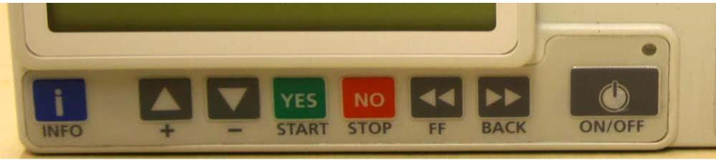
- INFO Key use to access event log, set up, volume infused, battery status and activates keypad lock on/off
- UP/DOWN arrow keys use to increase/decrease parameters/scroll options
- YES/START key- confirms selection/start
- NO/STOP- step back a screen/stop
- FF (forward)-moves actuator forward
- BACK-moves actuator back
- ON/OFF
Syringe Loading
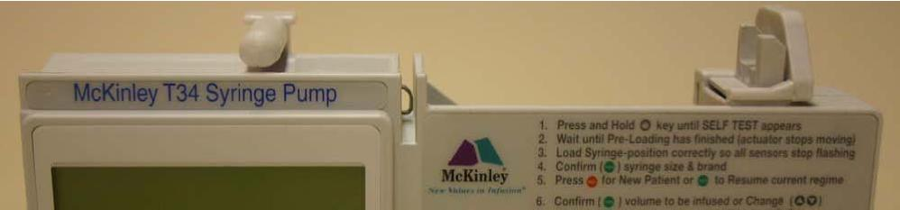
- Barrel clamp arm- (detects syringe size/width of barrel/secures)
- Syringe ear/collar sensor (detects secure loading of syringe collar)
- Plunger sensor (detects secure loading of syringe plunger)
NB : Procedure for first infusion or when changing the line – please note that the infusion will be completed in less than 24 hours as the line needs to be primed after the rate has been set to ensure the patient receives the correct dose of the drug prescribed.

Step 1 - Prepare syringe

Decontaminate hands as per local policy and apply PPE
Use a luer lock syringe of at least 10ml
Check compatibility of prescribed medications
Draw up and check prescribed medication. Transfer medication to l syringe size of choice. Invert syringe several times. Use diluent as per patient prescription to make up required amount for infusion
Label the syringe (name of patient, date and time of preparation, name quantity and batch number of all drugs and diluent, total volume of the contents to be infused, time they are to be infused over, initials of person(s) preparing infusion).
Attach label to syringe ensuring it doesn’t obscure visual scales or interfere with the mechanism of the infusion device i.e. where there is contact with the barrel clamp
Step 2 - Check battery life
Switch pump on and allow the pre-loading programme to complete (movement of actuator on screw mechanism). Flashing syringe icon will appear on the screen.
Press the INFO key once, followed by single press of YES key battery level will appear on the display after a few seconds, screen will default to flashing syringe icon,
Verify that there is sufficient battery power for the programme (note a fully charged battery lasts approx 3-4 days). In the community, should the battery life read 35-40% at the start of a 24 hour infusion, change
the battery
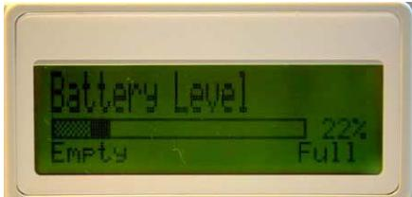
Step 3 - Pre loading and syringe placement
Install the battery into the syringe pump
Ensure the barrel clamp arm is down and press/hold the on/off key to turn the pump on. The LCD display will show “preloading” and the actuator will start to move.
When it stops moving “load syringe” will appear on the display (note the actuator always returns to the start position of the last infusion programmed)
If the actuator is not in the correct position to accommodate the syringe leave the barrel clamp arm down and use the FF or BACK buttons on the keypad to move the actuator.

Lift the barrel clamp arm
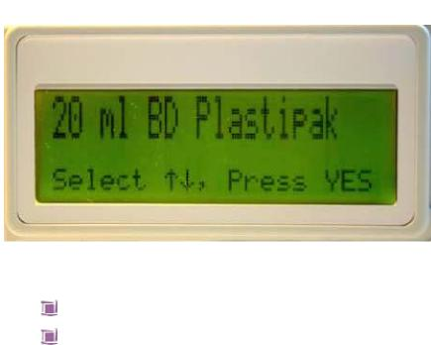
Seat the filled syringe collar/ear and plunger so the back of the collar/ear sits against the back of the central slot. The syringe collar/ear should be vertical.
Lower the barrel clamp arm
Confirm the syringe size and brand by pressing the YES button or use the up/down arrows to scroll through the other options for brand/size and press YES
The volume in the syringe will be displayed, press YES to confirm If the volume displayed does not match the volume in the syringe (allow +/- 5% system accuracy – pump & set combined), remove the syringe and start again
Step 4 - Setting infusion parameters
After the syringe confirmation the 1st screen which appears is the volume screen. Upon confirmation of the volume with the YES key, the screen below will appear
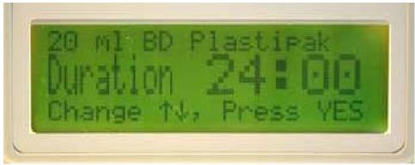
Press YES to confirm the duration of the infusion is to be 24 hours. Use the up/down arrows to scroll down if a different time of infusion is required. The syringe pump will automatically default to 24 hours the next time it is used.
The pump calculates and displays the rate of infusion, press YES to confirm
Step 5 – prime line
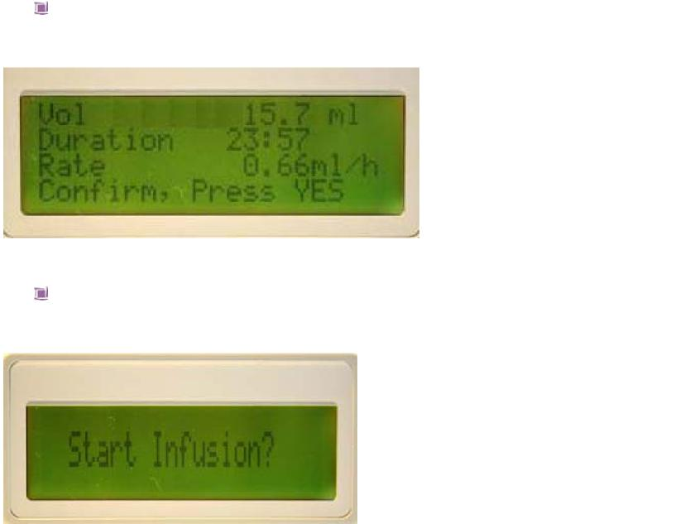
The summary screen confirms the volume to be infused, duration of infusion and rate in mls/hour. Press YES to continue
Pump prompts to START INFUSION?
Lift barrel clamp and remove syringe – do not switch the pump off
Place the barrel clamp arm back into the down position
Prime line
Re-adjust the actuator with FF key to accommodate new syringe
volume/syringe size
Lift up the barrel clamp arm
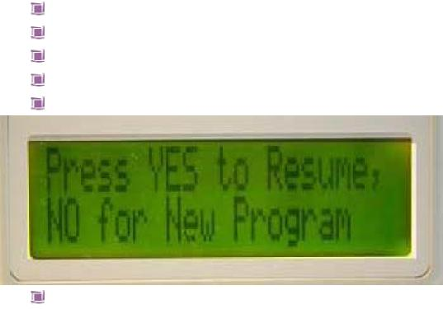
Re insert syringe
Lower the barrel clamp
Re confirm syringe size/brand
The following screen will be displayed
Press YES. The volume, duration and rate will be displayed (note the rate will remain the same but the duration of infusion will be less to take account of the amount in the primed line. Press YES
Pump prompts to Start infusion?

Step 6 - Connect syringe pump to patient
Insert the administration device into the subcutaneous tissue at the selected site
Secure with a transparent dressing. Include a loop of the infusion set under the dressing to avoid direct pull on the administration device Document drugs, diluent administered and time infusion commenced in patient record as well as medical devices information e.g. serial number
Step 7 – Start infusion
- The pump will still be displaying ‘start infusion’ Press YES (in the event that the ‘pump pause too long’ alarm has commenced, press YES key) this will return you to the ‘Start Infusion’ screen
- The pump will display the following screen which will remain throughout the infusion
- The Green LED indicator flashes
NB It can take up to 4-6 hours for drugs to reach therapeutic blood plasma levels therefore a breakthrough dose may be required during this initial period
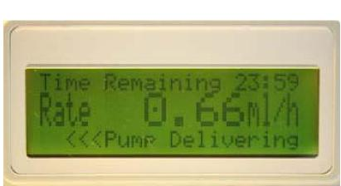
NEVER TAKE A SYRINGE THAT IS NOT EMPTY OFF THE PUMP IF IT IS STILL CONNECTED TO THE PATIENT
Key pad lock
The CME T34 allows all users to lock the operation of the keypad during the infusion. This function prevents tampering with the device and should be routinely used (most trusts/community teams make this a mandatory requirement)
To activate – press and hold the ‘INFO’ key while the pump is infusing until a chart is displayed showing a ‘progress’ bar moving from left to right. Do not remove your finger until a beep is heard otherwise the keypad will not have locked/unlocked
- Hold the key until the bar has moved completely across the screen and a beep is heard to confirm the lock has been activated. NB The YES/START, NO/STOP and INFO keys are still active
- To deactivate repeat the procedure. The bar will move from right to left and a beep will be heard

Step 8 – Infusion complete
- As the pump nears the end of the infusion it will alarm intermittently to alert you that it is almost complete

- When the infusion is complete and the syringe is empty the pump will stop automatically and the alarm will sound
- If the syringe pump is no longer required press ‘OFF’ then disconnect the infusion from the patient. - - Remove battery from syringe pump Clean the pump and lock box (do not immerse in water)
- If the patient requires a further infusion – switch pump off
- Remove syringe
- Repeat steps 1-4 as above
- At the ‘start infusion?’ prompt connect syringe to existing
set if site shows no signs of inflammation/irritation and then press ‘YES’
Temporary interruption of infusion e.g. bathing
Press ‘STOP’
Press and hold off button until beep is heard and screen will go blank Do not remove the syringe from the pump
CME would recommend that the pump be taken down before entering the shower or the bath and that you do not secure the pump in plastic bags!!
Neria needle -subcutaneous
Disconnect the line from the syringe and cap both the line and the syringe if using a needle/needle safe device. Give consideration to breakthrough medication whilst the child/ young person is disconnected from the syringe pump.
Via central line
If a central line is being used with the T34 syringe pump, check with your local policy and use all usual precautionary methods to protect the central line during a shower or bath. Reconnect the syringe pump to the central line using the ‘non touch technique’ as per policy as soon as the shower or bath is complete. Reassess child/ young persons pain after the shower or bath and consider the need for breakthrough medication.
Press and hold the ‘ON’ key until a beep is heard, the screen will request a conformation of syringe size and brand, press ‘YES’ to confirm
The screen will display –
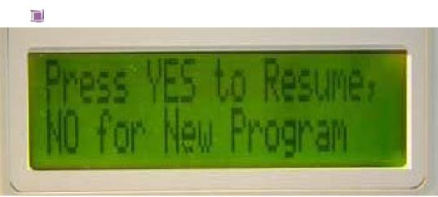

Press ‘YES’ - the screen will display volume, duration and rate of infusion, press ’Yes’ to confirm
NB if you press ‘NO’ the pump interprets this as a completely new 24 hour period and you would need to commence a completely new prescription from the start
Screen will display ‘start infusion?’
Press ‘YES’
The ‘pump delivering’ screen will now be displayed again
What to do if a patient dies whilst the syringe pump is running.
Leave the pump insitu until the child/young person’s death has been
verified by an appropriately trained person
Following verification of death - Press ‘STOP’
Record date, time and amount of solution remaining to be infused left in
syringe
Switch pump off
Remove syringe from pump, destroy contents as per policy .Document
and sign in the patient’s record.
Remove any needle/needle safe device from the patient
Remove battery from pump and clean pump/ lock box
Care of infusion site
Transparent dressing should be used to enable visible monitoring of the site
If there is evidence of inflammation or poor absorption (hard subcutaneous swelling) the site should be renewed
The administration device/line should be renewed if there are signs of irritation/inflammation/device displacement

Care during infusion
Explain care of the pump to the child/young person if appropriate and carers, including when the pump will alarm and procedure to be followed
Check battery each visit
Disconnect when taking a bath or shower and cap the ends of the syringe/line (see previous entry in guidelines re disconnecting the lines.) Record on the monitoring chart the length of time the infusion was stopped for.

Checks whilst syringe pump is in use
Assess symptom control regularly
Check site for redness, inflammation, infection or administration device
displacement
Check syringe and line for signs of precipitation, crystallisation,
cloudiness or colour change of contents or leakage
Check the display – pump is delivering and infusion rate is as
programmed and record rate setting
Check the LED is flashing green
Press ‘INFO’ key to check
Single press – infusion summary – record VTBI (volume to be
infused) and VI (volume infused)
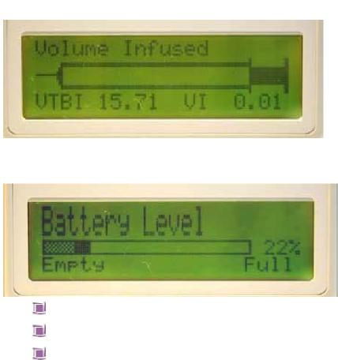

Double press – battery life remaining
Visual check of fluid remaining in syringe compared with pump reading Monitor patient for any signs of drug toxicity Record in child/young person record
Reducing the risks of complications
Ensure child/young person has no allergies
Rotate the site of needle insertion
Ensure all drugs to be mixed are compatible
Be aware that certain drugs can be irritant to the skin
Try not to use more than 3 drugs in one infusion, if necessary set
another syringe pump infusion up and mark contents of each syringe
pump accordingly.
Ensure the administration device and lines are secured to reduce drag
and risk of disconnection

Troubleshooting
Problem: | Possible cause: | Action:
The pump will not start | No battery present Battery inserted incorrectly  Battery is depleted/very low  Pump is faulty | Fit a battery  Re-align battery terminals Fit a new battery Service required
Infusion ended  early/going too quickly | Incorrect rate set Wrong syringe brand selected during set up  Pump faulty or incorrectly calibrated | Check displayed rate against  prescription change if necessary  Ensure correct understanding of user Service/calibration required
The pump has stopped before emptying syringe | Exhausted battery Faulty pump | Fit new battery, turn pump on,  confirm syringe size and brand  select to resume infusion Return for service

CME T34 Pump Alarms
When the pump detects a problem four things occur
The infusion stops
An audible alarm is activated
A message appears on the display screen indicating the cause of the
alarm
The LED indicator turns red

The following table indicates the appropriate actions to be taken
Alarm: | Possible cause: | Action:
Occlusion or syringe empty | Patient access device blocked, kinked, clamped or occluded  Actuator has reached minimum travel position | Remove occlusion and restart or re-load syringe  Flush or replace access device  Release clamp  End of program, turn pump OFF
Syringe displaced | Syringe has been removed or displaced | Check & confirm syringe seated correctly and resume
Pump paused too long | Pump left or no key presses detected for 2 minutes | Start infusion, continue programming or switch off
Near end | 15 minutes from end of infusion | Prepare to change syringe or switch off
End program | Infusion Complete | Pump will either default to KVO (keep vein open) or it will alarm in which case switch pump off and await nurse to replenish/remove
Low battery | Battery is almost depleted (30 minutes left) | Prepare to change battery
End battery | Battery is depleted | Change battery

This page is intentionally left blank

Symptom Control Support Bag/box
For Use With a CME T34 Syringe Pump
In addition to the ‘Just in Case Drug Boxes’ provided to support symptom control in end of life care in the community, it is also helpful to provide a ‘Symptom Control Support Bag’ that can be kept in the home containing items that might be required when delivering end of life care.
This list can be printed off and used as a check sheet when preparing the support bag.
It is useful to sign and date the sheet when contents are checked and correct.
Equipment and Disposables
CME T34 syringe pump
Spare battery 9V (6LR61) type X2 or rechargeable battery
Pump lock box
T34 Administration Sets:-
Length 100cm, prime vol 0.5ml with Anti-siphon valve x5
Dressing packs x 5
10ml Luer Lok syringes x 10
20ml Luer Lok syringes x 5
1ml syringes x 10
2ml syringes x 10
Red filter needles x 20
Blue needles x 20
Needle/needle safe device x 5
IV bungs x 10
Tape x 1 roll
Film dressing x 5
Hydrocolloid Thin dressing x 2
70% v/v Isopropyl alcohol and 2% w/v Chlorhexidine gluconate swabs x 40
bandage x 3
Gauze squares 5 x 5 cm x 5 packs
Drug additive labels x 10
Sterile gloves x 2 size 7/large
Sterile gloves x 2 size 5.5/medium
Small sharps bin
Plaster remover swabs x 10
Liquid soap
Hand decontamination equipment
Calculator
Post It notes
Pens x 2
Mouth care finger cots x 2
Dark coloured cotton hand towels x 2
Checked by Date

Drug Administration Document
The Drug Administration Document has been produced primarily to support symptom control in the final days of life within the community where a syringe pump may be required. It is for medical and nursing staff use only.
This document should be completed by the doctor or Independent Non –Medical Prescriber managing the child’s symptoms, where a child is being discharged from hospital and is anticipated to need a syringe pump. When the document is initiated in the community, the doctor with responsibility for the child’s symptom control should complete the documentation. This would usually be the Paediatrician. GP’s would not normally be expected to write the initial instructions for the syringe pump use nor prescribe initial opiate doses in children.
The document enables the prescribed just in case syringe pump medications to be written in the document and instructions on their delivery to be given to provide authorisation for nursing staff to commence and continue the infusions when agreed as indicated. It also allows for increased doses, should symptom control require increased doses.
It provides for the documentation of all controlled drug use including stock taking of all strengths required.
Additional just in case medications and breakthrough medications can also be written up to provide authorisation for nursing staff to administer when needed Sheets follow this, along with a ‘Carer’s/Self Record’ for medication taken.
Example symptom control flow sheets are within the document to remind staff of the breadth of symptoms to be enquired of, and can be photocopied for daily use and handover support. (This sheet is also available separately in the Toolkit for ease of access).
Likewise, Pain control assessment tools are located within the Drug Administration Document and also, for convenience, in the Toolkit.
An important aspect of the Drug Administration Document is that it allows for all drugs in the syringe pump being administered at any one time to be able to be viewed together, so that safe interpretation of drug dose changes and symptom control measures being employed can be supported.
Please note carefully the requirements for its completion as indicated on the back page of the Drug Administration Document.
For further information contact : Sue Davies on : 07768930402

Carers/Self Record of Medication Taken

Date | Name of Medicine | Amount Given | Time Given | Reason Given | Effective Yes/No

When a Child Dies At Home

This document aims to provide useful information and advice to help you at the very difficult time of the death of your child, when this takes place at home, during the early stages of your bereavement. If you are unclear about any information please ask your named nurse.
Practical Necessities: What to Do First
Following the death of your child at home there are certain things that need to be done. It is important to feel that you have a choice in what happens next. You may wish to be on your own as a family, call upon friends and family or call professionals to offer support.
Who to Call
When your child dies following planned terminal care at home, there should be no need for the G.P or lead doctor in your child’s care to be contacted immediately by yourselves. You may feel that you would like to spend some time together on your own as a family first. However (due to the Child Death Review Process) the nursing team will need to be informed by telephone when your child dies. They will not necessarily visit immediately. They will let your child’s GP or lead doctor know of your child’s death.
The nurse on call will then be able to visit when you as a family feel ready. One or two nurses may come to your house; they may not live in close proximity to your address but be reassured they will get to you as soon as they possibly can.
When the nurses arrive they will do as much or little as you wish. This may include arranging when your child’s GP or lead doctor will visit and contacting your chosen funeral directors.
Your child’s G.P or lead doctor will need to visit your home to verify your child’s death and to arrange for your child’s death to be certified, where this follows a planned episode of terminal care at home.
Funeral Directors
You will need to contact a funeral director and you can ask your nurse to help you with this.
You may wish to keep your child at home after they have died, for a short period of time or until the funeral. Your child’s nurse and the funeral directors can give you support and advice about how to keep your child at home in the most appropriate environment.
You need to consider a few things when keeping your child at home. Your child’s body will begin to deteriorate. Therefore if you are keeping your child at

home for more than a few hours you will need to keep the room as cool as possible by opening windows and turning off radiators. The section below gives more detailed advice about caring for your child’s body at home and your child’s nurse and funeral directors will be able to give you further help.

If you wish to keep your child at home for more than a couple of days your child may need to be embalmed. Your chosen funeral directors will be able to inform you of the advisability of this. The embalming usually takes a few hours. The funeral directors will come to collect your child from home and return them following the procedure.
Information on Caring for Your Child’s Body at Home if Your Child Has Died in Hospital or Hospice
If you wish, it is your right as a parent to take your child’s body home unless your child has an infectious disease, or the death has been reported to the coroner. We hope that this information will help you at this sad and difficult time with some of the practical matters.
Children of any age can be taken home. You can decide whether this is in your own car or with assistance from your chosen funeral director. It may be advisable to have relatives or friends with you if you are wishing to undertake this in your own vehicle. If you use your own transport you will be provided with a letter from the hospital or hospice which will explain the situation to the relevant authorities in the event of a motor vehicle accident during the journey.
On reaching home please ensure your child is kept in a cool, well ventilated room. It is normal for your child’s skin to become cold, pale or discoloured. Think about which room you would like your child to be in. As friends and relatives may frequently be in an out of the house in the days following the death, it may be advisable to not place the child in the main living area of the house. Prepare a bed in the chosen room and keep bedclothes to a minimum. It may be helpful to place a waterproof cover over the mattress.
The room needs to be kept cool therefore we would advise you to keep the windows open, turn off any heating in the room and close the curtains if the sun is shining in. During hot weather it may be possible to hire a portable cooling system from the undertaker; this may help to delay the changes that occur. Air fresheners and or aromatherapy burners /candles may help. Small amounts of clinical waste may be disposed of by wrapping up within normal household waste.
During hot weather it may be best to think about letting your child’s body go to the Chapel of Rest. Again you can discuss this with your funeral director.
Embalming your child is sometimes possible. This process is performed by the funeral director and may delay the breakdown of the body. We would advise you to telephone your chosen funeral director who will be able to help with any further questions and assist with the funeral arrangements.

If your child is being cremated the cremation forms will need to be completed before embalming can take place.

If you are going home with your child, your GP and Health Visitor/Community Nurse will be notified by the hospital or the hospice so that they can be there to support you.
Registering the Death
Once you have obtained the Medical Certificate (stating the cause of death) the death must be registered. The death can be registered at the local office of Registration of Births, Marriages and Deaths in the district where the death occurred. This needs to be done within five working days of the death.
You will usually need to ring the Register office to make an appointment to register the death. Appointments last approximately 30 minutes. People who can register a death which has occurred at home are:
A relative of the deceased.
Someone who was present when your child died.
The person making the arrangements with the funeral directors.
Local Register Office Contact Details:
What Should You Take To The Register Office?
The Medical Certificate of the cause of death.
Your child’s NHS number which is on his/her medical card.
Any forms given to you if your child has been referred to the coroner. Your child’s birth certificate if the birth has been registered. (The date and place of birth are required if your child’s birth has not been registered).
Money to obtain copies of Death Certificate which may be required for insurance policies or financial matters.

What Will The Registrar Give You?

A certificate for burial or cremation. This form is currently a green form. You will need to give this to the funeral directors before the final arrangements for your child’s funeral can be made. An additional certificate is needed if you are planning to have your child cremated. The funeral director will arrange to get this form for cremation from the doctor.
Form BD8 - notification of the registry of the death. You will need this form if you are applying to the DSS for a funeral grant.
The registration and issue of these two forms is free. A certified copy of the Death Certificate is also available for a small charge. This is essential if arranging a funeral abroad or if your child had any savings accounts.
(If the coroner has been involved you will have been given an order for Burial or a Certificate for Cremation.) The Funeral Director will need whichever form you are given so that the funeral can take place.
Financial Assistance
Some funeral directors offer “free” services for children’s funerals; however there may be some costs if you have special requirements. If you receive certain benefits (for example, Income Support, Housing benefit and others) you can apply to the Social Fund for help to pay for the costs of the funeral. However, please be aware that if funds are allocated they may not cover all of your requirements.
You will need to complete an Application Form SF200. This is available from your social services office, post office and most funeral directors.
We understand and acknowledge that this is a very difficult and emotional time for you and your family and wish as a team to offer our sincere condolences for your loss.

